Multiple Choice – Circle the BEST answer
- Write a better question for: Do you spend a lot of time each day on your computer?
  - How much time to you spend on the computer each day?
  - Do you spend less than 2 hours a day on the computer, more than two hours, more than 4 hours, or more than 6 hours.
  - Do you have a lot of screen time each day?
  - What devices to you use every day?

- On which day was the most donuts sold? 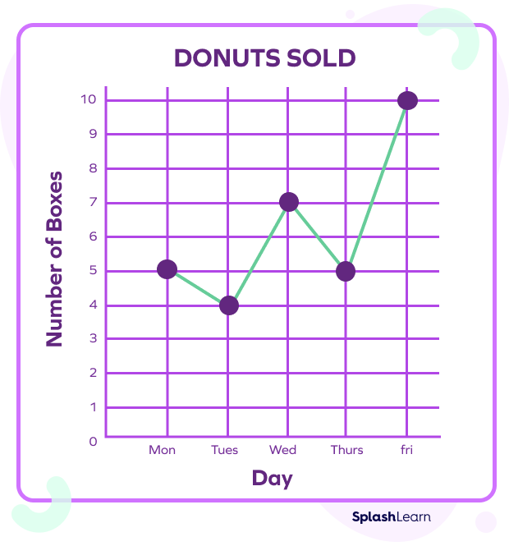
  - Monday
  - Thursday
  - Friday
  - Wednesday

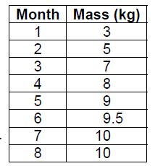
- What type of graph would you use to display this data?

  - Bar graph
  - Line graph
  - Double bar graph
  - Double line graph

ALL ANSWERS TO QUESTION #1 CAN BE PLACED IN THE GRID PAPER.
- (2 points)
Amy surveyed the middle school students to answer this question:
What is your favorite subject at school?
This table show the data she collected.
Subject | Number of students
Math | 20
Science | 35
Phys.Ed | 40
French | 30
L.Arts | 15

- Graph on your own graph paper

- (3 points)
Which type of graph would you use to display each set of data?
Justify your choice each time.
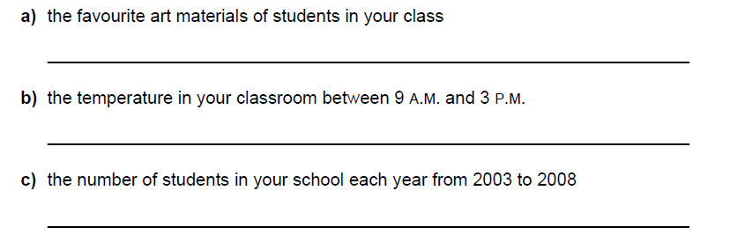

- (4 points) Include probability statements or full value will not be granted. Reduce Fractions
Tim places 2 yellow, 4 green, 1 blue, and 6 re tiles in a bag. He picks one tile without looking. What is the theoretical probability of drawing each color?

- Jael and Kam were spinning the spinner below:

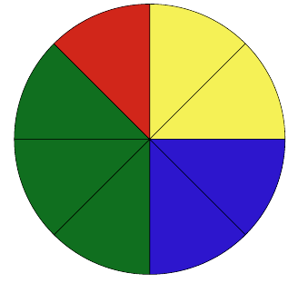
- What is the theoretical probability they land on green?

- They spun the spinner 20 times. They landed on red 2 times, green 11 times, blue 3 times, and yellow 4 times. What is the experimental probability they landed on green?

