Name: ________________________
Remembrance Day
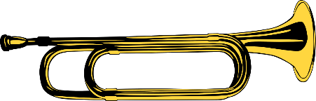
Why do we play the national anthem, O’Canada, at school? Why do we play the traditional trumpet or bugle call, The Last Post, and pay tribute in silence for two minutes once a year?
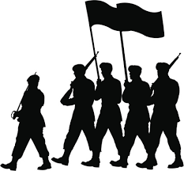
Every year, on the eleventh hour of the eleventh day of the eleventh month, there are over two million three hundred thousand Canadians whom we need to remember and thank. These brave soldiers have served, and continue to serve and protect our beautiful nation. Among these soldiers, more than one hundred eighteen thousand have sacrificed their lives to preserve peace and freedom.
Remembrance Day was first observed in 1919, and its original name was “Armistice Day”. An armistice is an official agreement between opposing sides to stop fighting. The armistice agreement that ended World War 1 was signed on November 11 at 11 a.m.
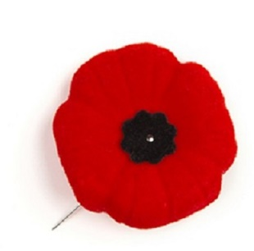
In additional, Remembrance Day can also be known as “Poppy Day”. The poppy is a powerful red flower that has become the symbol of Remembrance Day. During World War One, the land in Western Europe was destroyed, and the poppy was one of the only plants to be able to still grow on the devastated fields. Today, artificial poppies are sold by the Royal Canadian Legion, and the money collected is used to support veterans, people who have served in the military.
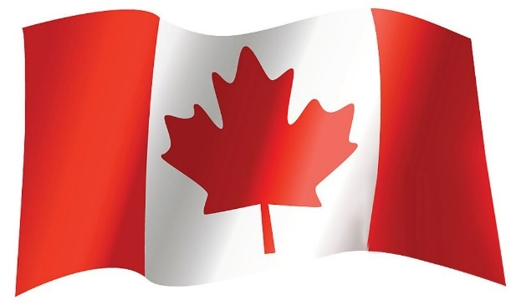
Life can get busy, and we often take our freedom and choices for granted. We can believe in whatever we want, participate in whatever activities we want, and vote for whomever we want. However, we need remember that the freedom we enjoy has been and is still being protected by our Canadian soldiers. On Remembrance Day, we specifically take time to acknowledge their sacrifice and courage. As Canadian citizens, we must also contribute and help preserve the peace in our homes, schools, communities, and country.

PRE and POST DISCUSSION QUESTIONS
Remembrance Day
PRE-discussion Questions
- What do you know about Remembrance Day?
- What do we do as a school to celebrate?
- What do you do by yourself or with your family to celebrate?
- What are you thankful for?
- Do you have any family members or friends who have gone to war or who work in the military?
- How many world wars have there been? (WW1 and WW2)
- How many other wars have there been? (too many to list, it can be between countries, or civil within the country)

POST-discussion Questions
- What do we do as a school to celebrate Remembrance Day? What different things would you add to help other students understand the importance? (visual, musical, poetry, explanation, etc.)
- When O’Canada plays over the PA system, what should we be doing? (we can sing, reflect, think, be thankful, etc.)
- How can we pay tribute to the soldiers? (study hard, learn about history, attends Cadets, maintain peace and be kind to others, etc.)
- What are your thoughts about war? Why do you think it happens?

Name: ________________________
Remembrance Day Questions
1) What is 2 million 3 hundred thousand in numerical digits?
a) 2,000,000,300 b) 2,300,000 c) 2,030,000 d) 2,000,300
2) What does this number represent?
a) the number of days that have passed since World War 1.
b) the number of soldiers around the world
c) the number of Canadian soldiers who have served for in war
d) the number of Canadian soldiers who passed away in war
3) What is one hundred eighteen thousand in numerical digits?
a) 100,180,000 b) 1,001,800 c) 118,000 d) 100,180
4) What does this number represent?
a) the number of Canadian soldiers who passed away in war
b) the number of days that Canadians have fought in wars.
c) the number of poppies we use each year
d) the number of Canadian soldiers who have served for us
5) How long do we remain silent and reflect on Remembrance Day?
a) 1 minute b) 2 minutes c) 11 minutes d) 1 hour
6) What day is Remembrance Day on?
a) September 11 b) November 11 c) every day d) it changes
7) In which year did the tradition of Remembrance Day start?
a) 1819 b) 1911 c) 1919 d) 2019
8) What are two other names for Remembrance Day? (circle two)
a) National Soldier Day b) Armistice Day c) Agreement Day d) Poppy Day
9) What symbol represents Remembrance Day?
a) a soldier b) a trumpet c) a flag d) a poppy
10) When artificial poppies are sold, what happens to the money?
a) It is sent to Canadian soldiers at war in other countries.
b) It is used to make more poppies.
c) It is given to help soldiers who have come home from their service at war.
d) It is used to create programs to educate people about Remembrance Day.
11) Match the vocabulary by drawing a line to connect the words on the left to the right.
● armistice | ● a person who finished serving in the military
● veteran | ● a red flower
● poppy | ● an agreement
● to preserve | ● to show respect
● to pay tribute | ● to protect or maintain

Name: ________________________
Remembrance Day Crossword
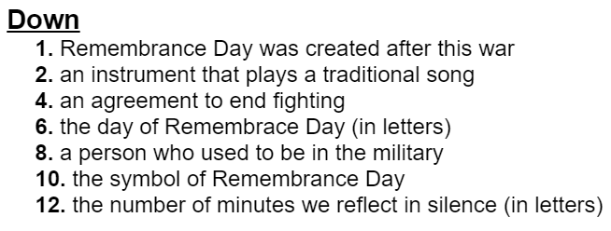
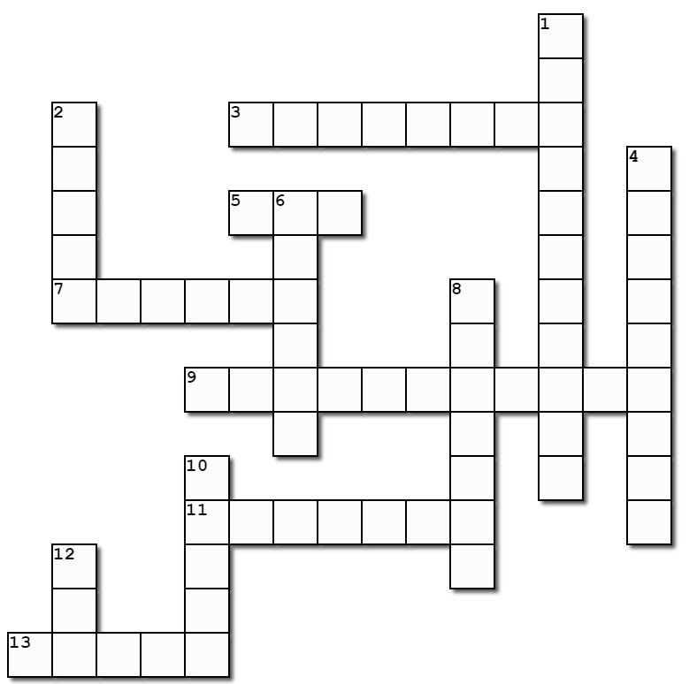

Across
3. the month of Remembrance Dayayy
5. the colour of the flower of Remembrance Day.
7. the continent where poppies grew
9. the name of the song played when we reflect in silence
11. our national anthem 13. This is collected to help veterans
Remembrance Day Word Search
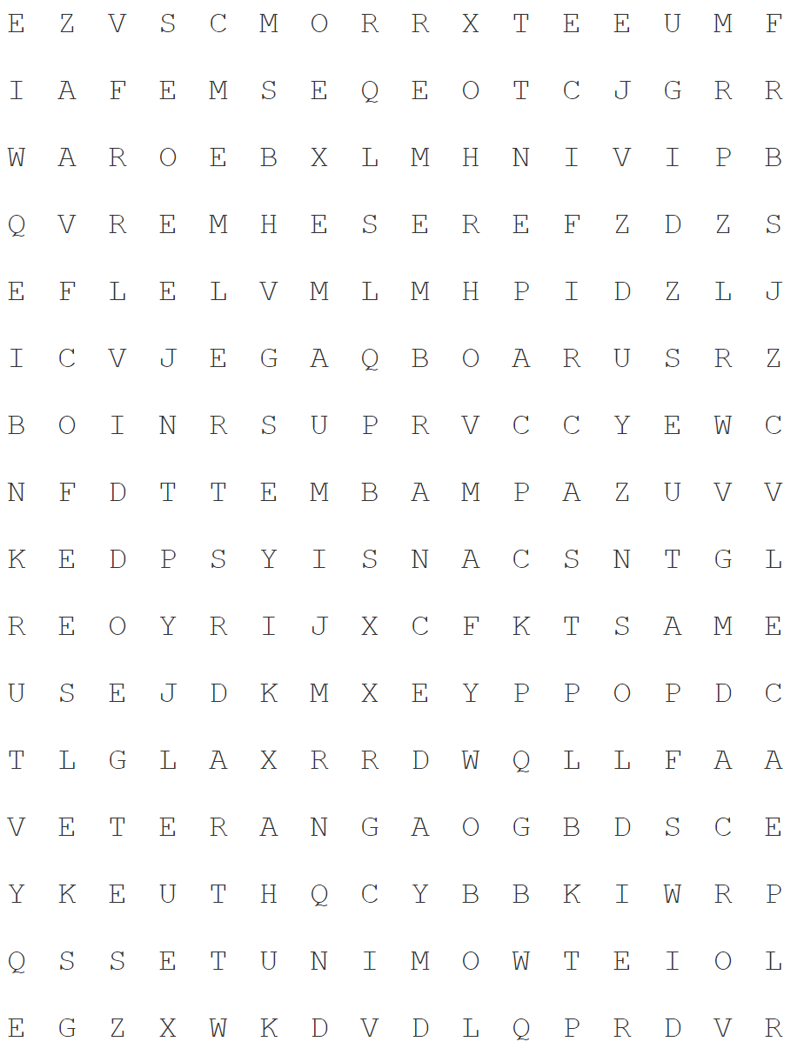

ARMISTICE | BUGLE | ELEVEN
NOVEMBER | OCANADA | PEACE
POPPY | RED | REMEMBRANCEDAY
SACRIFICE | SOLDIER | THELASTPOST
TWOMINUTES | VETERAN | WAR

