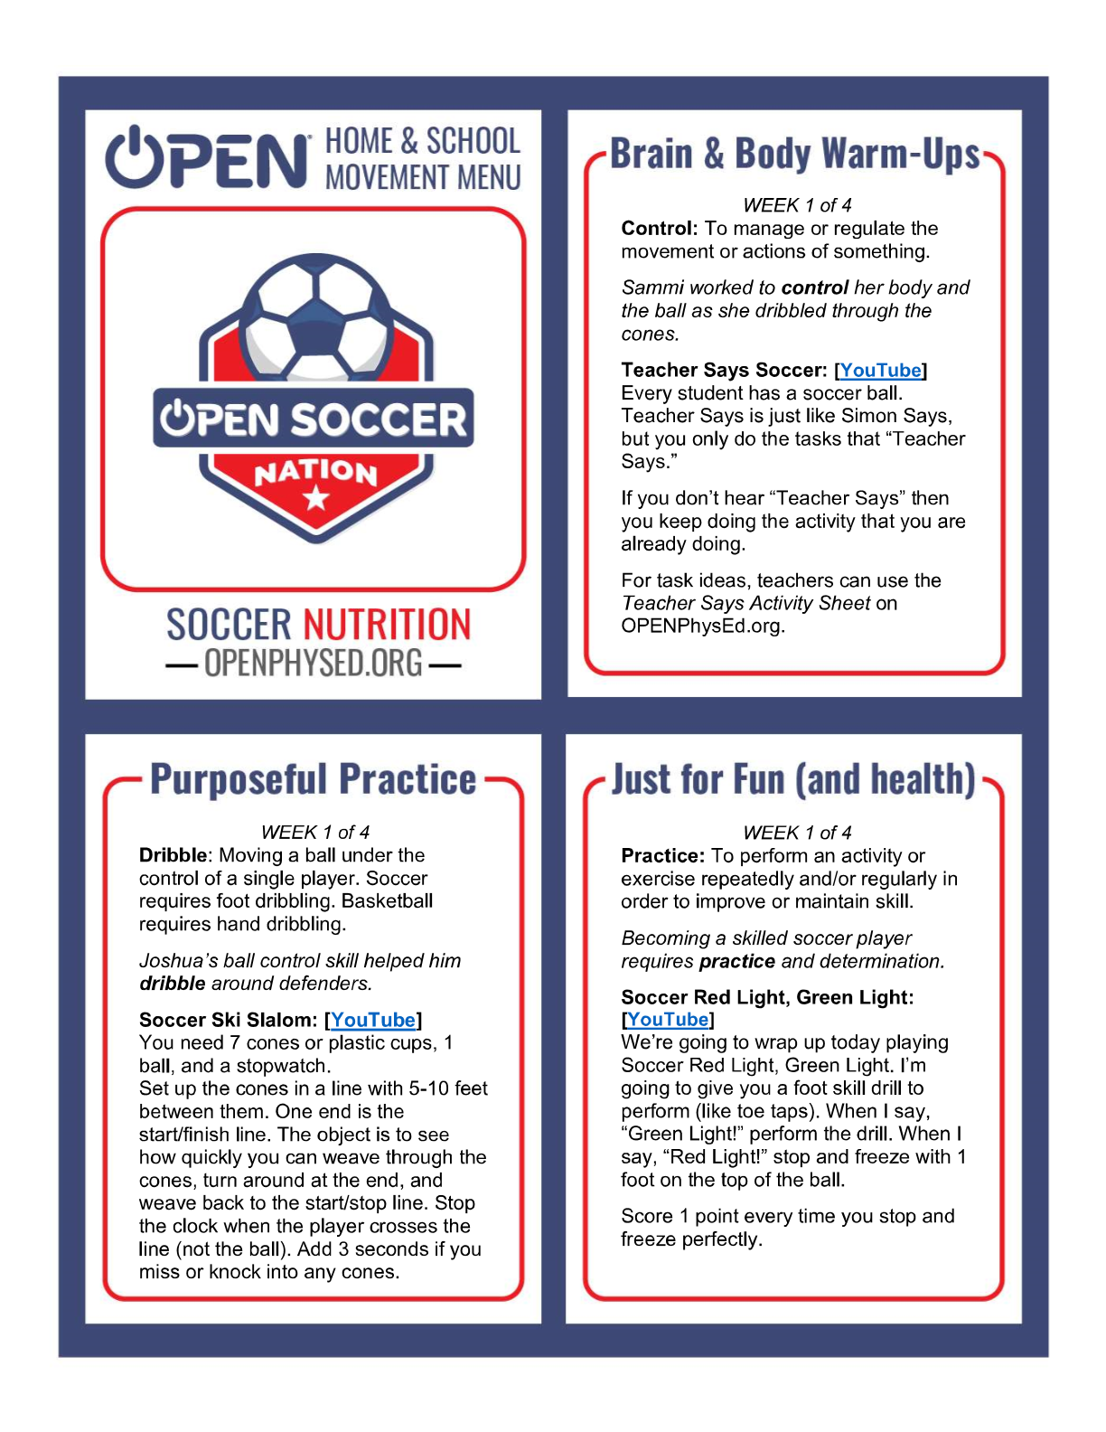

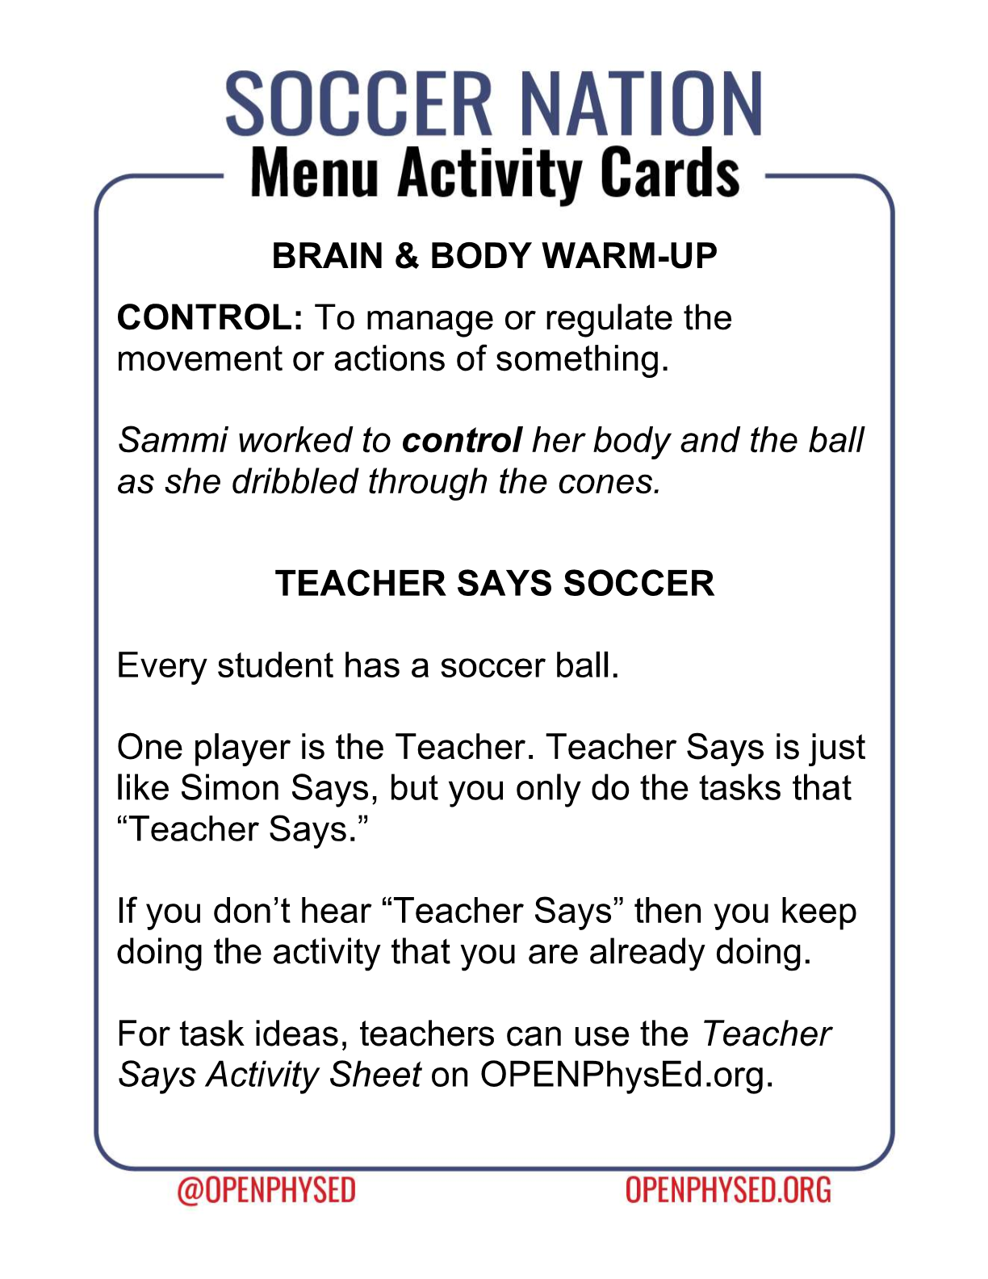https://www.youtube.com/watch?v=22uAgqmG7_M

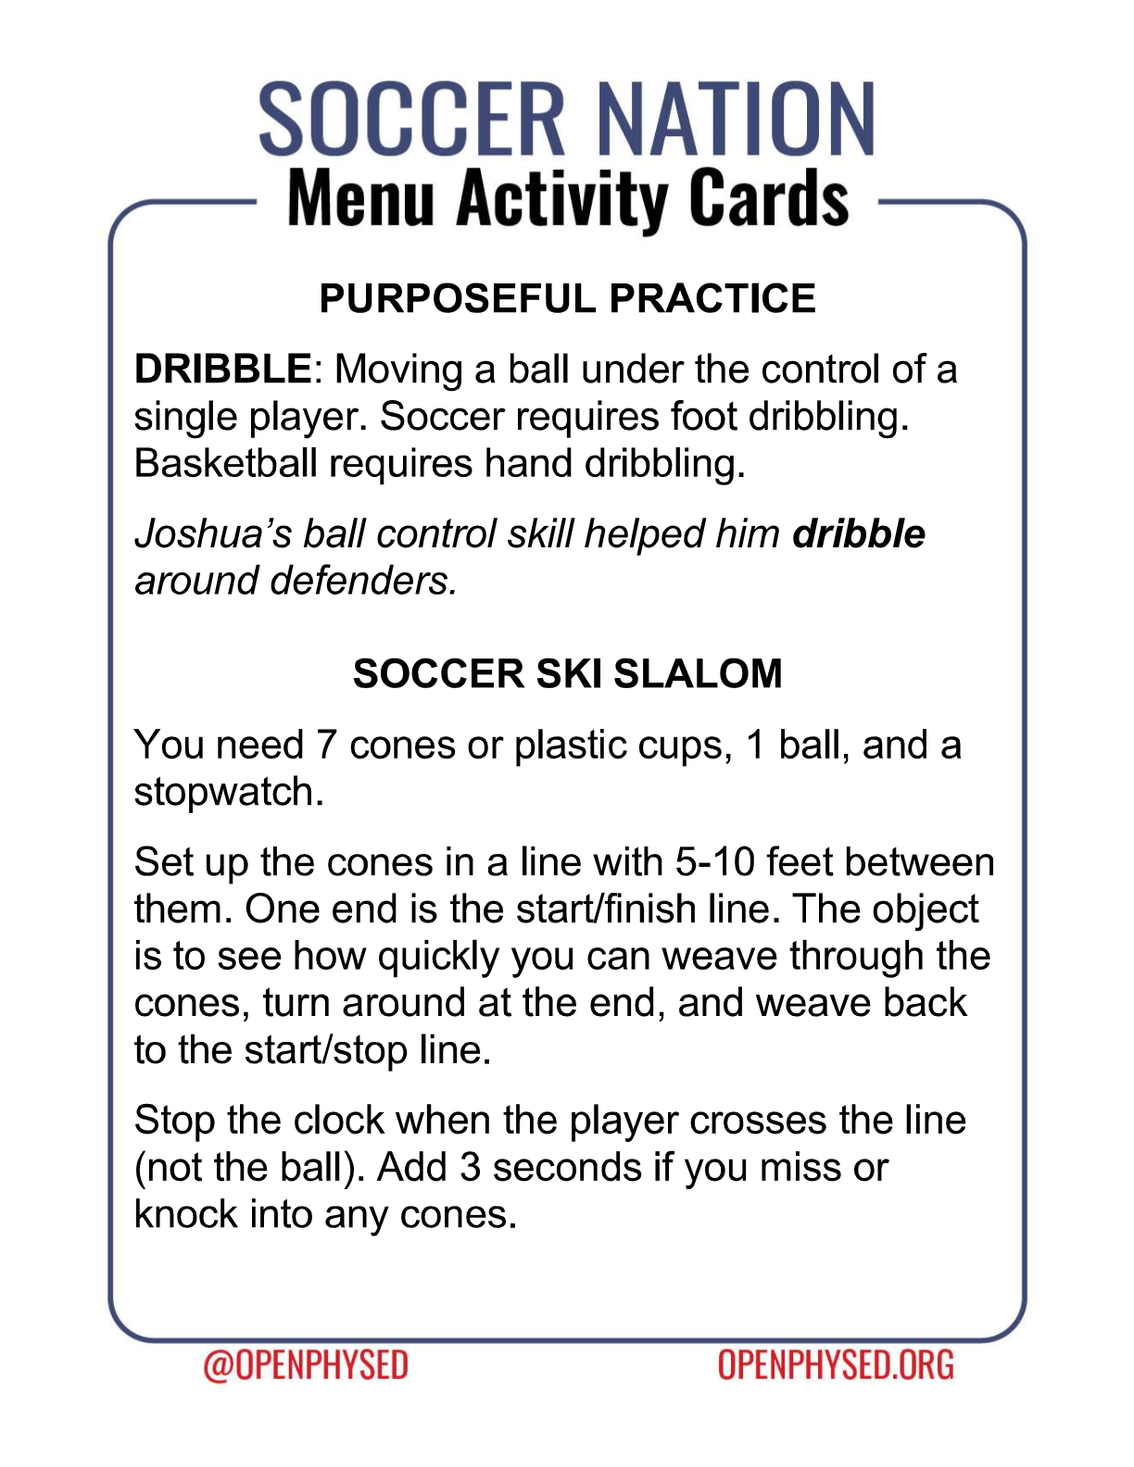https://www.youtube.com/watch?v=NtE2yw2eQ9M

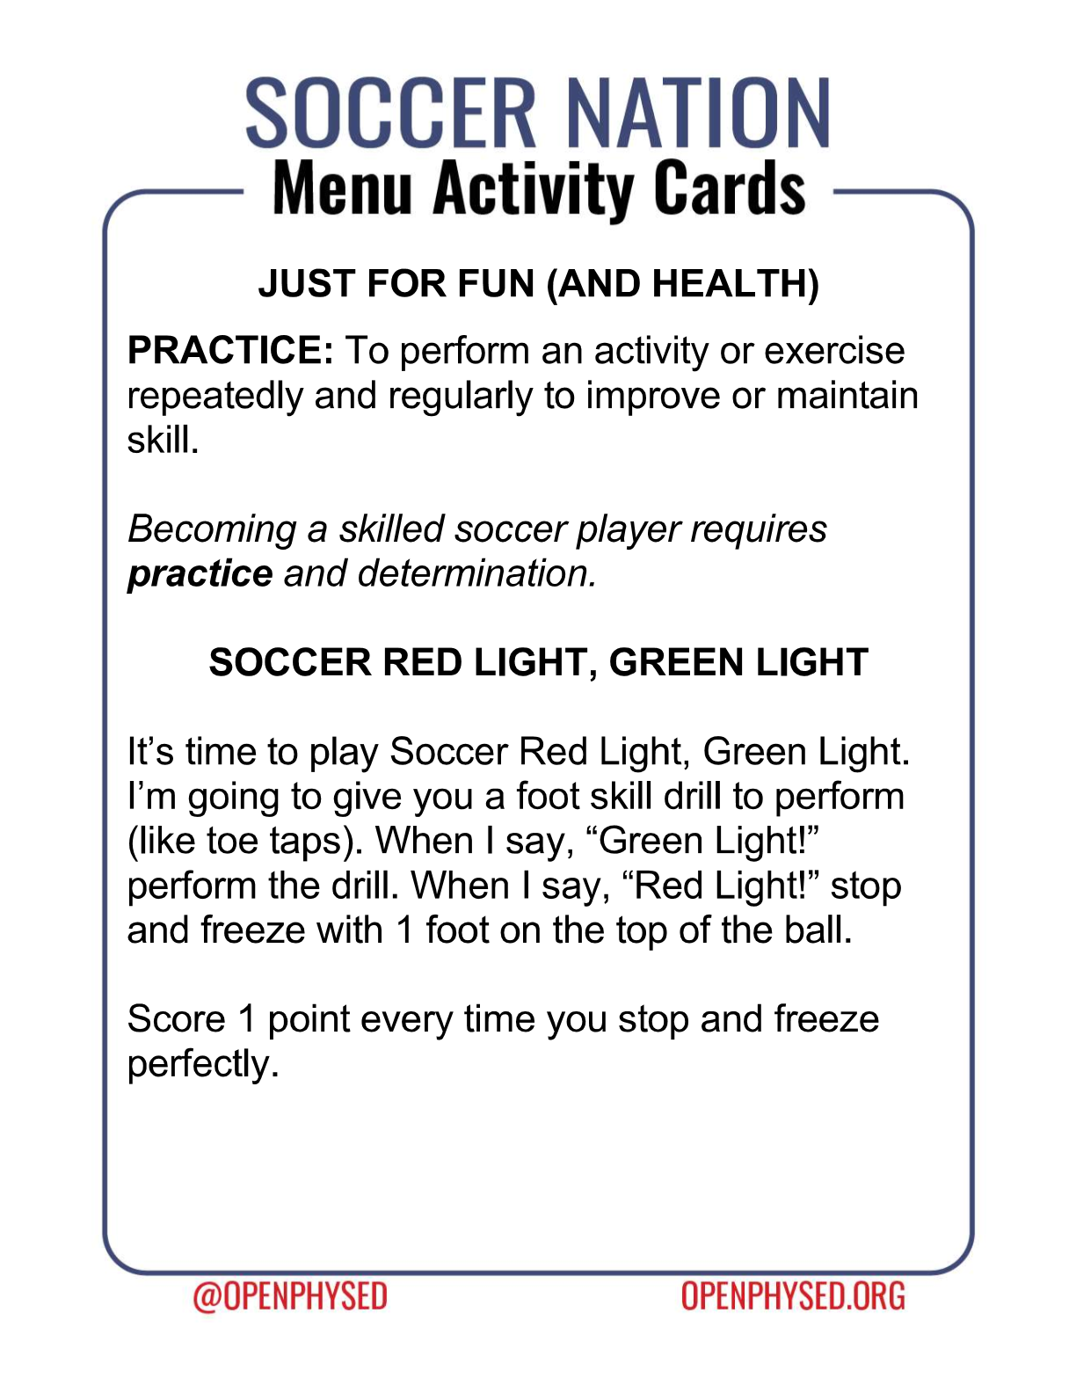https://www.youtube.com/watch?v=Qp5mGsKY-ZQ

