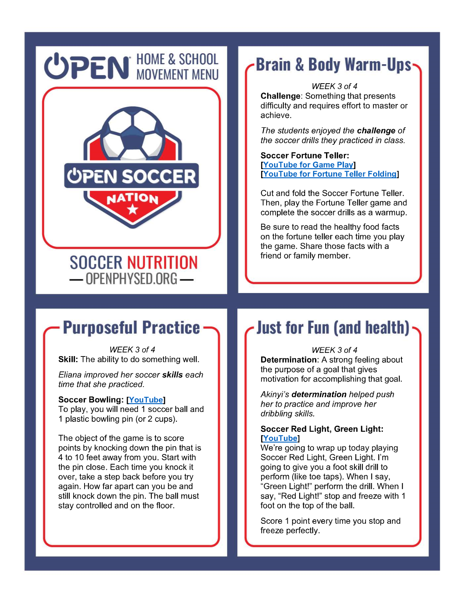

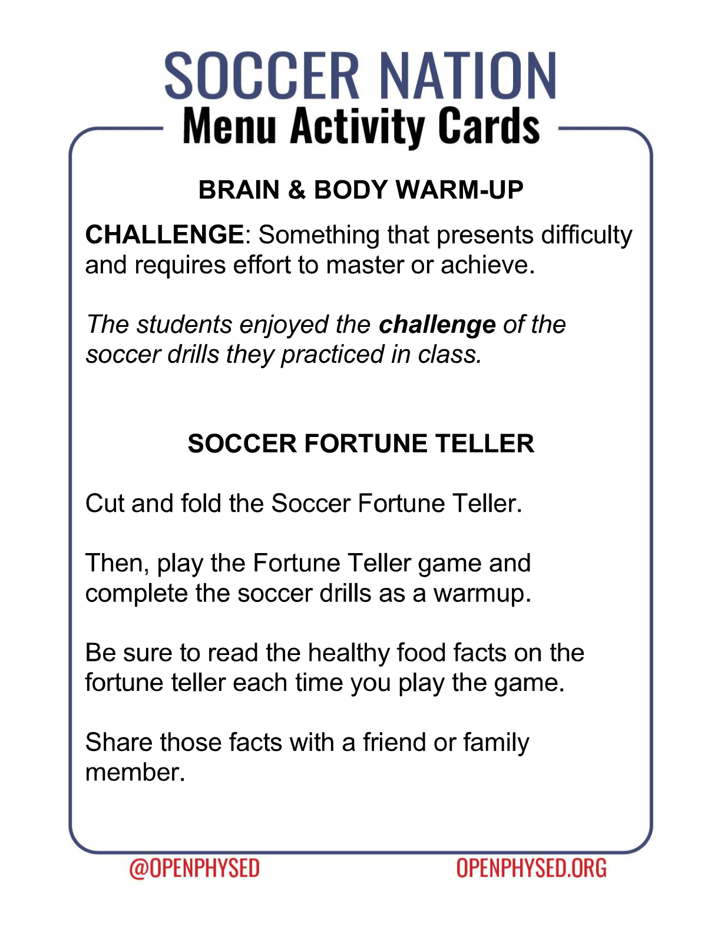

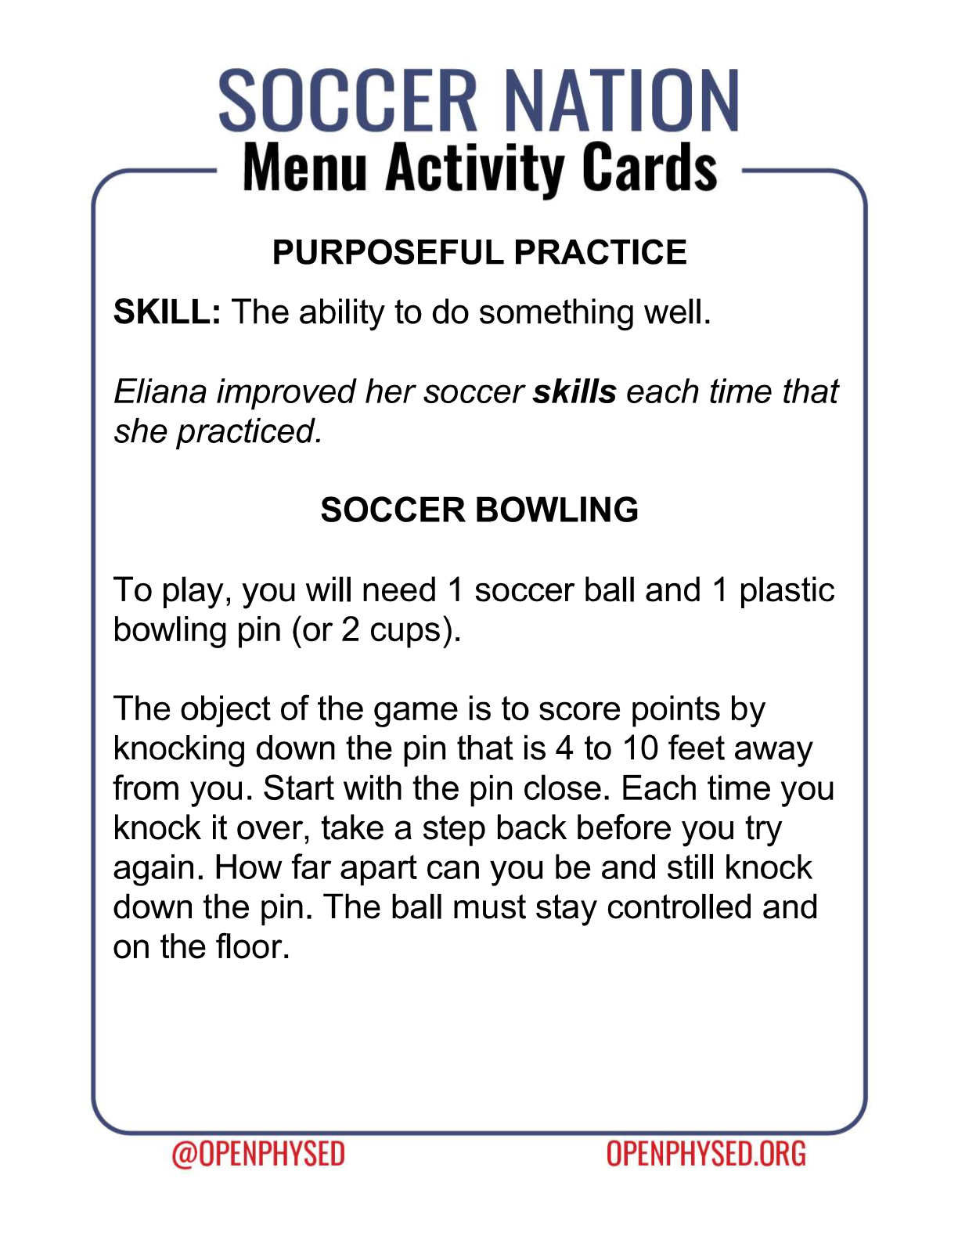https://www.youtube.com/watch?v=-Vy4p7c32CA
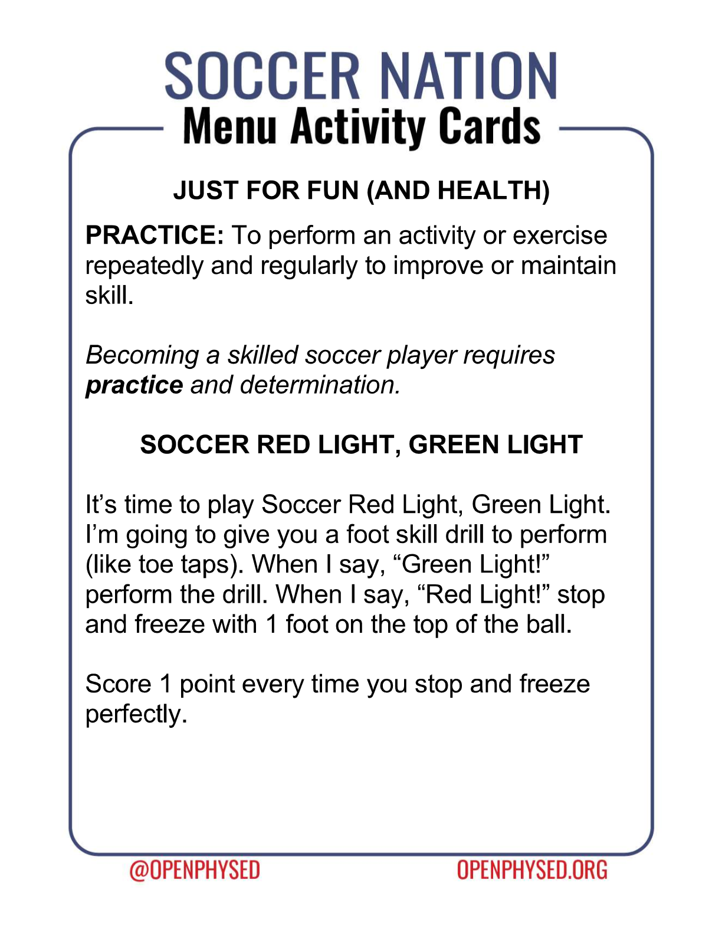
https://www.youtube.com/watch?v=Qp5mGsKY-ZQ&t=3s

