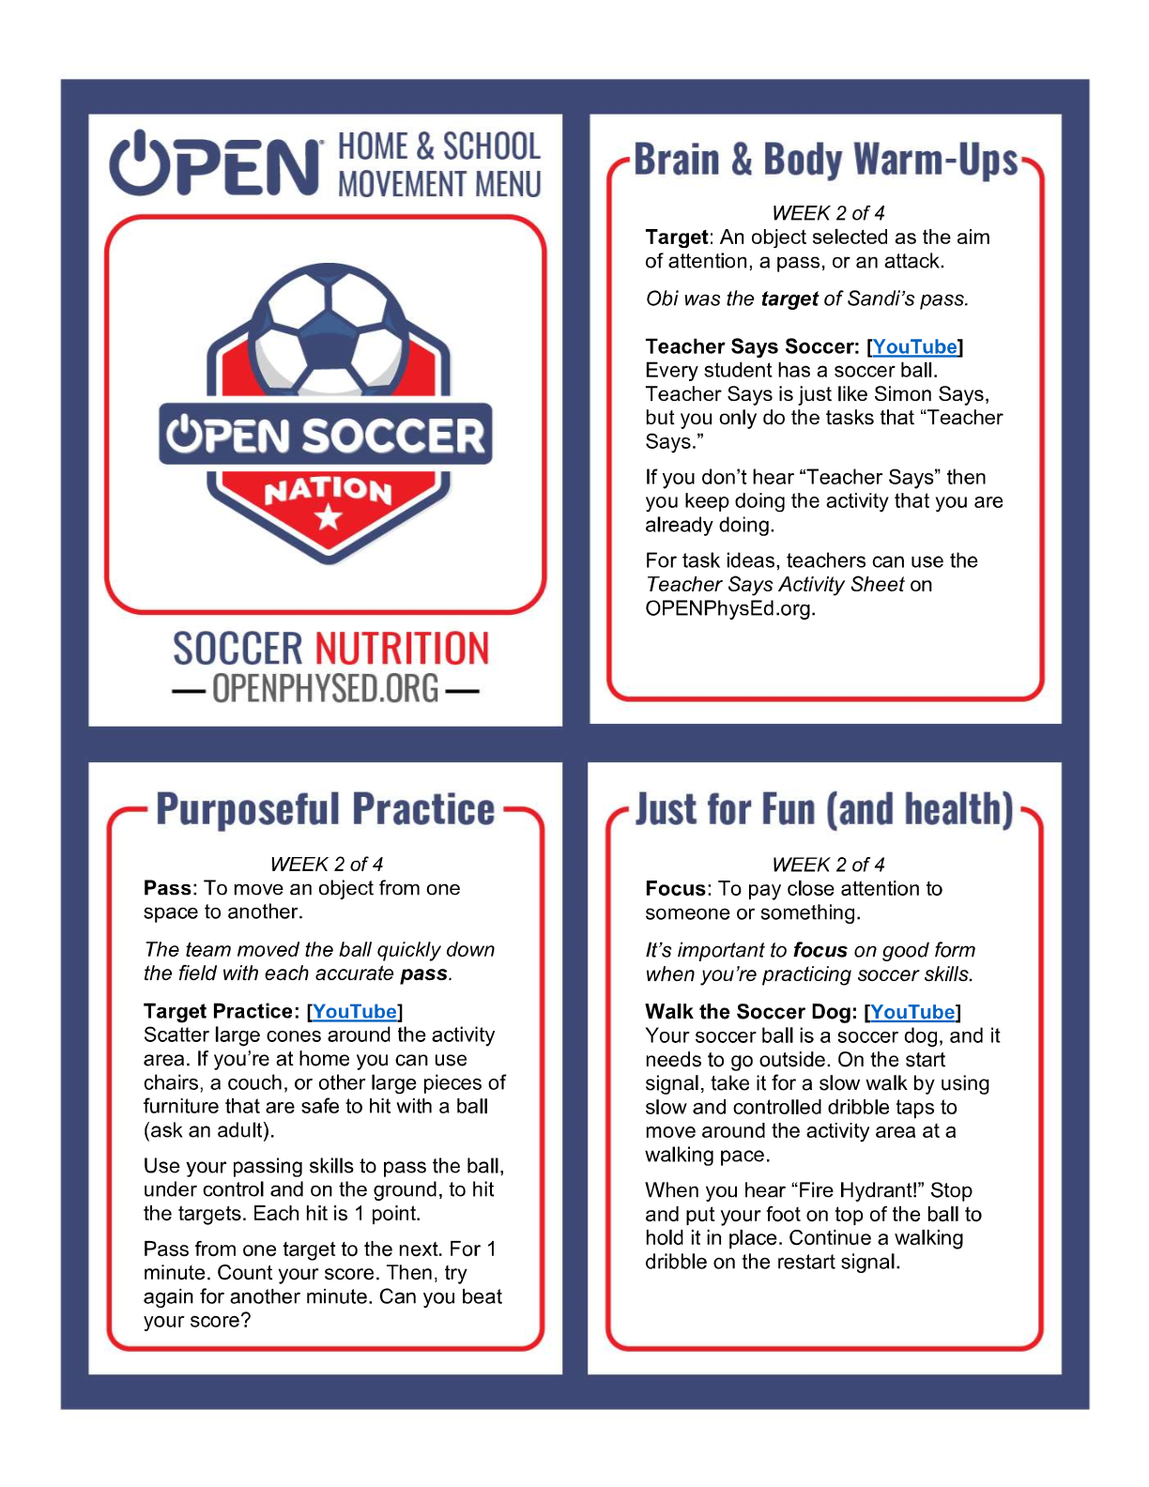

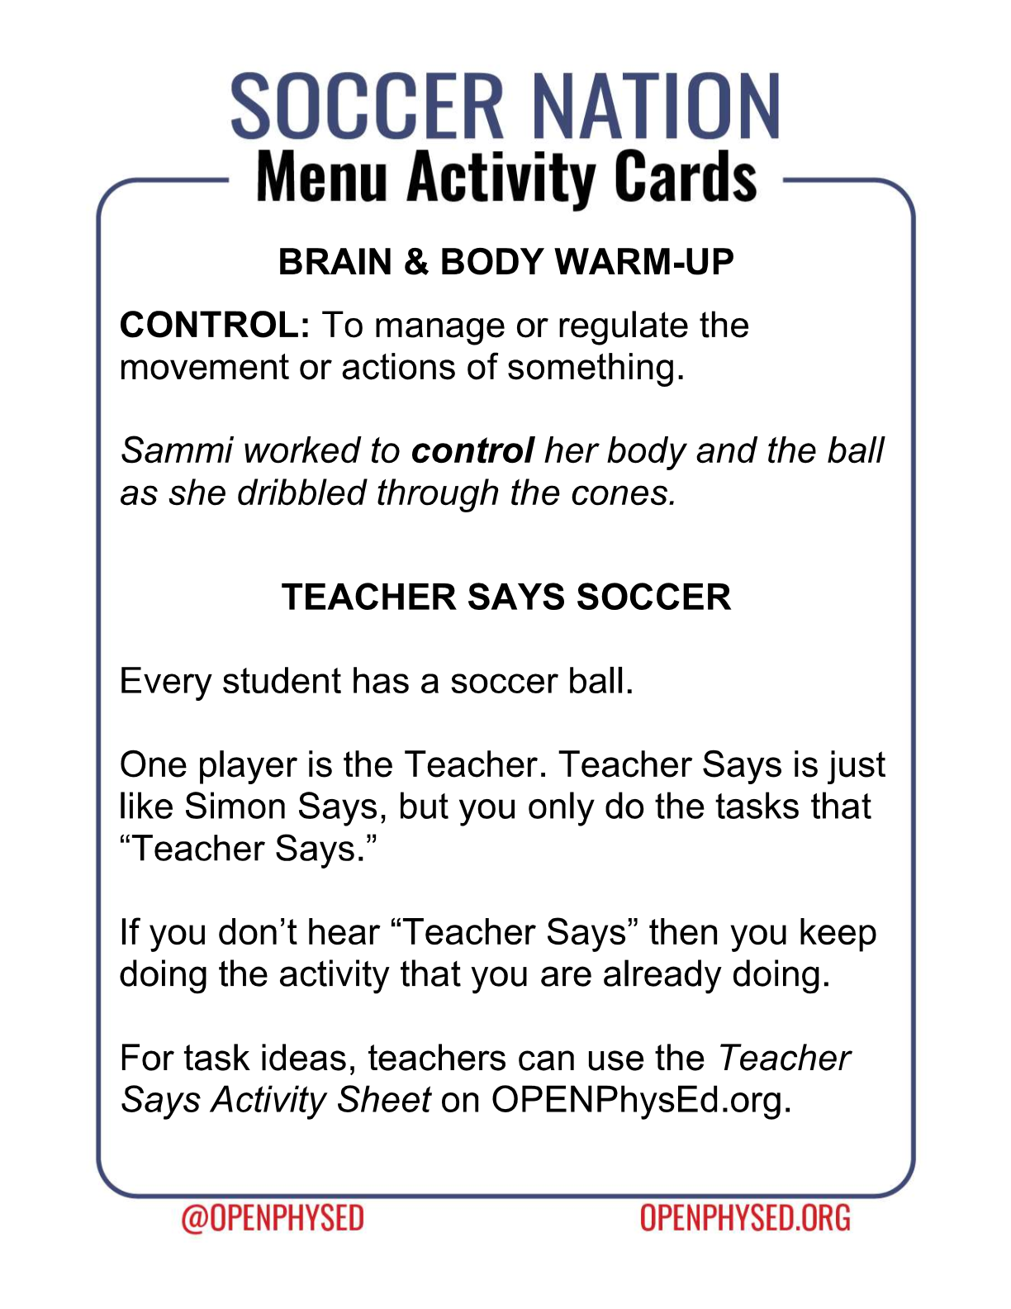https://www.youtube.com/watch?v=22uAgqmG7_M

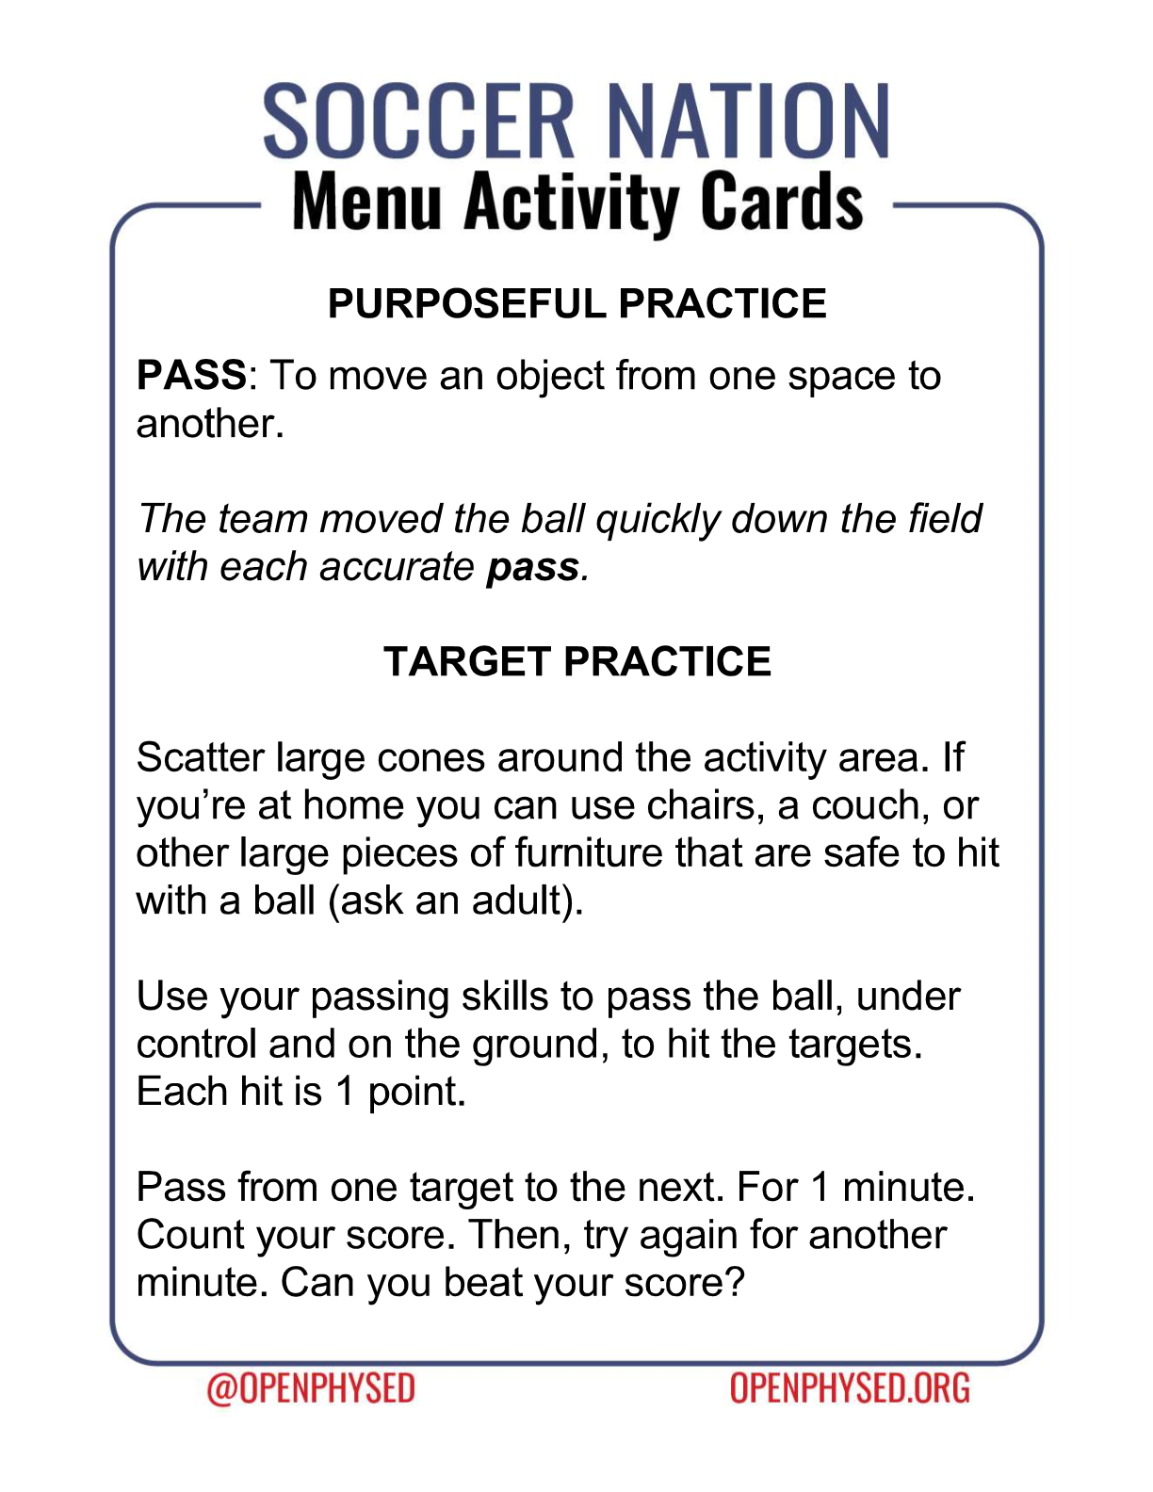https://www.youtube.com/watch?v=OPoIVj2dfBE

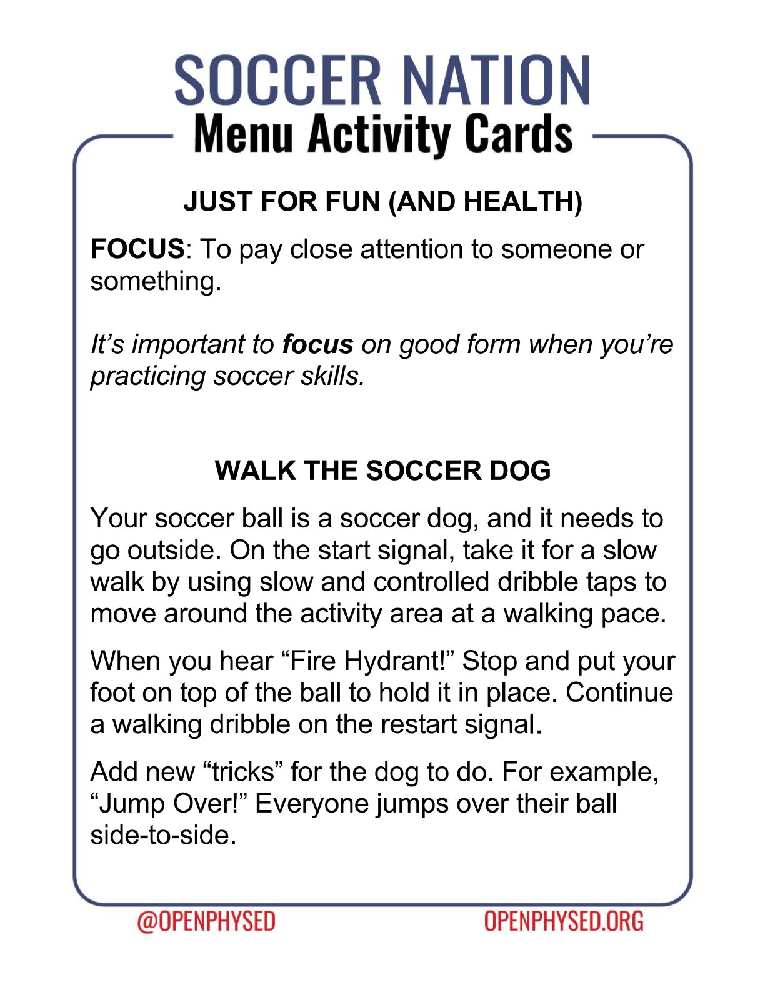https://www.youtube.com/watch?v=OfpcwCnDZKE

