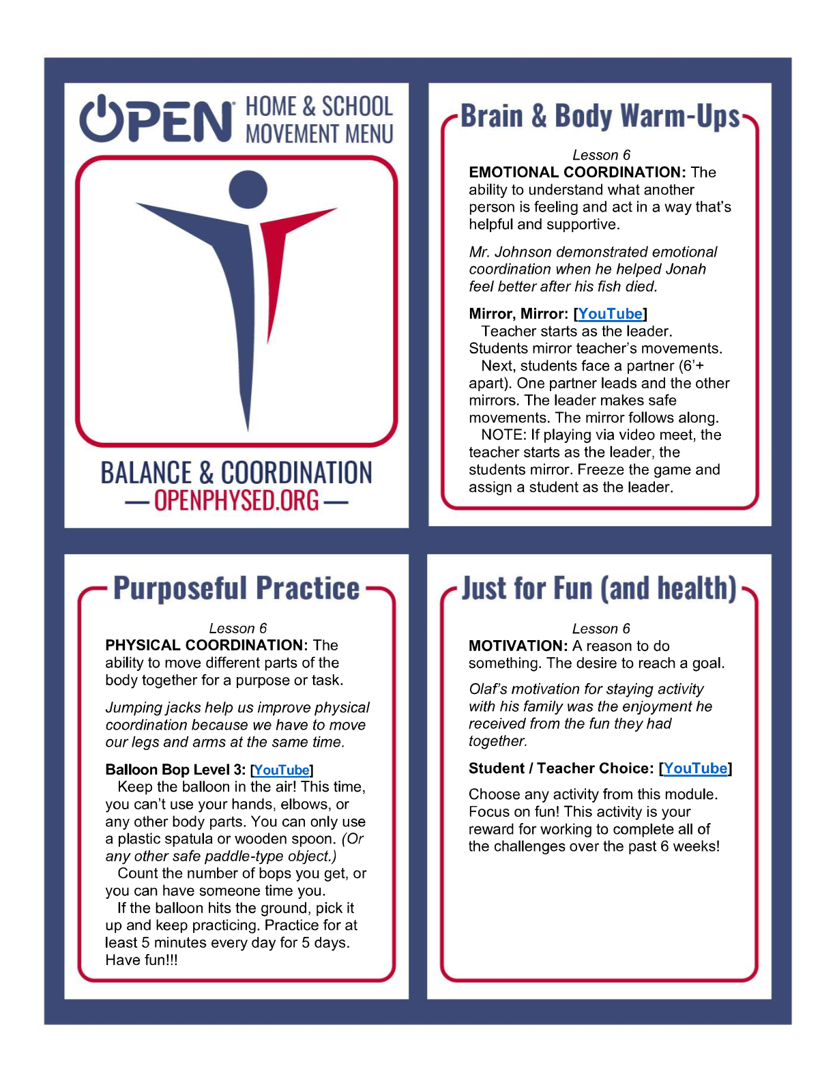

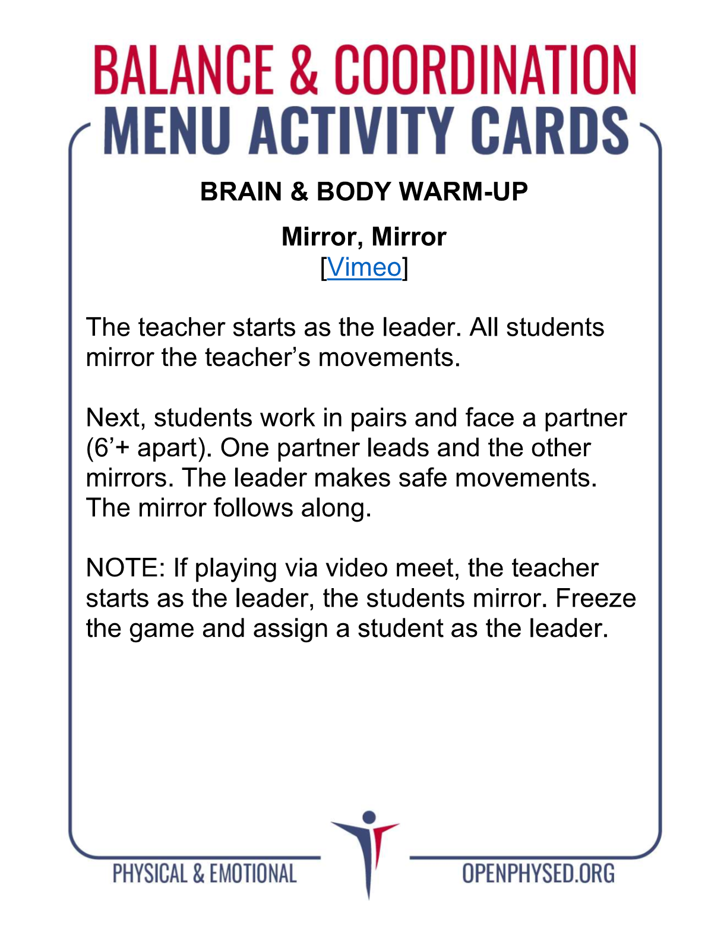https://www.youtube.com/watch?v=gsp8DxPxh-k

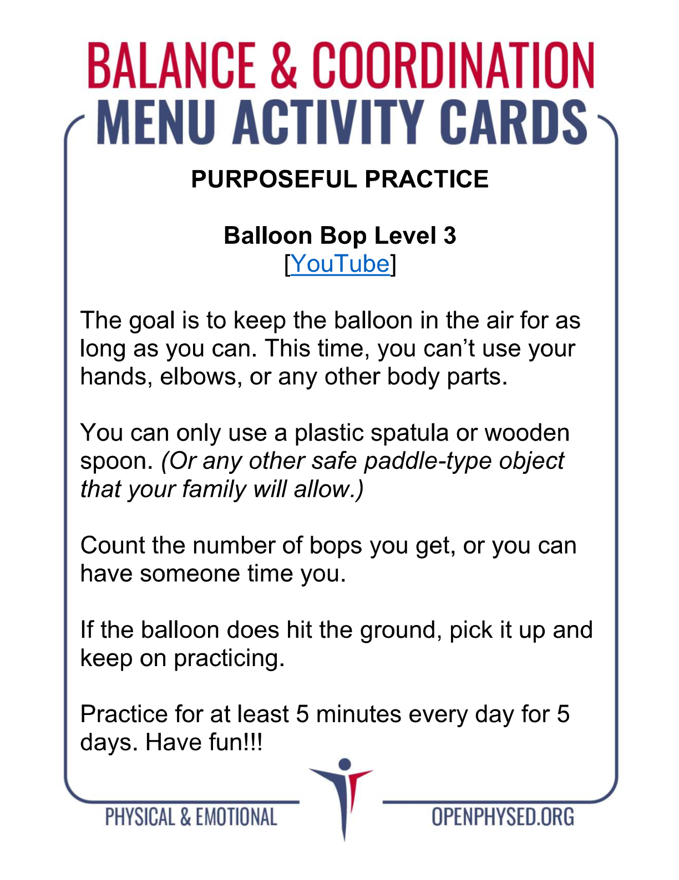https://www.youtube.com/watch?v=dCN1THQrtIA

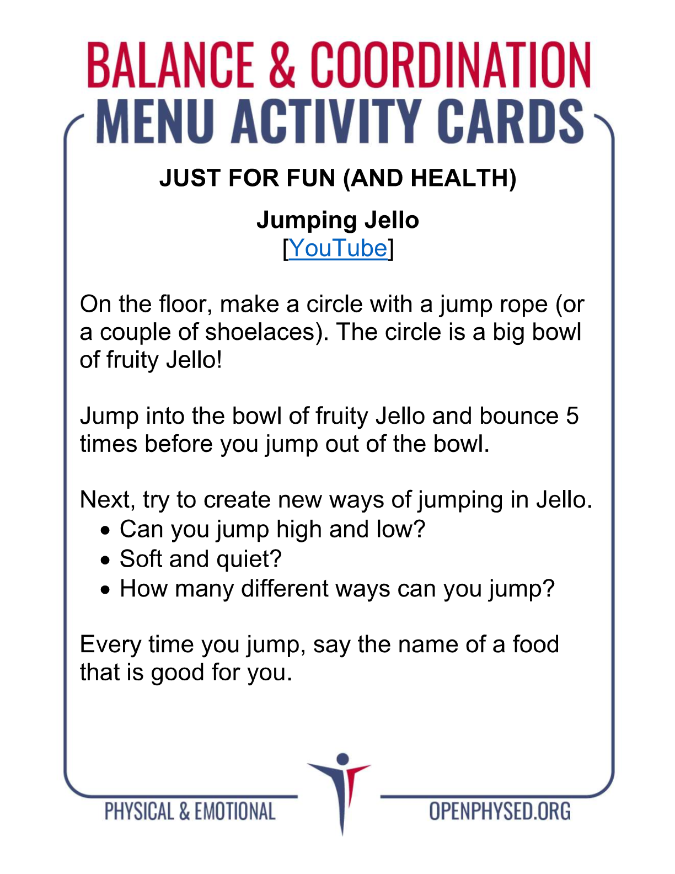https://www.youtube.com/watch?v=krWHTHtdsDs

