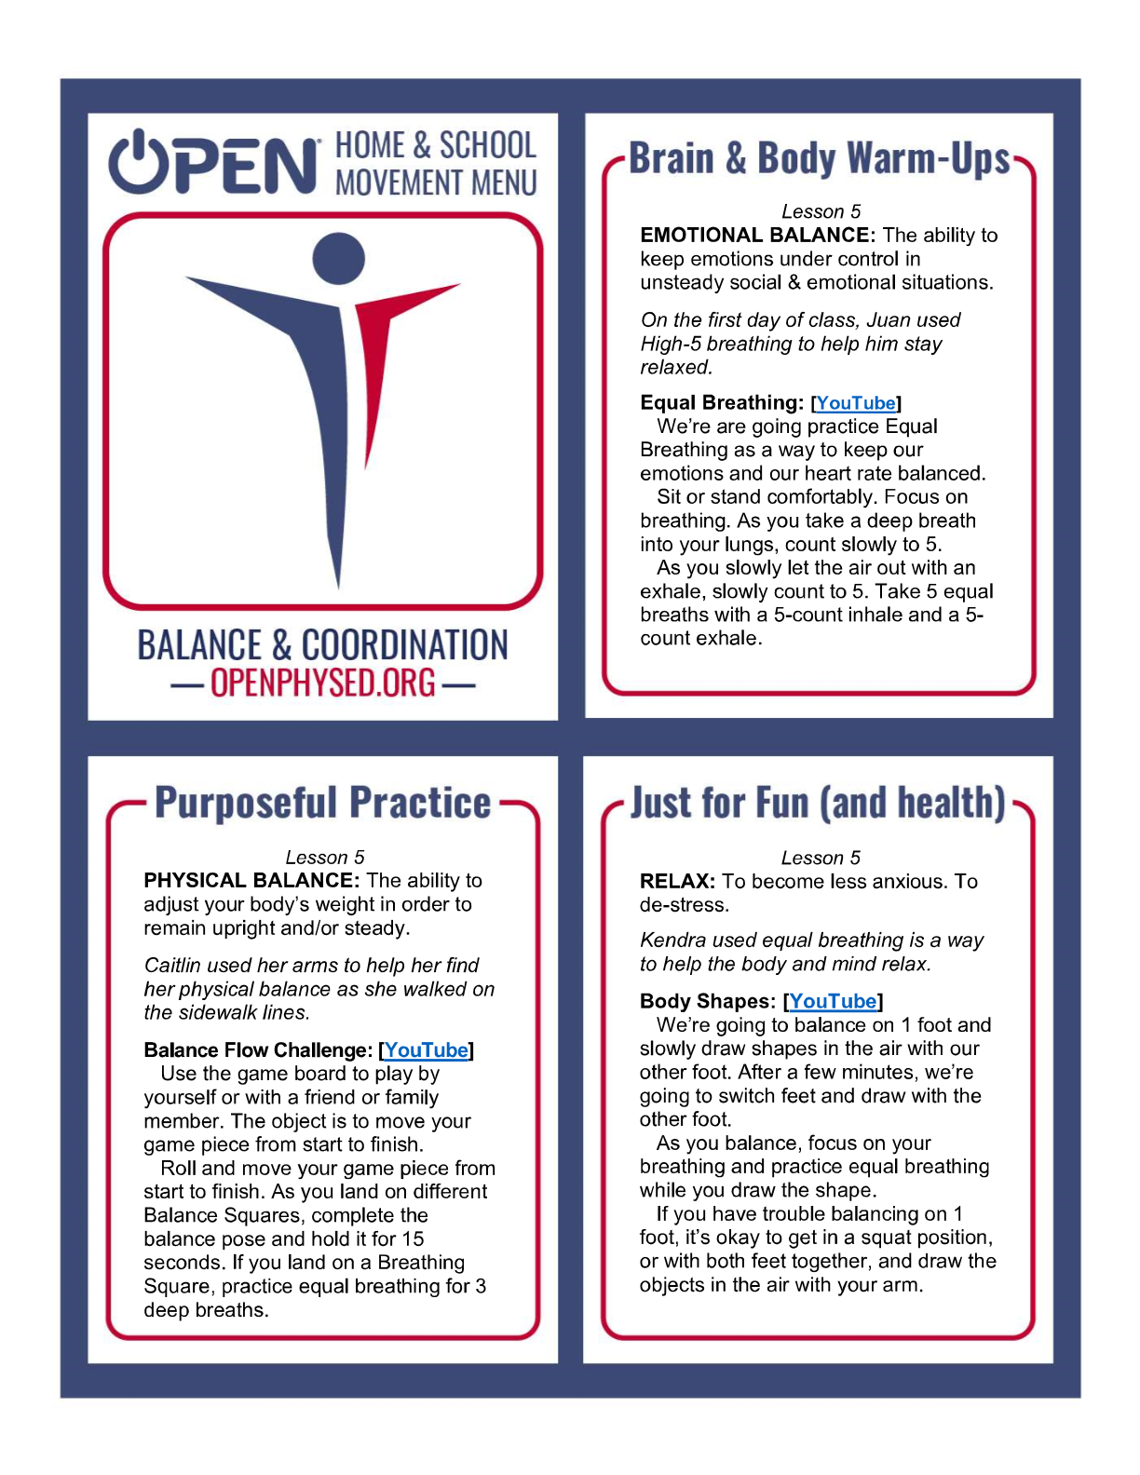

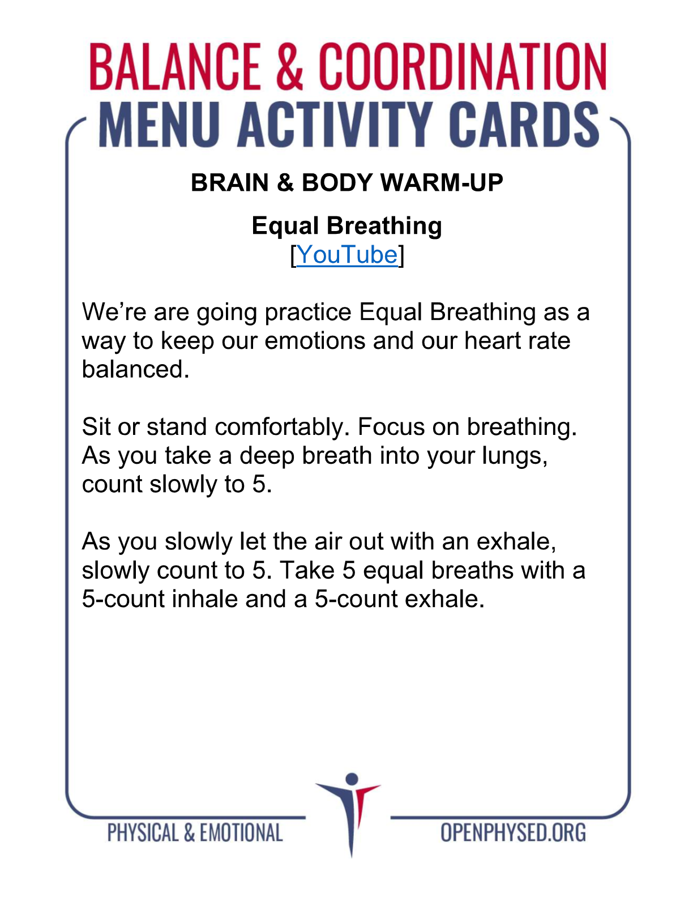https://www.youtube.com/watch?v=84GLR4e4Sc4&t=25s

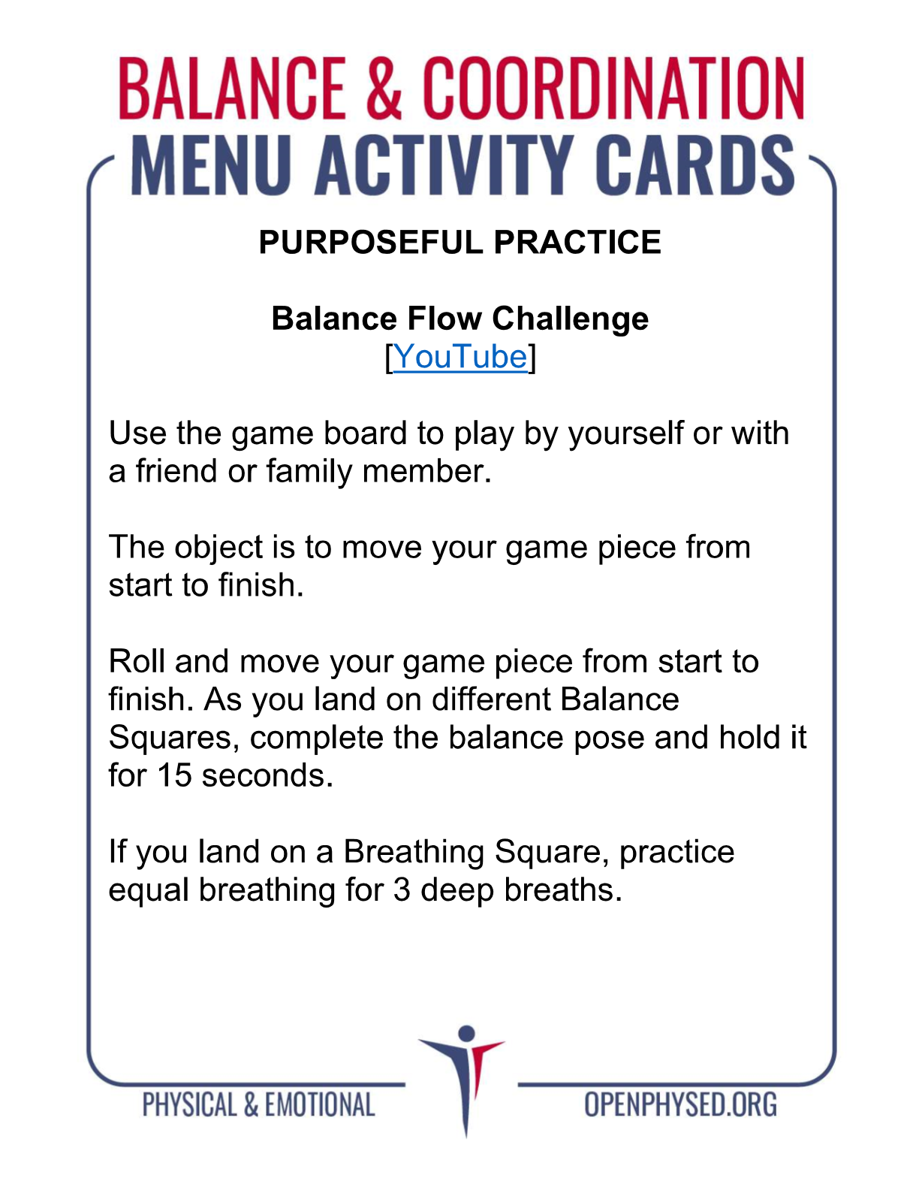https://www.youtube.com/watch?v=3r5eZgW9abY

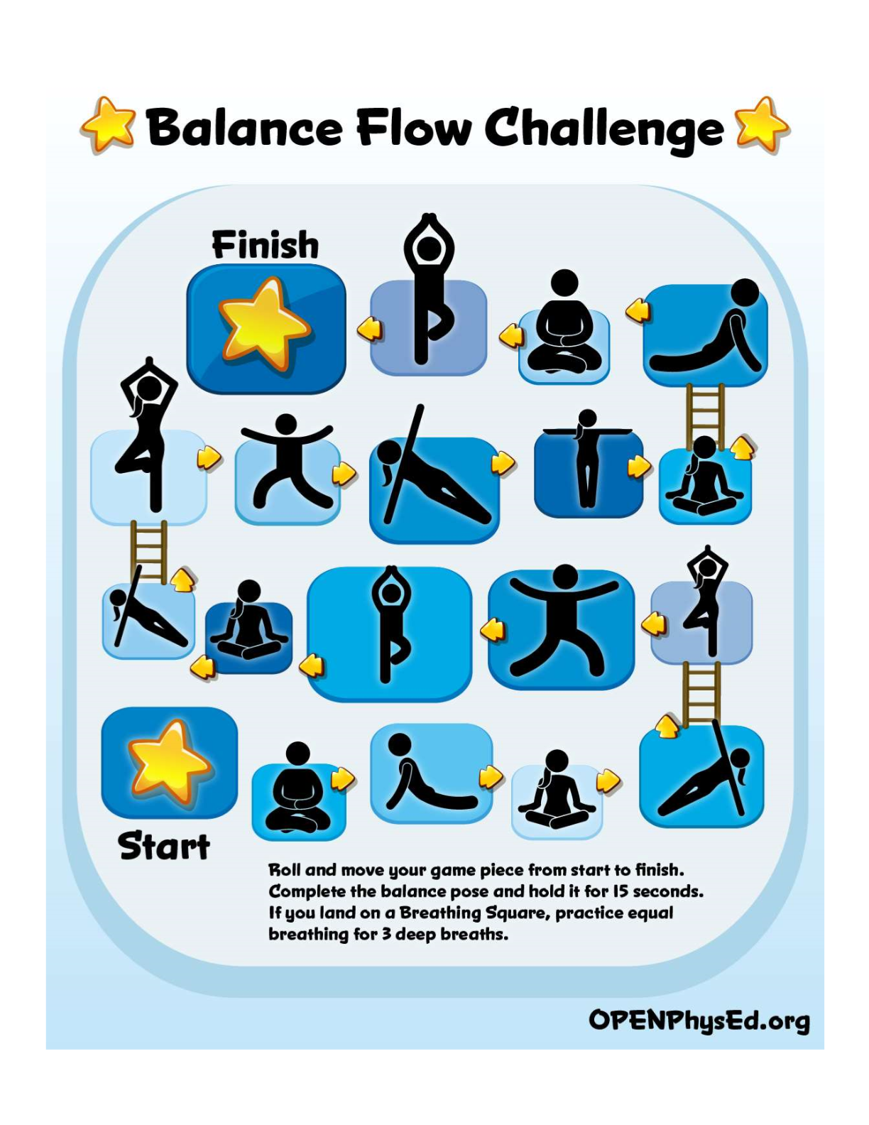

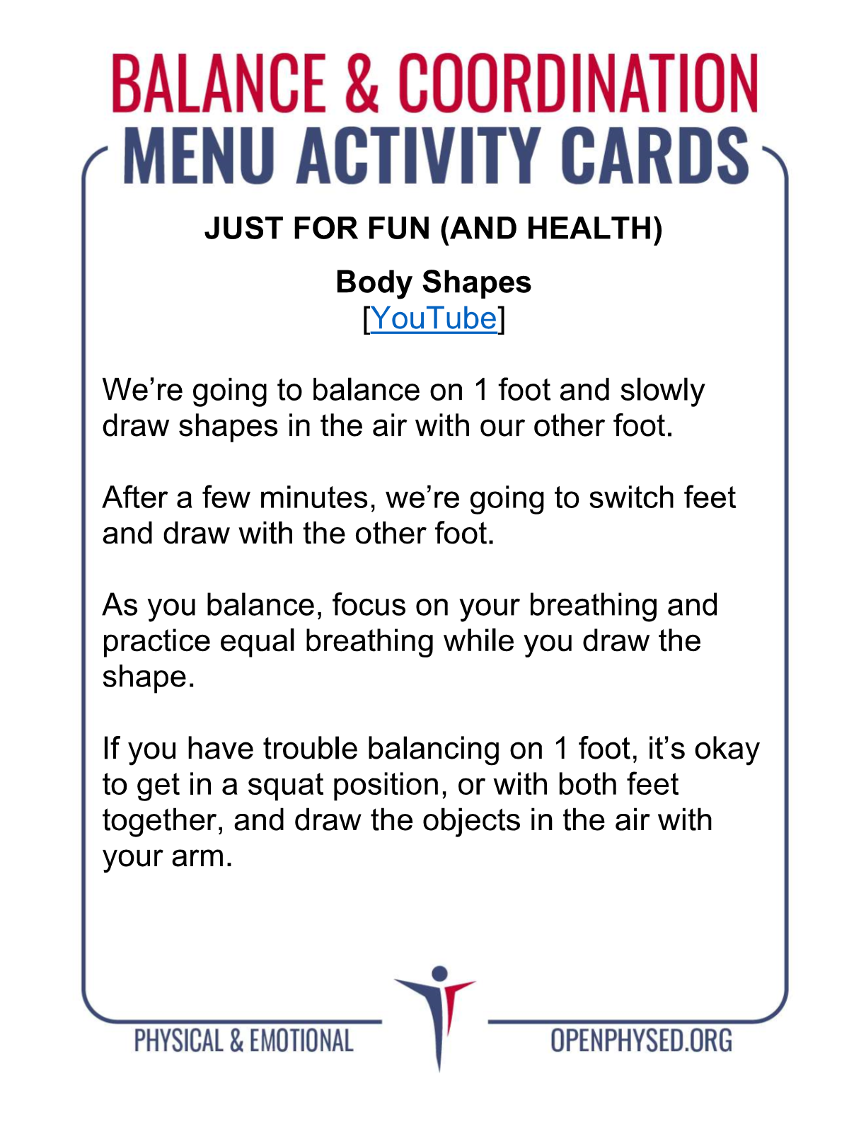https://www.youtube.com/watch?v=fPZ8GJyNLOI

