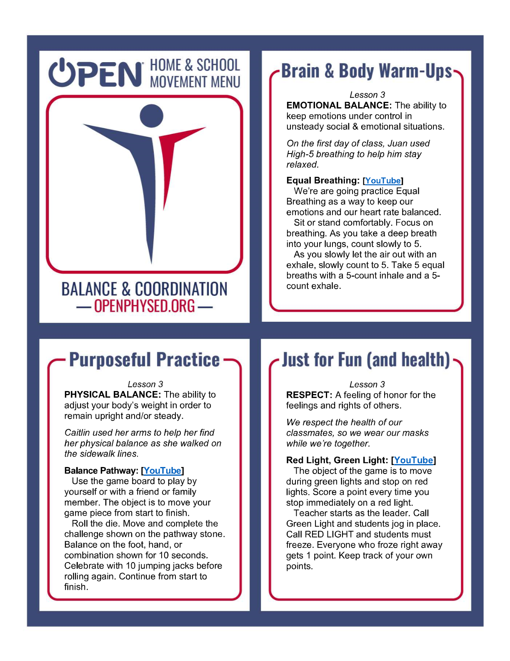

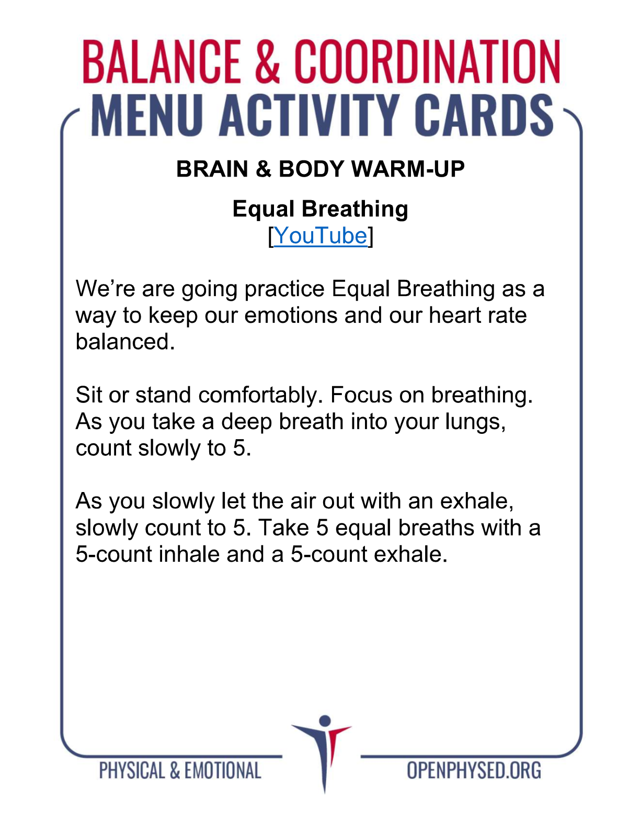https://www.youtube.com/watch?v=84GLR4e4Sc4

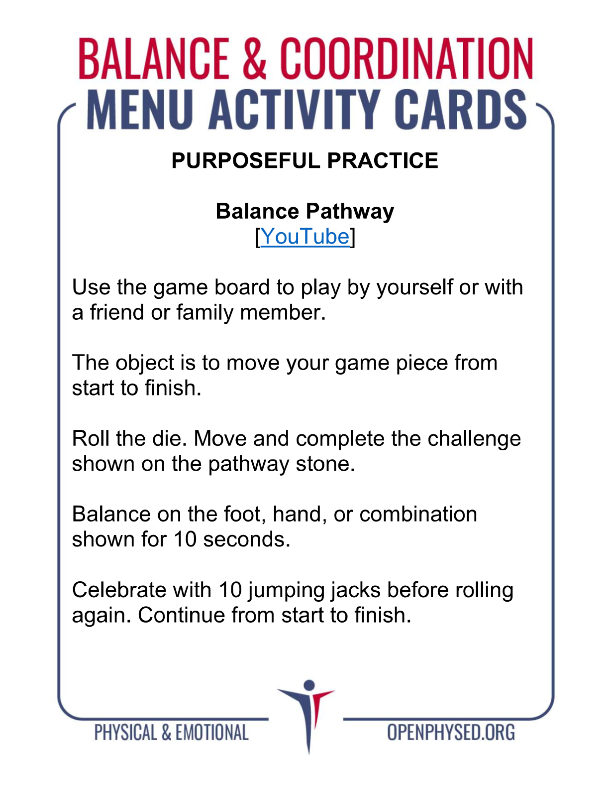https://www.youtube.com/watch?v=SFCE-dc-3F4

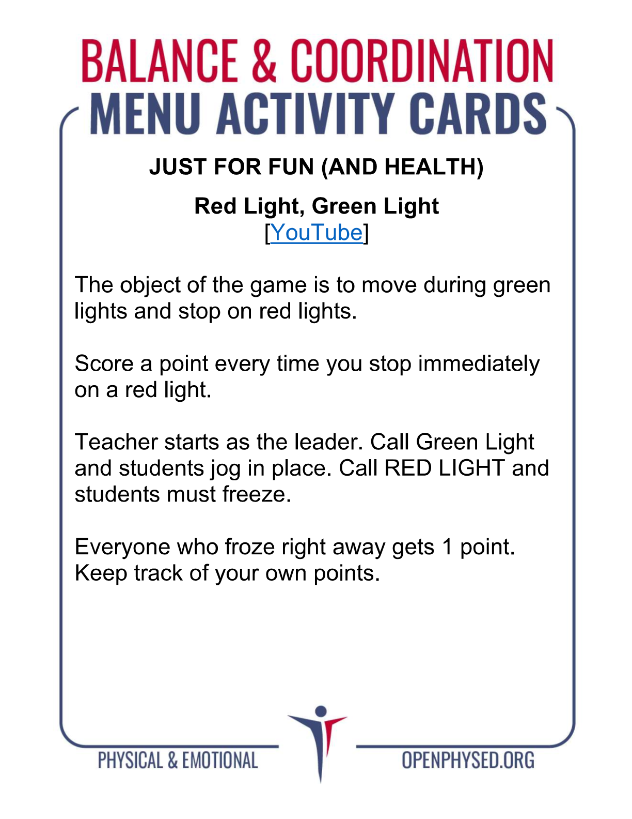https://www.youtube.com/watch?v=Qp5mGsKY-ZQ

