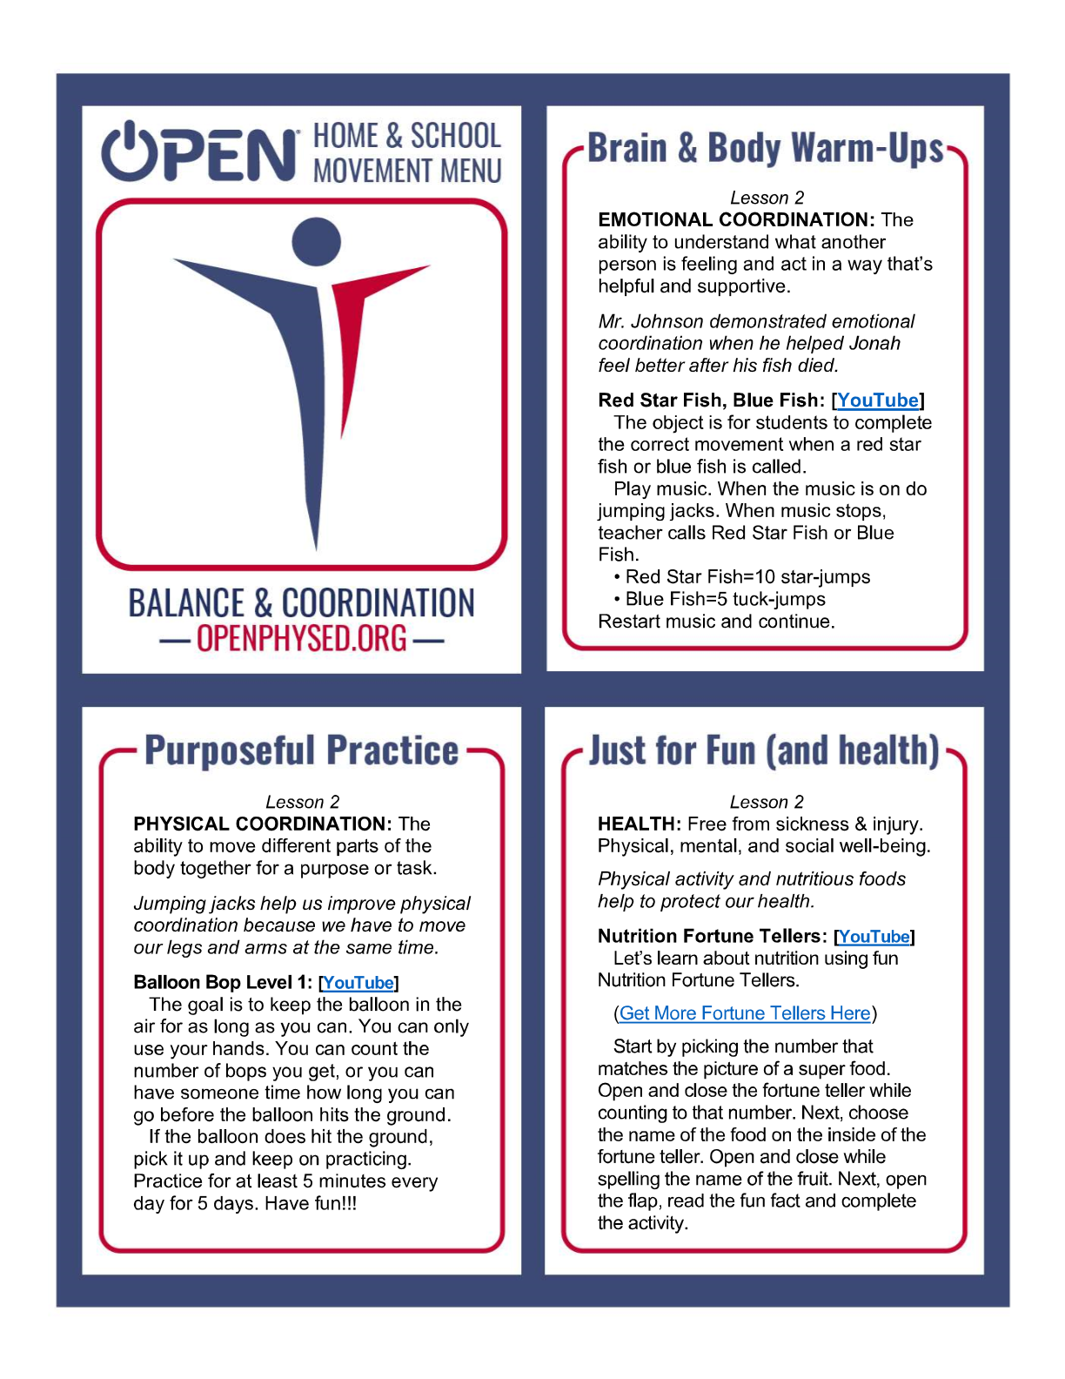

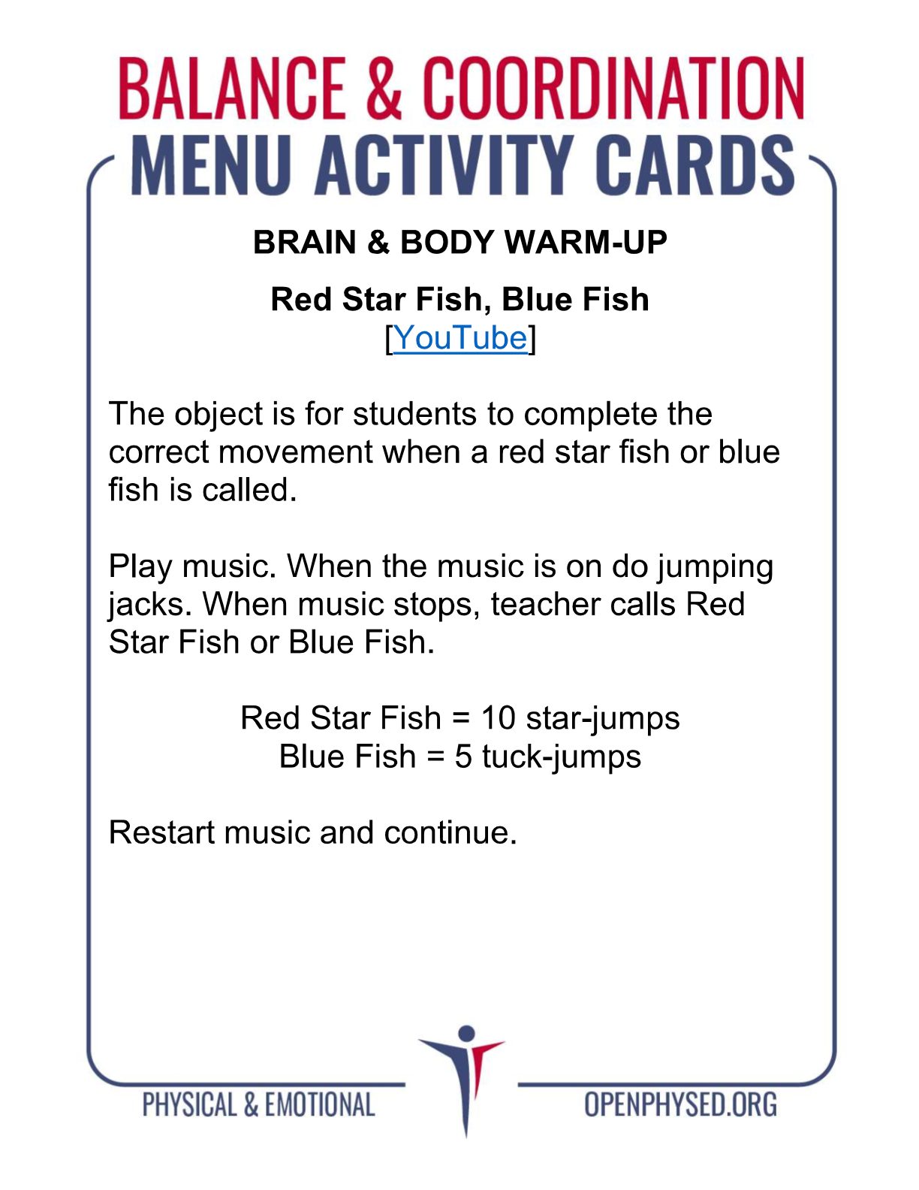
https://www.youtube.com/watch?v=oTBSB54n-UQ
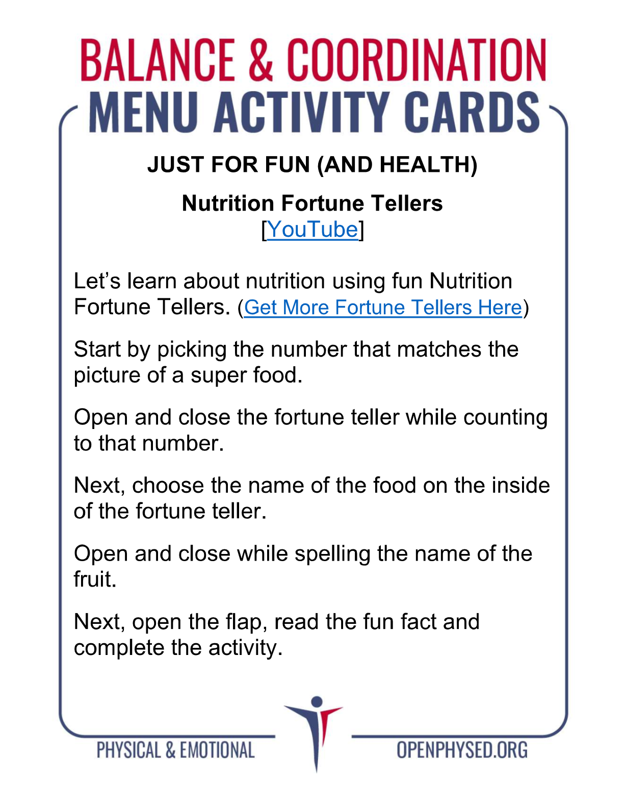https://www.youtube.com/watch?v=xsK4RQv4Cug

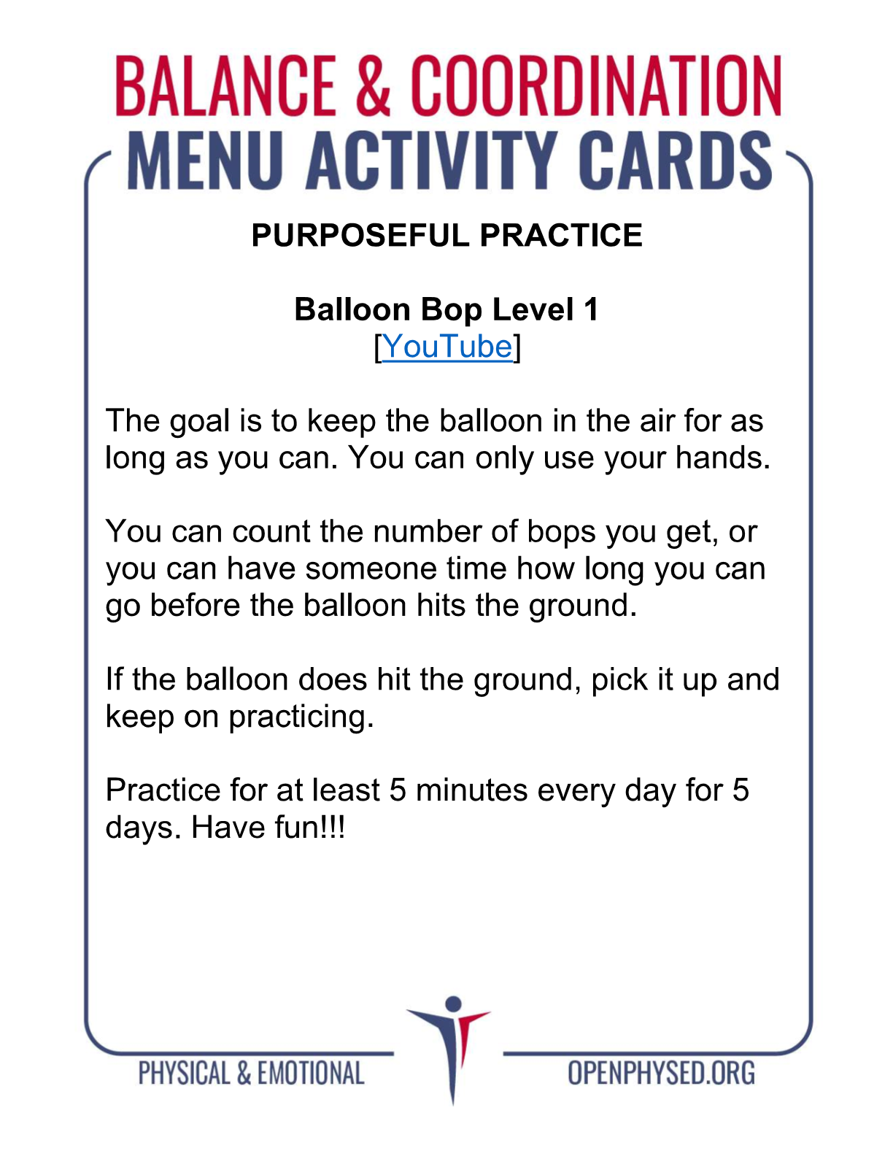https://www.youtube.com/watch?v=dCN1THQrtIA

