Cases: Assault
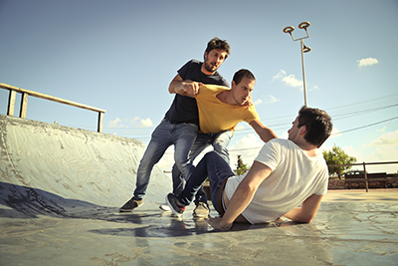
For the remainder of the course, you'll continue to examine case studies. Make sure you have reviewed the Case Study section of Week 8a lesson before going any further, as these tips will be important for the Case Studies assignments.

Assault
Did you know that you don't actually have to touch anyone to be guilty of assault? Threatening behaviour is enough in some instances. If you convince someone you are going to cause him or her bodily harm, and his or her fear is a reasonable and an immediate one, you could be guilty of assault. Assault may take place in the mind of the victim!
For an excellent plain language elaboration on assault, refer to the Public Legal Education and Information Service of New Brunswick (PLEIS NB) resource below. Read through this resource and make notes on its key points.

PLEIS NB: Assault - http://www.legal-info-legale.nb.ca/en/criminal_law_assault

There is also a discussion of spousal assault in the "Family Violence" section of the PLEIS NB site, and another on dating violence and assault under the heading for "Violence in Schools."
Find the full text of the Criminal Code of Canada provisions on assault by visiting CanLII https://www.canlii.org/en/ca/laws/stat/rsc-1985-c-c-46/latest/rsc-1985-c-c-46.html. On the CanLII site, Code sections are connected to the related case law from appeal courts across Canada. After looking up the Criminal Code section, click on the linked number beside the section. Then click "Citing documents" to see a list of cases relevant to that section.
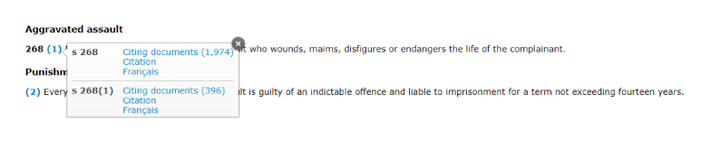
As you can see from the readings, consent may be an issue in assault cases. Prize-fighters and professional wrestlers regularly attack each other physically. It's how they make their living. Why aren't they charged with assault? The answer is, of course, that they consent to take part in the fights. However, consent only goes so far. The law does not allow anyone to consent to having major injury or death inflicted on them. The degree to which consent is a defence to assault charges has been the subject of several notable cases concerning professional sports.

Cases: Assault (Continued)
Consider the following case as you ponder the legal definition of assault. Working through the illustrative case and questions should help clarify some key points. Record your responses to each question before consulting the Expert Opinion.
Jack was having the worst week of his life. He got fired, his girlfriend dumped him and his car broke down. Bill collectors were calling him daily and his own family was demanding he shape up or ship out.
So it's no surprise that Jack was at least a little fired up when he went bar-hopping, very late on a Saturday night. He entered a spot he often visits. He spotted Kurt in the corner hanging out with friends. Jack approached—drunk, and looking for a fight. He waved his fists, cursed, swore and insulted Kurt in every way. Among other comments to Kurt, Jack said "Step outside, and I'll beat the #%@& out of you." When Kurt turned away, Jack shouted more insults and obscenities, punched Kurt in the arm and then in the face.
Kurt had enough. He hit Jack back and knocked him off his feet. Kurt then walked away, but Jack jumped up and hit him again. Kurt turned around and hit Jack in the face so hard that he broke Jack's nose. Despite his broken nose, Jack was charged with assault.
- List the facts of the case. Remember to omit anything that isn't clearly factual.
- Review the parts of the law on assault relevant to this case. Explain them in your own words.
- Explain the arguments for Jack's guilt.
- At what point was the offence of assault complete? Explain.
- If Jack had continued to insult Kurt, but had made no gestures and had not hit Kurt, would your answer be different? Explain.
Expert Opinion
- The facts are:
  - Jack approached Kurt shouting insulting remarks and waving his fists at Kurt.
  - Jack invited Kurt outside to fight.
  - Kurt initially ignored Jack. Jack continued insulting Kurt then hit him twice.
  - Kurt struck back, knocking Jack over.
  - Kurt turned away from Jack.
  - Jack attacked Kurt again.
  - Kurt hit Jack hard enough to break his nose.
Note that the first sentences of the case study are not included as facts relevant to a charge of assault. The reason for this is that they address motive and, while a prosecutor might make good use of this material, it is not essential to the actus reus or mens rea of the offence.
- Criminal Code Section 265 (1) clearly says that a person commits an assault when he attempts or threatens, by an act or a gesture, to apply force to another person, if he has, or causes that other person to believe on reasonable ground that he has, present ability to effect his purpose. In other words, one way in which assault happens is when a threat is made by an act or a gesture and it is clear to the victim that the attacker has the ability to make good on his or her threat.
- Jack came into the bar where Kurt was sitting quietly and started shouting and waving his fists threateningly at Kurt. This threatening act is the actus reus required by law. Jack also made his intent, or mens rea, clear when he invited Kurt to step outside and fight him. The act and the threat are both present and he should be found guilty.
- An assault had occurred before anyone struck anyone else. When Jack waved his fists at Kurt and invited him outside, the requirements of the offence were complete.
- In this case, the act and gesture would be missing. Jack's behaviour would still be objectionable and grounds for the management to remove him from the building, but it would not be assault in the eyes of the law.

Assignment: Assault Case Study
Law 120 – Assignment
During a hockey game, Alex and Henry fought over the puck. Henry checked Alex hard, stole the puck off his stick and skated off. Alex tried to hook Henry with his stick but hit him on the back instead. Henry swung around with his stick in both hands and hit Alex. The blow caught Alex in the throat and caused serious injury to his vocal chords; enough to potentially affect his speech for the rest of his life. Henry was charged with assault causing bodily harm.
Use the guidelines listed below to analyse the case and see rubric in the inset picture.
1. List the facts of the case in point form
2. Explain the points of law relevant to both the defence and the prosecution. Refer to the Criminal Code as needed.
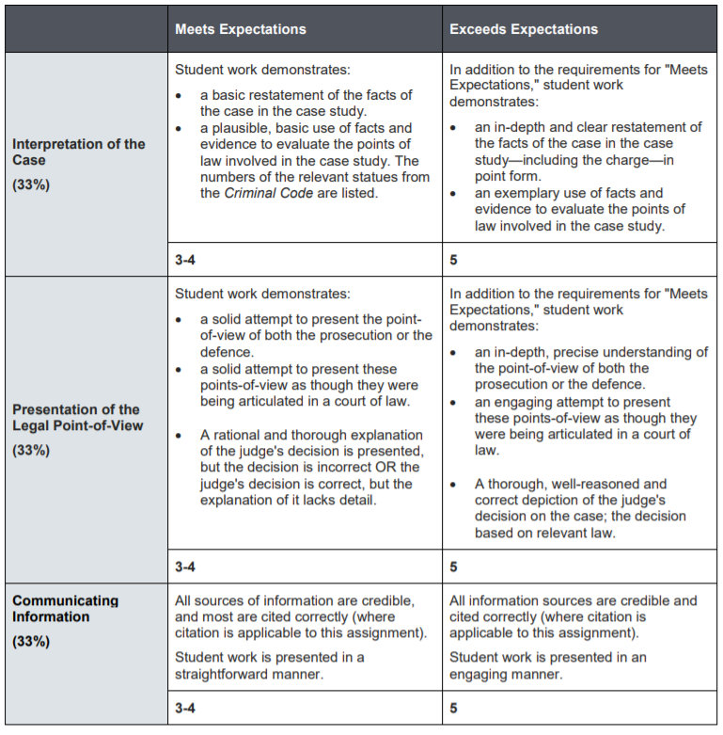
3. Argue the prosecution, attempting to prove guilt beyond a reasonable doubt. Argue as though you are the Crown prosecutor, speaking in court.
4. Argue the defence, demonstrating reasonable doubt, presenting a reasonable defence, or arguing a lesser charge. Write this as though you are the defence lawyer speaking in court. Render judgment stating your supporting reasons for accepting one argument over the other. Write this as though you are the judge in the trial.

