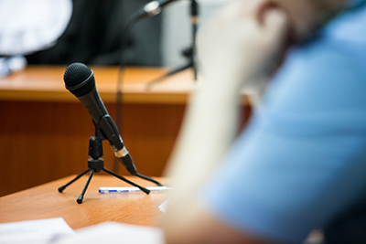
Judicial Procedures: Arraignment

Let's now return to John's case: the stolen console. We are now ready for the trial. Offences have been committed. John was charged with two offences—theft, and assault causing bodily harm—and will be tried in Provincial Court. There will probably be only a few people present for the hearing. There will be no jury.
Section 717 of the Criminal Code describes an alternative measures program for offenders who admit responsibility for the offence. Rather than going to court, John could admit to his offence and become involved in some form of community service. In such a program, there would also be a mediation process with the victim. The Crown Prosecutor or police would decide whether John could participate in the program. As a result, John would not necessarily receive a criminal record.
John is well aware of the offence he committed, but he's decided he will face the charges in court. John will also attend his court session, though he is aware that in certain circumstances, an accused person does not always have to be present (see section 650 of the Criminal Code).
John's first appearance in court will be for the arraignment. The arraignment is a hearing to identify the accused and provide the opportunity to plead guilty or not guilty (A plea is stating the guilt or innocence of a person's actions. See section 606 of the Criminal Code). If John pleads guilty, his case will never reach the trial stage and the judge will give sentence. If John pleads not guilty and goes to trial, he may have a preliminary inquiry before trial.
At his first court appearance, John's name will appear on a list called a court docket. There is a good chance other trials will be before his, so he may have to wait until a court official calls his name. When his name is called, he will go to the front of the court to stand in front of the judge, and a court official will read the charge. If John does not have a lawyer, the judge will usually ask him if he wants to consult with a lawyer. If he tells the judge that he would like to talk to a lawyer, the judge will give him another date to return to court. If the judge does not ask, John can ask the judge for time to consult with a lawyer.
If he already has a lawyer or does not want to see a lawyer, the judge will ask him if he understands the charge. He will then be asked to plead guilty or not guilty.

Judicial Procedures: Pleading and Sentencing
It is possible to plead guilty at any time before the court finds a person guilty, but it is much more difficult to change a guilty plea. See Sections 606 - 613 of the Criminal Code.
Continuing with the stolen console story, John originally decided to plead not guilty, but as he heard the evidence, he soon realised that he couldn't get out of this situation, so he pleaded guilty. Pleading guilty means he is admitting in court that he has committed the offence. Even though he pleads guilty, the court will still hear the facts of the case as presented by the prosecutor. The court will then listen to any explanations offered by John. Finally, the judge will pass sentence.
The judge may also ask a probation officer to prepare a pre-sentence report. A pre-sentence report contains information about the accused to help the judge decide on a proper sentence. When a pre-sentence report is requested by a judge, the person charged (in this case John) would be required to go to court at a later date, as the judge may need time to think about a proper sentence or to provide preparation time for the pre-sentence report.
As John has pleaded guilty, he will receive a criminal record. His sentence will be decided by the judge after the pre-sentence report.
When passing sentence, the judge must abide by limits set for the specific conviction. The judge must give at least the minimum sentence and must make certain considerations when sentencing (see Section 718.2). The judge must also state the reasons for the sentence given:
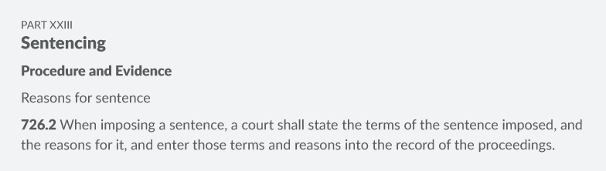

Judicial Procedures: Discharges and Appeals
There are a number of sentences a judge may choose from. Rather than convicting the accused and sending the offender to prison, the judge may give the accused a discharge. There are two types of discharges:
- An absolute discharge takes effect immediately, automatically removing the criminal record one year after the discharge.
- A conditional discharge requires that conditions must be met, as set by the judge (see sections 742.1 and 742.3 of the Criminal Code). A conditional discharge will automatically remove the criminal record three years after the conditions are met. A person can also apply to the parole board for a record suspension (formerly known as a pardon) three years after serving the sentence of a less serious offence and five years after serving the sentence of a more serious offence.
Other than conviction and discharges, there are alternative sentences the judge may choose from. The accused may pay a fine, may have to provide restitution, may receive a suspended sentence or may receive some form of prohibition.
A fine is money paid to the court. Failing to pay the fine will result in a jail term. It is possible to request a pay schedule (time to pay the fine) or provide community service work. | For a suspended sentence, the judge will postpone the sentence for a period of time during which conditions must be met in order to avoid further punishment, returning to court and sentencing. These conditions will be written in a probation order.
Restitution is the order of a judge to pay money to the victim of the crime for any damage or loss caused by the crime. | Prohibition is the judge's suspension of a person's driver’s license or an order prohibiting the ownership of a firearm.

Appeals
If the Crown Prosecutor or the convicted is not satisfied with the judge's decision, an appeal can be filed. A single judge of the Provincial Superior Court will hear appeals for a summary conviction. A panel of three or five judges hears appeals for indictable offences at the appeal division of the Superior Court. See PART XXI APPEALS of the Criminal Code, sections 673 - 696 and sections 821 - 840.

Check Your Understanding: Discharges and Sentencing
You've learned a lot of terminology in this section on legal procedures. Now it's time to check your understanding. In the activity below, match each term to its description. One term will NOT have a match. Once you've completed the matches, sent it to me for correct. Once you've correctly matched the descriptions, you can move on to the next question in the activity.
_____judgement where the accused is found not guilty of the offence  _____money paid to the court  _____where an accused person could admit to their offence and become involved in some form of community service  _____removal of the criminal record after one year  _____removal of the criminal record after three years and after certain duties have been performed ordered by a judge | - Acquittal  - Fine  - Alternative measures program  - Conditional discharge  - Record suspension  - Absolute discharge

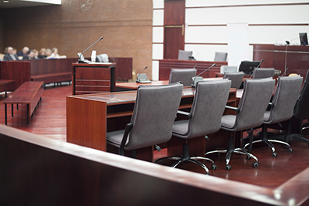
Trial Procedures

After a crime has been committed and someone is charged with an offence, the case is brought to the attention of the court. The court procedure will vary depending on the type of offence (summary or indictable). It is the Crown Prosecutor who will determine the type of offence.
The proceedings usually start with the laying of information. The term "information" refers to an official statement recorded to inform the court of the details of the offence. The information document is signed by the person charged with the offence.
Generally speaking, less serious offences will not have juries. Summary offences, such as those found in Section 553 of the Criminal Code and some hybrid offences are tried in Provincial Court before a judge but with no jury. There are no juries at the Provincial Court level. However, for a more serious offence, an accused may elect (choose) to have the case tried by either judge alone or by judge and jury. Indictable offences listed in Section 469 can only be tried in a Superior Court. A judge and jury will hear these trials unless both the accused and the Crown consent to trial by judge alone (see section 473).
A person charged with an offence not found in Sections 553 and 469 may elect (choose) to be tried in the Provincial Court (no jury), by a judge alone at the Superior Court, or by judge and jury at the Superior Court. This may be the case for dual (hybrid) conviction offences. Check out Sections 553 and 469 in the Criminal Code to see which offences are excluded.
The Charter states that a person charged with an offence for which the maximum punishment is five years or more has the right to a jury trial.
If an accused person elects to be tried in a Superior Court, the accused must first have a preliminary inquiry in Provincial Court (see Section 536). The preliminary inquiry ensures that there is sufficient evidence to make a trial worthwhile.
Even though the Canadian Charter of Rights and Freedoms guarantees the right to be tried by a jury, it is possible for the Crown to insist on a trial in Superior Court by judge and jury (section 568). However, the right to trial by jury can be lost if the accused fails to appear for trial (Section 598).
Finally, a young person charged under the Young Offenders Act and tried in Youth Court is not entitled to a jury trial. Section 52 of that act states that all such charges, whether summary or indictable, must be dealt with by summary conviction procedures.

Trial Procedures: Example
MODULE 2: CRIMINAL LAW
Read the following account of what John experienced during his trial. Think about the terms you've recently defined, and how they apply here. Make notes on the sequence of events.
"As I enter the courtroom, I see a judge, a prosecutor, a court clerk, a sheriff's deputy, and a few spectators. When the judge enters, the room is called to order and everyone stands. Bows are exchanged between the judge and some of the people in the room. I heard that this is a custom between court officials and members of the Bar, something not required of other people. The judge is having a seat. Oh, I better sit down … everyone else is seated. People stand when they speak or are being spoken to by the judge.
There are microphones in front of the judge and the lawyers' tables and in the witness box. They will record everything that is said. That's how I can get a printed transcript later if I decide to appeal the verdict.
The clerk just called the case. He mentions my name. The prosecutor is introducing herself to the judge. My lawyer (the defence) now introduces himself. He tells the judge that he is ready to go ahead with the trial.
The witnesses are kept outside since we don't want them to be influenced by others who testified before them. The prosecution is now calling the first witness … oh, it's the cashier from the store. His nose looks bad. I didn't realize I had hit him so hard. Maybe I should have pleaded guilty…
He is swearing an oath (making a solemn declaration) to tell the truth. The prosecutor is now questioning him to determine what he observed. This is called the examination of the witness.
Now it's my lawyer's turn. He is going to test the accuracy of the testimony of the opposing attorney. He may find that the cashier didn't mention something that may help my case. He may also try to find inconsistencies with his story to see if he was honest. My lawyer asks a few questions, but I don't think it's going to help me out. The process of my lawyers questioning the Crown's witness is called cross-examination.
Once the prosecution's witnesses have all testified, the Crown Prosecutor closes his case. If my lawyer can prove beyond a reasonable doubt that I didn't steal the gaming console and assault the cashier, he could ask for a dismissal.
It's now our turn: the defence response. If my lawyer calls witnesses, he will question the witness first. Following this, the Crown can ask questions in cross-examination. My lawyer can then ask more questions during what is called re-examination if he thinks it will help my case. I don't have any witnesses. My friend told the police that he could be a witness. Apparently he told my lawyer that he heard I was a shoplifter. My lawyer said I was in luck; witnesses can't give evidence based on what someone else told them. That's what is called hearsay. I was hoping this friend of mine would provide me with an alibi by telling the court that I was with him the whole time.
Now that all the witnesses have testified, the judge is asking my lawyer to sum up the evidence for an acquittal. The prosecutor is now making her own final points, trying to convince the judge to convict. The judge is going to have a recess. Sometimes, he gives his verdict right after the prosecutor's remarks. Guess he needs a break.
There is no acquittal. I am not free to go. Since there is a conviction, the judge will probably deal with sentencing right away. Not bad, the whole thing took 25 minutes. Sometimes it can be shorter; sometimes it can last up to two days."

The Jury System
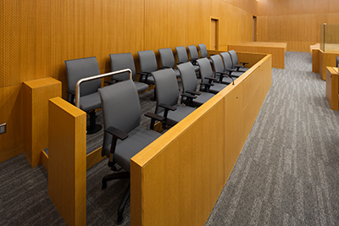
Each province has laws set out on how juries are selected and who is eligible to serve on a jury. When a jury is needed, names of potential jurors are randomly selected from a variety of sources, such as an electoral list (names of people eligible to vote in elections). From this list, the sheriff will call a number of people to court. The Crown Prosecutor and the defence lawyer will then choose the jury from amongst these people.
The jury is made up of 12 people who do not have legal training. During the trial, the jurors listen to all the evidence. Sometimes the judge asks the jury to leave the courtroom while the lawyers argue about whether the jury may hear certain evidence. This is called a voir dire.
After the Crown Prosecutor and the defence lawyer complete the final list of jurors, the judge explains the law to the members of the jury. The jury members must decide whose evidence they believe. They may choose to believe or to not believe any witness or any part of the witness's evidence. They must decide whether they are satisfied beyond a reasonable doubt of the accused person's guilt. If they have a reasonable doubt about guilt, they must choose to acquit the accused person.
A conviction is a finding of guilty; an acquittal is a finding of not guilty. After the judge's explanation, the jurors leave the courtroom to decide. They must consider what the judge has said before they return with a verdict. The jury members must all agree on the verdict. If they do not agree, the judge lets them go and ends the trial without a conviction or an acquittal. This is called a hung jury. The Attorney General may order a second trial with a different jury.
If all the jury members agree to the same verdict, they tell the judge what they have decided. Their job is then done. If the verdict is not guilty, the accused person is released and is free to go. If the verdict is guilty, the judge will sentence the person. For certain cases, such as murder, the jurors may recommend a certain number of years before the accused be eligible for parole. More information can be found in the resources below:

Try Judging Resource – see the attached file on my website & only need to look at Section 2B

Court of Queen's Bench: Juries - https://www.courtsnb-coursnb.ca/content/cour/en/queens-bench/content/trial-division/juries.html

The Jury System
Law 120 – Assignment

So far you've learned the basics of the jury system in Canada. Now, you'll dig a little deeper and formulate your own thoughts about how well the system works. First, explore the resources below to familiarize yourself with the issues related to jury selection and function. Feel free to do additional research to find out more.

• Department of Justice: The Role of the Public - https://www.justice.gc.ca/eng/csj-sjc/just/12.html
• Law Now: Why do we have jury trials? - https://www.lawnow.org/why-do-we-have-jury-trials/
• Law Now: Jury Trials: Cost, Controversy and Secret Powers - https://www.lawnow.org/jury-trials-cost-controversy-and-secret-powers/
• CBC: It's time to let Canadian jurors speak freely about their verdicts, experts say - https://www.cbc.ca/news/canada/jury-secrecy-colten-boushie-gerald-stanley-1.4533893
• CBC: Jurors in traumatic trials need counselling and support - https://www.cbc.ca/radio/thecurrent/the-current-for-january-15-2019-1.4975304/jurors-in-traumatic-trials-need-counselling-and-support-not-just-a-coffee-and-a-handshake-advocate-1.4975309
• CBC Sunday Edition: How to Reform Canada's Jury System - https://www.cbc.ca/radio/thesundayedition/the-sunday-edition-february-18-2018-1.4538717/how-to-reform-canada-s-jury-system-1.4538728

Using the resources you've examined to back up your points, consider three (3) of the following issues. Write a short essay (2-4 paragraphs) about each issue, explaining the advantages and disadvantages from different perspectives (for example, consider the point of view of offenders, victims, society, and/or jurors themselves.) End each essay by stating what you would recommend to reform or improve that aspect of the jury system.

1. The need to unanimously find the defendant guilty beyond reasonable doubt in order to convict him or her
2. The experience of being a juror
3. The jury selection process (Include "peremptory challenges" in your discussion.)
4. Juror secrecy
5. The roles of human emotion and legal expertise in a criminal trial

