Legal Process: Release and Promise to Appear
Most Canadians get their ideas about court procedures from television, and many legal shows are based on American law. U.S. law is rooted in British common law and traditions, as our law is, so most American procedures are similar to ours. However, they are not identical and most of us have some erroneous ideas about how our courts operate as a result of television. This lesson is intended as an antidote to some false impressions you may have. Remember John, the young man who stole the gaming console and punched the store cashier? He is going to give you a direct account of his arrest experience. Although not all cases are the same, this will give you an idea of the process.
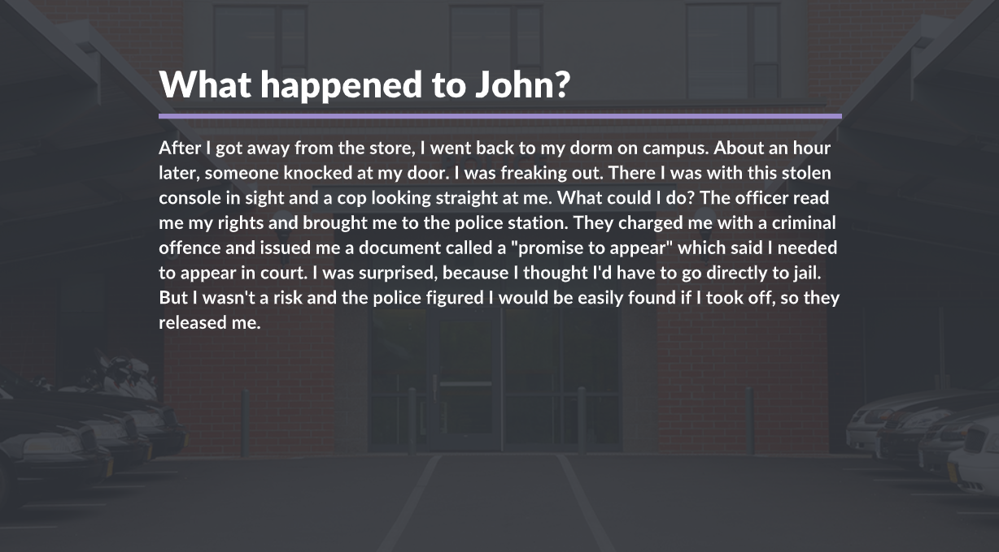
There are various reasons why a person may be released. The police will usually release an arrested person soon after charges have been laid unless there is a good reason to keep the person in custody. Only a judge or a justice of the peace can order the person to stay in jail longer than 24 hours.
If a person is charged with a less serious offence, the police officer must release that person. However, there may be circumstances where the officer may need to keep him longer, such as:
- If there is a need to identify that person, to prevent another offence from being committed
- To protect evidence about the offence
- If the officer believes that person will not appear in court
As mentioned earlier, before releasing the arrested person, the officer will usually give the accused person an appearance notice/ promise to appear or a summons. The appearance notice will be given to the accused at the scene of the crime. If an investigation is required, and once the perpetrator is discovered, the accused person will receive a summons to appear in court.
If a person charged with a crime fails to appear in court, the police can lay a charge with another offence for failure to appear. This is described in section 502 of the Criminal Code.
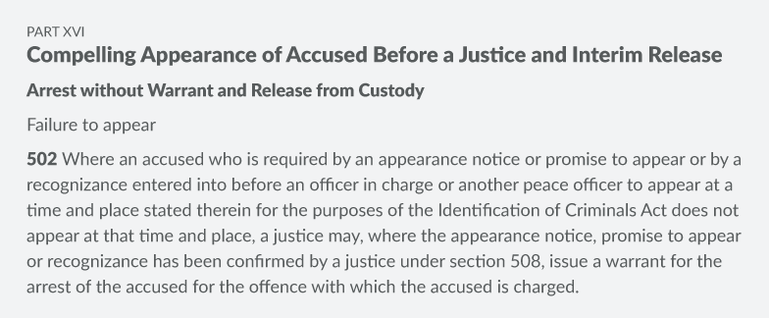

Judicial Procedures: Officers of the Court
If you have never visited a courthouse, take some time and make the arrangements to visit one. You may even meet one of the officers of the court introduced in this section. There are many people involved in a criminal case. This section will introduce you to who is involved during a criminal trial.
1
2 | 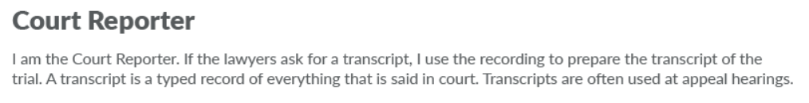
3 | 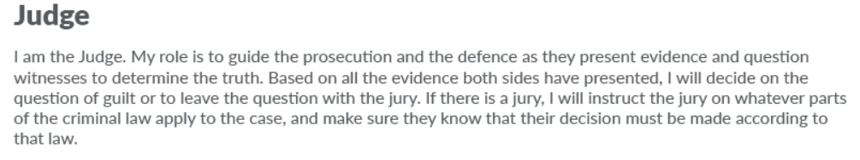
4 | 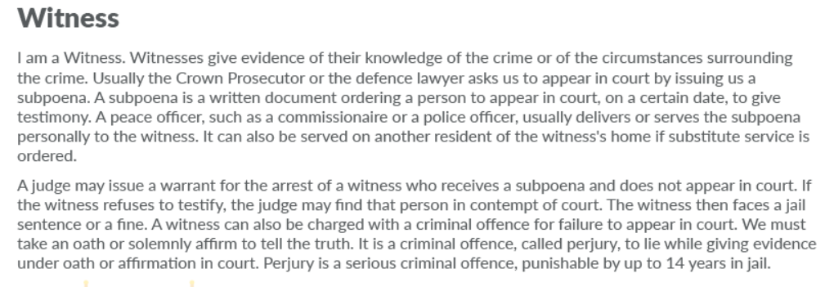
5 | 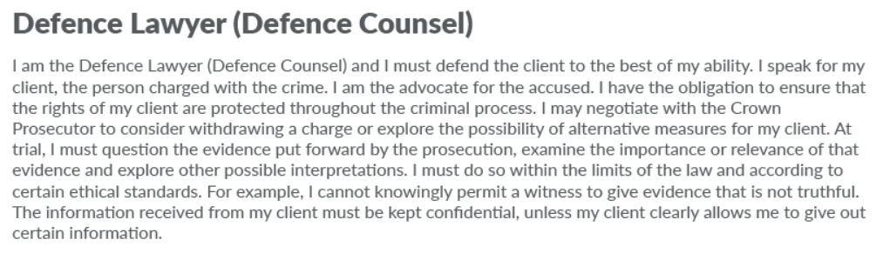
6 | 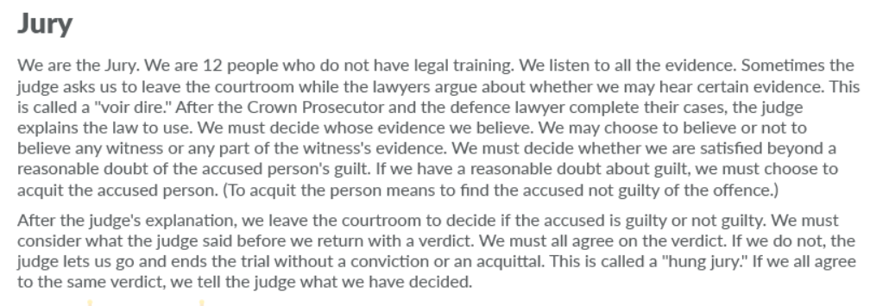
7
8 | 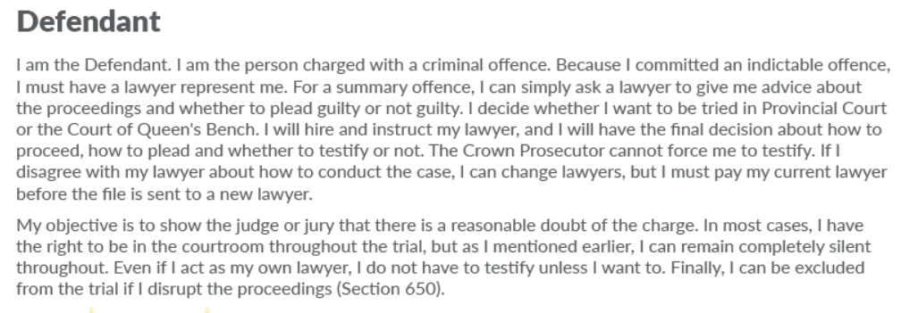
9 | 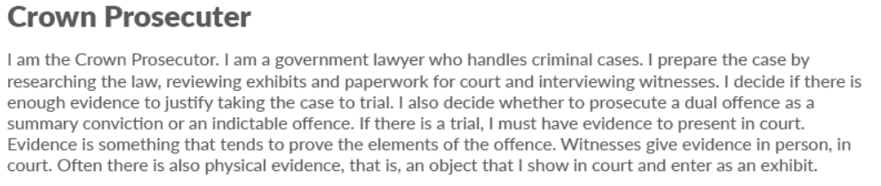

More Officers of the Court
There are additional officers of the court, who may or may not be present in the courtroom:
- The Justice of the Peace is a Justice official authorized to carry out some judicial functions, such as issuing arrest or search warrants. Sometimes an accused person will appear before a Justice of the Peace rather than a judge, however, they do not conduct criminal trials or sentence people.
- If the accused person or a witness is in custody, the Bailiff accompanies him or her to court. The bailiff also helps to maintain order in the court.
- Police Officers investigate crime, arrest people suspected of committing offences and charge people with criminal offences. They sometimes prosecute minor provincial offences, such as traffic offences, but Crown Prosecutors handle criminal prosecutions

Check Your Understanding: Officers of the Court
Now that you have been introduced to the officers of the court, do you think that you can identify them? Try to identify the officer(s) being described below. There are a total of seven descriptions that you will need to identify.
____________________”I have the obligation to ensure that the rights of my client are protected throughout the criminal process.”  ____________________”I assist the judge, announce when the court is in session and record the exhibits.”  ____________________”I give evidence of my knowledge of the crime or of the circumstances surrounding the crime.”  ____________________”I decide whether an offence is a dual offence, a summary conviction or an indictable offence.”  ____________________”I must decide whether I am satisfied beyond a reasonable doubt of the accused person’s guilt.”  ____________________”If the lawyers ask for a transcript, I use the recording to prepare the transcript of the trial.”  ____________________”I’m there mainly for security purposes.” | Prosecutor  Witness  Court Clerk  Sheriff’s Deputy  Jury  Court Reporter  Defence Counsel

Check Your Understanding: Legal Terms
Below is a list of definitions that are used to describe legal terms. Match the term on the right to its definition on the left.
_____an agreement between two or more people to perform an illegal act  _____an offence that is serious and carries a greater penalty  _____choosing to ignore certain facts that lead you to commit an illegal act  _____consciously taking unjustifiable risks  _____having every intention of committing a crime but not having completed the action  _____an offence that is not as serious as others and carries with it a lighter penalty | - Attempt  - Summary conviction  - Recklessness  - Indictable  - Conspiracy  - Wilful blindness

