Summary Conviction Offences
We all agree that some offences are more serious than others. There is a difference between shoplifting, armed robbery and murder. Consequently, punishments must fit the crime. The severity of a crime is laid out in the Criminal Code using two terms: summary convictions/offences and indictable convictions/offences. Many crimes can be punished as either an indictable offence or a summary conviction offence, depending on the severity.
Summary conviction offences:
- are less serious and thus have lighter penalties.
- usually entail a fine up to $5000 and/or imprisonment for up to six months.
- are tried in Provincial Court before a judge without a jury. With the judge's permission, the defendant may choose not to be present during trial if a lawyer represents him or her.
- do not result in a criminal record.
- must be prosecuted within six months of the date of the crime.
Summary convictions are detailed in the Criminal Code of Canada: PART XXVII SUMMARY CONVICTIONS, sections 785 to 840. But to find examples of summary conviction offences, you'll need to search the full text of the Criminal Code for the term "summary conviction." Go ahead and do this, scanning the results to get a sense of what types of offences can fall into this category.
Section 430 of the Criminal Code has an example of an offence punishable on summary conviction. And here is another example:
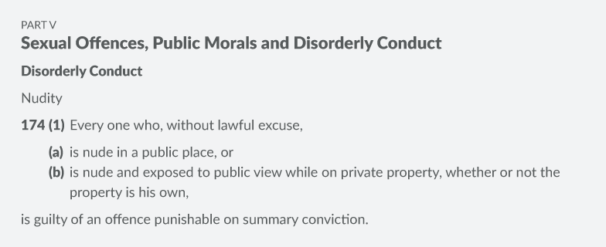

Indictable Offences
An indictable (in-dye-tah-bull) offence is more serious and carries a greater penalty. Maximum penalties for indictable offences range from two years to life. Usually, a trial for an offence with a maximum penalty of less than five year's imprisonment will be heard in Provincial Court or the Superior Court of the province, before a judge without a jury.
If the maximum penalty is more than five years, the accused may choose between a trial in Superior Court with a judge alone or with a judge and jury. The accused must be present during the trial of an indictable offence. If convicted, a criminal record will result. There is no time limitation regarding prosecution of the crime; in other words, regardless of how long ago a crime had been committed, a crime can still be heard.
The most serious indictable offences, such as murder and treason (listed in section 469 of the Code), are tried in Superior Court.
Here is an example:
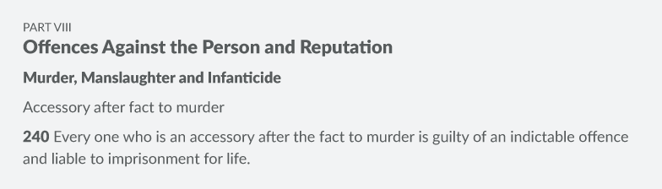

Hybrid Offences
MODULE 2: CRIMINAL LAW
There is also a third type of offence that is a combination of both indictable and summary. These are called hybrid offences or double offences and are indicated by the phrase "may proceed by way of summary conviction or indictable offence" in the Criminal Code. You would have seen many of these when you searched for "summary conviction" in the Code.
For hybrid offences, the prosecutor (the lawyer whose duty it is to convict the offender) has the option, depending on the circumstances and the record of the accused, to charge the person with a summary or an indictable version for the same offence. For example, a pushing and shoving incident might garner a charge of summary assault. A fight provoked by one party even though the other tried to avoid it and which involved punching and kicking the victim while he or she was on the ground and defenceless might provoke a charge of indictable assault. This charge is more likely if this is a repeat offence.
Section 266 of the Criminal Code is an example of an indictable offence with a summary conviction. In other words, the Criminal Code of Canada states that if the crime is rather serious, depending on the circumstances, the punishment may be up to five years:
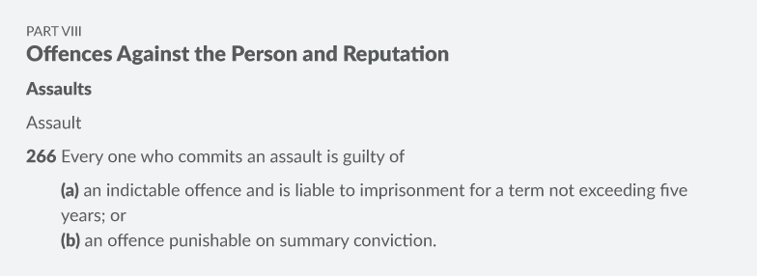
As you read, you may also encounter the term lesser included offence. This refers to an offence that is part of another offence. For example, one could not commit assault causing bodily harm without meeting all the requirements of a conviction for common assault. If a person was tried for assault causing bodily harm, but the prosecution failed to prove bodily harm had occurred, the accused could still be found guilty of the lesser included offence of assault.

Check Your Understanding: Types of Offences
Can you distinguish between summary conviction offences and indictable offences? Answer the series of questions below by classifying each description as "Summary conviction offence" or "Indictable offence." Please submit this to me for review before moving; I’ll respond as quickly as possible.
_____1. Fines of up to $5000.00 and/or up to six months in prison
_____2. Tried in Provincial Court or Superior Court
_____3. Accused must be present during trial.
_____4. Conviction results in a criminal record.
_____5. Prosecution occurs within six months of the date of offence.
_____6. Tried in Provincial Court
_____7. Accused may choose to be tried by a judge or jury.
_____8. Conviction does not result in a criminal record.
_____9. No time limitation on prosecution
_____10. No jury trial
_____11. Accused does not need to be present during trial.
_____12. Fines greater than $5000.00 and up to life in prison

Check Your Understanding: Types of Offenses in the Criminal Code
For this self-assessment, you will need to research offenses in the Criminal Code of Canada using links provided in the questions.
Refer to the Code to determine whether each offence is a summary conviction, indictable, or hybrid offence.
You must have a strong understanding of these concepts before continuing with the material.
Question #1:
Search the crime listed below in the Criminal Code and indicate if it is an indictable, summary or hybrid offence:
145 Escape and being at large without excuse
- Indictable
- Summary
- Hybrid

Question #2:
Search the crime listed below in the Criminal Code and indicate if it is an indictable, summary or hybrid offence:
177 Trespassing at night
- Indictable
- Summary
- Hybrid

Question 3:
Search the crime listed below in the Criminal Code and indicate if it is an indictable, summary or hybrid offence:
319 Public incitement of hatred
- Indictable
- Summary
- Hybrid

Question #4:
Search the crime listed below in the Criminal Code and indicate if it is an indictable, summary or hybrid offence:
375 Obtaining, etc., by instrument based on forged document
- Indictable
- Summary
- Hybrid

Question #5:
Search the crime listed below in the Criminal Code and indicate if it is an indictable, summary or hybrid offence:
66 Punishment for unlawful assembly
- Indictable
- Summary
- hybrid

