May 4, 2020
Hello Grade 7!
I am going to review last weeks work in our Math 7. For the students that followed along and completed the assigned work, thank you! If you are just visiting and going to try some Math- great We will still do our Mental Math, but we are going to review “Circles” and “Parallelograms”. We will move slowly for our review, so that you are able to remember vocabulary and the formulae that you need for this outcome. *Please send me ANY questions about anything we are doing this week!

Have a great week
Monday –Review Circles
Tuesday – formula practise for circles
Wednesday – formula practise for parallelograms
Thursday – What if you have to find the “other” dimension?
Friday – a “mini” assignment for review

*Remember, do what you are comfortable with. Do a little or it all, as long as you are doing something to keep your math skills fresh

Monday (mm)

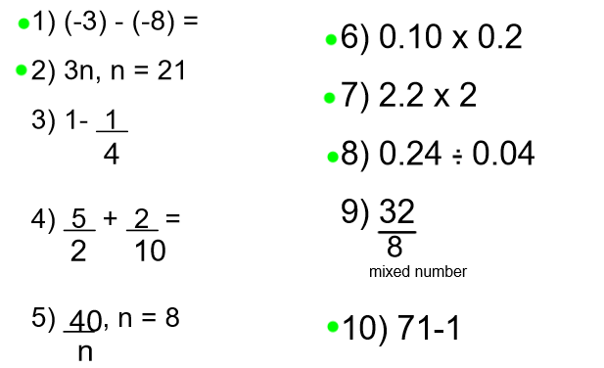

Tuesday (mm)
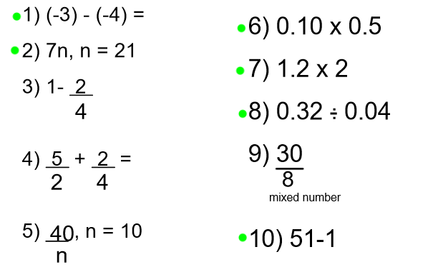

Wednesday (mm)
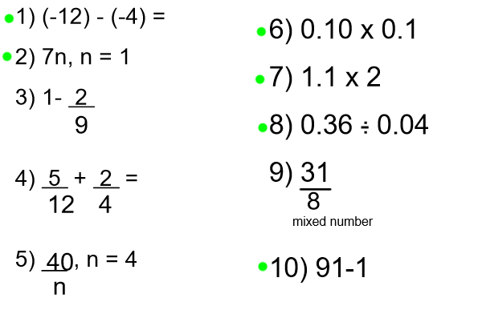

Thursday (mm)
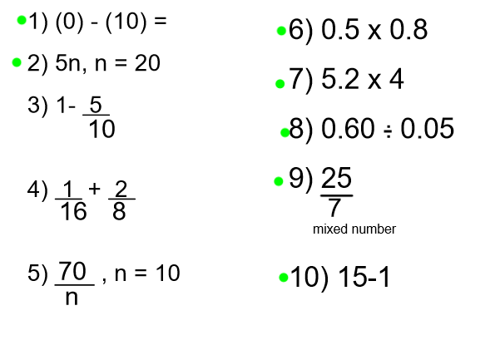

Friday (mm)
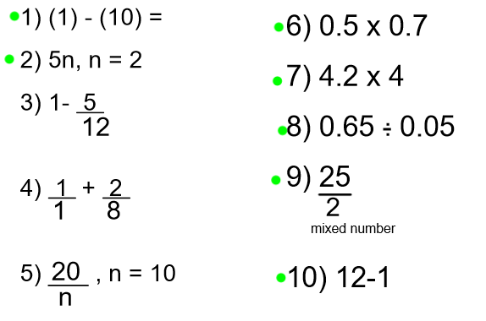

Monday
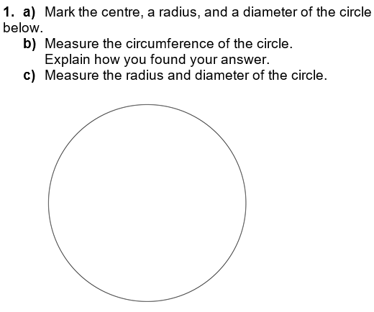

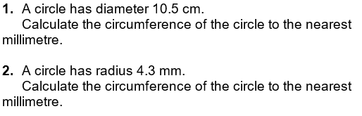

Tuesday
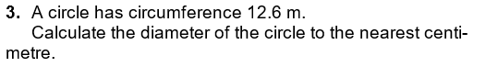
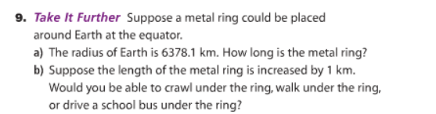

Wednesday

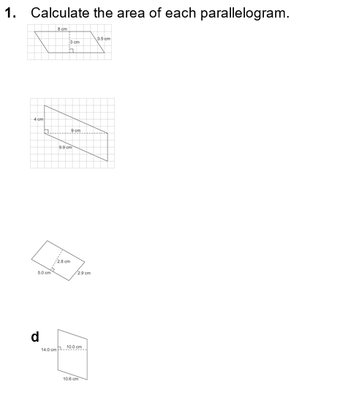

Thursday

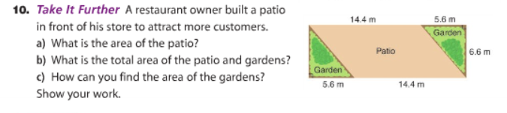

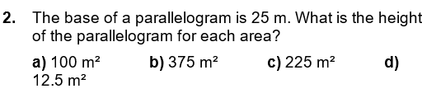

Friday
