6. RIGHTS AND FREEDOMS IN CANADA
ACTIVITY 14: RIGHTS AND FREEDOMS IN CANADA.
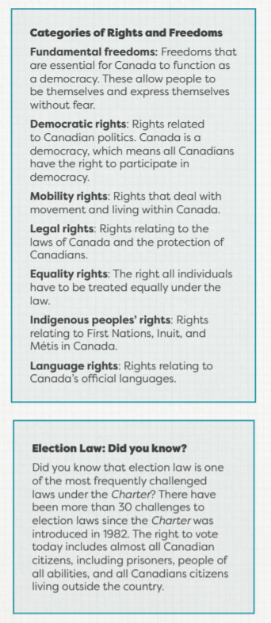
The Canadian Charter of Rights and Freedoms has been part of our Constitution since 1982. The Constitution is the highest law in Canada, meaning that it, including the Charter, is the most important law we have. The Charter tells people living in Canada what their rights and freedoms are. Many groups have used the Charter to help them fight for their human rights. For example, the Charter makes it illegal to discriminate against someone based on their sexual orientation. This contributed to laws that made same-sex marriage legal in Canada.
Canada has other laws that address rights and freedoms. Many of the rights of Status Indians in Canada are outlined in the Indian Act, which is different from the Charter and applies only to Status Indians in Canada. “Status Indian” is a legal term for members of First Nations who are registered under the Indian Act. Status Indians may be eligible for a range of services and programs offered by the federal or provincial/territorial governments.
1. Complete the Road to Rights Timelines worksheet attached below. It will require some internet research but is a matching activity; place the year from the left column with the statement in the right column
2. Use the Rights, Freedoms, and Responsibilities Worksheet to help identify the differences between rights, freedoms, and responsibilities. Use the information in the Categories of Rights and Freedoms box to help create a definition for “right,” “responsibility,” and “freedom.” Give an example or two to go along with your definition. If in a classroom, discuss the definition of rights, responsibilities, and freedoms. Are these concepts the same? How are they different? What do you think they protect in Canada?
3. Working on your own, fill in the chart in the worksheet by identifying if the answer is a right, a responsibility, or a freedom.
4. Afterward, assign each right, freedom, or responsibility to a category (use the Categories of Rights and Freedoms box to help you) and note these beside the chart. How do you see these rights, freedoms, and responsibilities in your daily life? Are there others that you can think of? How do they help shape life in Canada?
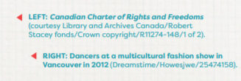
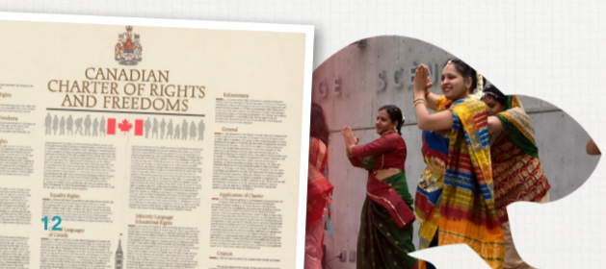
Match these events with the year in which you think they occurred. You can check your answers using an answer key that will be provided as an attachment on my website on Friday.
- The Road to Rights for LGBTQ2+ Canadians
- 1969  - Late 1980’s  - 1861  - 1978  - 2017  - 2003  - 2005  - 1971 | _____Sex between men became legal in Canada.  _____The first major LGBTQ2+ protests happened in Vancouver and Ottawa  _____The Immigration Act, which allowed gay men to immigrate to Canada for the first time came into effect.  _____The Canadian government made a law against discrimination on the basis of gender identity.  _____The penalty for sex between men was reduced from death to ten years-to-life in prison  _____Same-sex marriage was allowed in Ontario and British Columbia  _____The Canadian government made marriage between same-sex couples legal everywhere in Canada  _____Many provinces made laws against discrimination on the basis of sexual orientation.

- The Road to Rights for Canadians with Disabilities
- Late 1970’s  - 1950’s – 1960s  - 1970s  - 1918-1920s  - 1975  - Late 1940s  - 1990s | _____Governments cut spending for people with disabilities and for community services.  _____The federal government created new offices for disability issues because of the UN Declaration.  _____Many groups involving parents and families of disabled children created community organizations for people with disabilities.  _____The United Nations created the Declaration on the Rights of Disabled Persons.  _____Thousands of soldiers returned from the First World War with disabilities. Many organization were created to help them.  _____Many soldiers returned from the Second World War with disabilities, and the government gave them a lot of support  _____People with disabilities created their own groups to fight for their rights, including the Council of Canadians with Disabilities.

- The Road to Rights for Black Canadians
- 1834  - Early 20th Cent.  - 1600-1834  - 2005  - 1946  - 1916-1918  - 1960’s – Present  - 1982  - 1952 | _____An all-Black non-combat unit (the No.2 Construction Battalion) was created in the First World War  _____Slavery was abolished in the British Empire  _____The Canadian government passed the Canada Fair Employment Practices Act to reduce discrimination in the workplaces  _____Changes to immigration laws allowed many Black people to move to Canada from the Caribbean and Africa.  _____Viola Desmond, a Black business-owner in Nova Scotia, was arrested for sitting in an all-white section of a movie theatre.  _____Slavery was legal in Canada. Many Black people came to Canada from the United States or the Caribbean as slaves. After 1793, the Act to Limit Slavery passed in Upper Canada. This meant slavery was legal, but limited by law in Canada. Both free and enslaved Blacks moved to Canada during this time.  _____Canada’s Charter of Rights and Freedoms was created. It guarantees equal rights to Canadians of all ethnicities.  _____Michaelle Jean, who came to Canada as a refugee from Haiti when she was a child, became the first Black Governor-General.  _____Many cities, including Calgary and Vancouver, had laws about where Black Canadians could own property or rent.

- The Road to Rights for Women in Canada
- 1916  - 1970s  - 1897  - 1916  - 1918  - 1960  - 1993  - 1940 | _____Emily Murphy became the first female magistrate in Canada  _____Most women in Manitoba, Saskatchewan, and Alberta gained the right to vote.  _____Kim Campbell became Canada’s first female Prime Minister  _____Most women in Canada gain the right to vote in federal elections  _____Quebec became the last province to give most women the right to vote in provincial elections.  _____Clara Martin became the first female lawyer in Canada.  _____Indigenous women won the right to vote in federal elections for the first time.  _____Half of Canadian women had paying jobs outside their homes for the first time.
Use this worksheet to complete Activity 14: Rights and Freedoms in Canada, in the section ‘Rights and Freedoms in Canada’ of Canada Past and Present: A Citizenship Education Guide.
Part 1: Create your own definition for each of these terms. Consider adding 1-2 examples to help explain.
Rights: _______________________________________________________________________________________________________________________________________________________________________________________________________________________________________________________________
Freedoms: _______________________________________________________________________________________________________________________________________________________________________________________________________________________________________________________________
Responsibilities: _______________________________________________________________________________________________________________________________________________________________________________________________________________________________________________________________
Part 2: For each of the following examples, classify if it is a right, freedom, or responsibility.
Example | Freedom | Responsibility | Right
1) Canadians can freely practice their religions.
2) Canadians serve on juries when called to do so.
3) Canadians can live and work anywhere in the country.
4) Canadians help protect the environment and Canada’s natural resources.
5) Canadians vote in federal, provincial/territorial, and municipal elections.
6) The French and English language have equal status in Parliament and government.
7) Canadians can express their thoughts, beliefs, and opinions.
8) In Canada, individuals and groups must obey the law.
9) Every individual is equal by law and is protected from

10) Everyone is allowed a fair trial and cannot be searched or arrested without a good reason.

Part 3: Fill in this chart to help identify and understand the different categories of rights and freedoms. To help with examples, think of the statements above and if they apply to one of these categories.
Category | What does it apply to? / What does it protect? | What are some examples?
Fundamental Freedoms | -Allow people to be themselves and to express themselves without fear. | -Freedom of religion  -Freedom of thought, belief, and expression.
Democratic Rights

Mobility Rights

Legal Rights

Equality Rights

Official Language Rights

Indigenous People’s Rights

