4. WORLD WARS Many countries in the world were involved in the First World War and the Second World War. Both wars had a huge impact on the world, including on Canada and all the people living here. Both were “total wars” for Canada. This meant that most aspects of Canada’s economy and society were involved in the war effort in some way. The World Wars were important for Canada. They helped build a sense of national identity among Canadians. The result was that Canada demanded more independence from Britain.
ACTIVITY 11: THE SECOND WORLD WAR This activity uses the Record of Service Experiences Worksheet, available at the end of this document.
The Second World War was a global conflict that lasted from 1939 to 1945. As in the First World War, Canada made significant military contributions to the war effort. Canadians helped by working in war industries, producing weapons, and providing food and other goods for use in war zones around the world. Many aircraft, military vehicles, and ships were built in Canada, often with the participation of women, who entered the workforce during the war to fill jobs traditionally performed by men. As a result, Canada’s economic and military status grew after 1945.
More than one million men joined the military to fight for Canada abroad. Some 50,000 Canadian women also enlisted. More than 44,000 Canadians were killed and approximately 55,000 were wounded. In this activity, you will learn about the experiences of a few of the individuals involved in the Second World War.
Examining significant events can give us a better understanding of the past. Listening to people’s experiences can help us understand how people were affected. In this activity, you will watch The Memory Project’s Record of Service Second World War testimonies, available at http://www.thememoryproject.com/educator-resources/video-resources. How do these testimonies change your understanding of the Second World War?

1. Begin by watching The Second World War video for background on the war. https://www.youtube.com/watch?v=IM3drkoScdU&feature=youtu.be (this may need to be viewed a few times to understand the content….its only 3 ½ minutes so take time to get familiar. Also, at 2:40 in the video, this is footage of the North Shore Regiment…these are men from Miramichi and surrounding area storming Juno Beach on D-Day).
2. Select two video testimonies to watch from the list below and watch. Use the Record of Service Experiences Worksheet to take notes on the videos (each video comes in at 10-15 minutes):
• John (Jack) Rhind – Italian Campaign https://www.youtube.com/watch?v=Yn7Wo0xE2IM&feature=youtu.be
• Lloyd Bentley – D-Day and Operation Market Garden - https://www.youtube.com/watch?v=YeqppotH94I&feature=youtu.be
• Pierre Gauthier – D-Day (in French) - https://www.youtube.com/watch?v=VUMu5NqLAkQ&feature=youtu.be
• Janet Hester Watt – Domestic Service - https://www.youtube.com/watch?v=DpXyaMB49bw&feature=youtu.be
3. As you watch the videos, pay attention to the experiences the speaker describes that you find important or interesting. Next, compare two speakers’ experiences. What was similar about their experiences? What was different? If in a classroom, discuss in small groups.
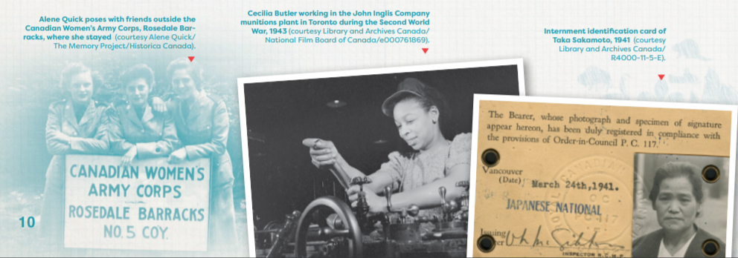

The Memory Project Speakers Bureau This is for extra and personal learning.The Memory Project is a volunteer speakers bureau that gives veterans and Canadian Forces members opportunities to share their stories. The Memory Project has more than 2,800 testimonials and more than 10,000 images in its archive. To learn more about the experiences of Canada’s veterans from the Second World War to the present time, visit the Memory Project Archive at http://www.thememoryproject.com/. Here you can choose to listen to veteran’s stories from the First World War, the Second World War, the Korean War, and Peacekeeping missions in which Canada has participated.

** I am also including the following website created by a friend about his great-uncle’s experience during World War II coming from rural Prince Edward Island.
Corporal Preston Duncan Campbell - https://darinmacdonald77.wixsite.com/info?fbclid=IwAR2q9n3FSfXESF-caekS936mZ_mNBb83dmoNaYxl5t999tklgIGRdbV7qs0

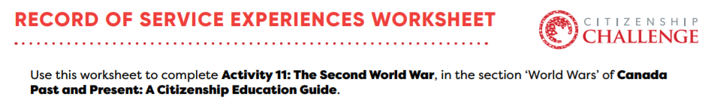
- While Jack Rhind’s account is started here as an example, it does not mean that he cannot be one of your two choices…this is merely done to show you the type of information with which to complete your chart.
Veteran | Experiences during the Second World War | Emotional impact of the war on the veteran | Lives after the war
Jack Rhind | -Was caught in a hurricane on the trip over to Europe | -He was scared when going in the trenches | -Married after the war

