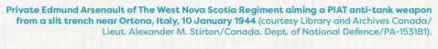
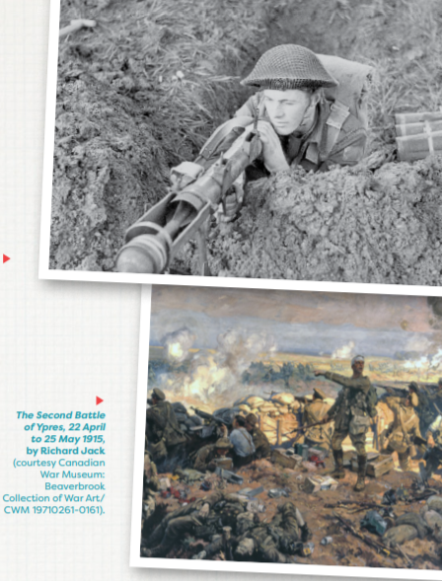
4. WORLD WARS Many countries in the world were involved in the First World War and the Second World War. Both wars had a huge impact on the world, including on Canada and all the people living here. Both were “total wars” for Canada. This meant that most aspects of Canada’s economy and society were involved in the war effort in some way. The World Wars were important for Canada. They helped build a sense of national identity among Canadians. The result was that Canada demanded more independence from Britain.

ACTIVITY 10: THE FIRST WORLD WAR
This activity uses the First World War Graphic Organizer, available at the end of this document. The First World War (1914–1918) was a long and bloody conflict with terrible consequences for every country involved. About 60,000 Canadians died and 170,000 were wounded. As part of the British Empire, Canada fought on the same side as Britain and made a significant contribution to the war effort. Following the war, Canada’s leaders decided that it was time for Canada to have greater decision-making powers.
Millions of Canadians supported the soldiers overseas, raising money for their families, working in factories that made weapons, and farming the fields to provide food for the armies. Canada’s experiences during the First World War involve multiple stories and points of view. In this activity, you will examine some of the diverse experiences of Canadians during the First World War.
The First World War was significant to Canadians for many reasons. Using the article sections listed below from The Canadian Encyclopedia, read about each topic to better understand how changes during this time were significant to Canada and how soldiers experienced the war abroad.
- Read these sections of the following articles and complete the graphic organizer as explained in #2, below. My suggestion is, do these readings one at a time in half-hour sittings. Doing them all at once will take too long:
• Canadian involvement: See the “Going to War” section of the First World War article.
• The Economy: See the “War and the Economy” section of the First World War article.
• Trench Warfare: See the “Battlefield Conditions” section of the Canada and the Battle of Passchendaele article.
• Conscription: See the “Borden and Conscription” section of the First World War article.
• Voting Rights: See the “Achieving the Vote in Federal Elections” section of the Women’s Suffrage in Canada article.
• Internment: See the “First World War” section of the Internment in Canada article.

2.Use the First World War Graphic Organizer to organize your answers to the following questions (there is a short example given in the Graphic organizer to get you started)
• What is it (a short definition of the topic)?
• What was it like? And/or how did it change?
• What are three or four key facts or events (in point form)?
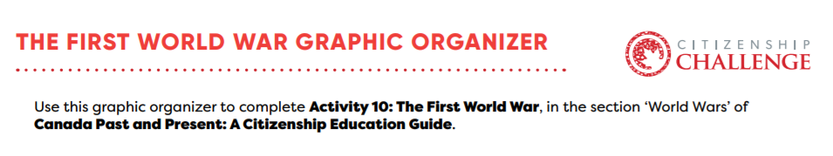
Topic | What is it? | What was it like? How did it change? | 3-4 key facts or moments
Example: Commemoration of the First World War | -Many Canadians lost their lives in the First World War. After the war and up to today, Canada commemorates those who fought and died during the war. | -During the First World War, Canada sent photographers and artists to document the war.  -In 1919, Canada established Armistice Day to remember the war.  -The Canadian Government build monuments commemorate the war. | -John McCrae wrote the famous poem “In Flanders Fields” in 1915. The poppy has become a symbol of remembrance in Canada.  -The National War Memorial in Ottawa was built in 1939 to commemorate Canada’s sacrifice during the First World War.  -An official arts program commissioned artists to travel with the Canadian forces to sketch and paint the war.
Canadian Involvement

The Economy
Trench Warfare
Conscription
Voting Rights
Internment

