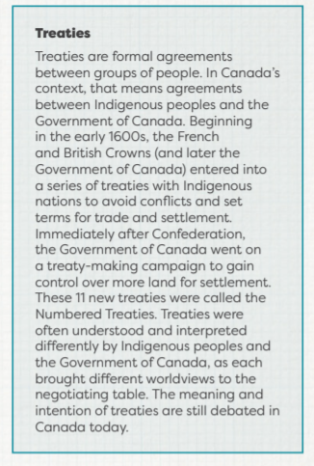
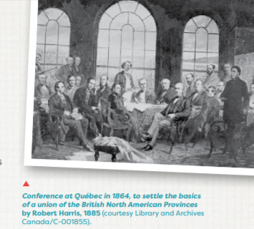
3. CONFEDERATION AND GROWTH Before 1867, the land we now call Canada was made up of several British colonies and Indigenous territories. Many of the European settlers in these colonies wanted better representation in government. They also feared that the Americans would invade again. Through negotiations and conferences, the colonies of New Brunswick, Nova Scotia, and the Province of Canada (now Ontario and Quebec) joined to create a new country in 1867, a process known as Confederation. The Indigenous peoples in these areas were not consulted about Confederation. The other provinces and territories that make up the Canada we know today joined or were created later. The last province to join Canada was Newfoundland and Labrador, in 1949. The territory of Nunavut was created in 1999. The anniversary of Confederation is on July 1, which is now called Canada Day.

ACTIVITY 8: CONFEDERATION
Confederation is when Canada officially became a country. In the 1860s, not everyone supported the idea of Confederation. Some colonies were not interested in joining together. And even though Confederation would have a huge impact on Indigenous communities, they were not invited to take part in the negotiations. After Confederation, the new Government of Canada created policies and institutions with the goal of eliminating Indigenous ways of life, languages, traditions, and culture, and forcibly assimilating Indigenous peoples into Canadian society. These policies had terrible and long-lasting consequences that still affect the lives of Indigenous peoples today.
1. Read the plain-language summary on Confederation (https://www.thecanadianencyclopedia.ca/en/article/confederation-plain-language-summary) on The Canadian Encyclopedia. Next, fill in the blanks on the Perspectives on Confederation Worksheet (found attached to this document).
2. Using the Perspectives on Confederation Graphic Organizer (found attached to this document), take notes on why some groups would be in favour of Confederation, and why some would be against it. Use the list of articles and sections below (in #3) for your research.
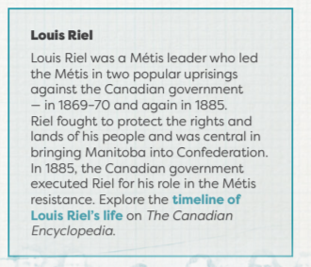
3. If we were completing this activity in a classroom, we would have divided into small groups where each group member would select one or two perspectives to research. So, in place, YOU will only choose one or two of the perspectives. Complete the graphic organizer with your research. The following articles are available on The Canadian Encyclopedia:
• Ontario/Quebec (Province of Canada): See the “Confederation, Quebec and Ontario” section of the Province of Canada (1841-67) article.
• Western Canada: See British Columbia and Confederation; Alberta and Confederation.
• First Nations: See the “Indigenous Peoples and Confederation” section of the Confederation article.
• Métis: See “The North-West Rebellion” section of the Confederation’s Opponents article.
• Nova Scotia and New Brunswick: See the “Atlantic Canada and Confederation” section of the Confederation article.
• Prince Edward Island: See the “PEI’s Resistance” section of the Confederation’s Opponents article.
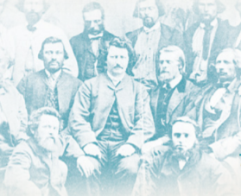
• The Mothers of Confederation: Select one or two articles from the list found under the “Mothers of Confederation” heading on the Confederation Collection: Lady Agnes Macdonald; Anne Brown; Anne Elizabeth Haviland; Eliza Richie; Elizabeth Lee Macdonald; Lady Dufferin; Luce Cuvillier; Mercy Anne Coles.

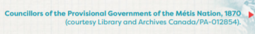
ACTIVITY 9: THE IMPACTS OF CONFEDERATION FOR INDIGENOUS PEOPLES
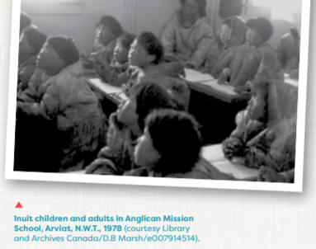
After Confederation, the Government of Canada created policies to force Indigenous peoples to give up their cultures and ways of life and assimilate into Euro-Canadian society. In 1876, the Government of Canada passed the Indian Act, which gave the federal government the power to control every part of Indigenous peoples’ lives. For example, the Indian Act outlawed many Indigenous cultural practices (including traditional ceremonies and languages), introduced travel restrictions, and forced Indigenous children to attend residential schools. At first, residential schools were operated by the Protestant and Catholic churches with the support of the government. Later, the government took control of the residential school system. The main goal of these schools was to force Indigenous children to abandon their Indigenous identities and assimilate into Euro-Canadian society. Children were forced out of their communities and placed in residential schools, where starvation, neglect, and abuse were common.
Residential schools have had a lasting impact on Indigenous peoples. Generations of Indigenous peoples were disconnected from their beliefs, traditions, and lifestyles. At least 6,000 Indigenous children died while attending residential schools. The residential school system is one of the darkest chapters in Canadian history. The last government-run residential school in Canada closed in 1996. It is a living history, meaning that the legacy continues to affect generations of Indigenous peoples in Canada today.
Activity: Indian Act of 1876 The Indian Act was introduced in 1876 to bring together past colonial laws that were aimed at controlling First Nations peoples. The Indian Act is still in place today, though it has changed over the years. It is still used by the government to control many aspects of First Nations people’s lives: Indian status, land, resources, wills, education, band administration, and more. Read the Indian Act plain-language summary on The Canadian Encyclopedia. List three of the negative impacts of the Indian Act for First Nations peoples in Canada. Think about how those negative impacts furthered the Government of Canada’s goal of forced assimilation of Indigenous peoples.
Despite this legacy of racism and oppression, Indigenous peoples in Canada have always fought to preserve their traditions, languages, beliefs, and rights. Indigenous people today continue to focus on revitalizing their communities and are working with the Government of Canada to re-establish their rights, ensure that Canada honours its treaty obligations, and advocate for self-government.
1. Think about your family, your school, or your community. What do you need for a healthy family, school, or community? Make a list of 5 things needed to create and sustain a healthy family, school, or community. If working in a classroom, together, make a list of 12 to 15 things.
2. Read the plain-language summary on Residential Schools in Canada, available on The Canadian Encyclopedia, including the “Key Facts About Residential Schools” section. Make notes on the important points. As you learn about the history of Indigenous peoples in Canada after Confederation, think about how many of the things on your list changed because of the actions of the Government of Canada.
3. Return to the list you made of things you need to create and sustain healthy families, schools, and communities. Which things were taken from or restricted for First Nations, Inuit, and Métis peoples by the Government of Canada? Discuss which things were removed from or restricted for First Nations, Inuit, and Métis peoples. How did these losses affect Indigenous communities?
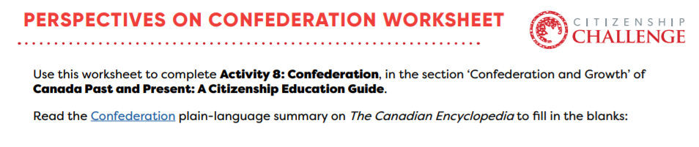
A. Leaders wanted Canada to become a country for many reasons. One main reason was: _________________________ .
B. The three men who led the Province of Canada into Confederation were: _________________________, and _________________________.
C. Canada became a country in the year _________________________.
D. The four provinces that made up the Dominion of Canada were _________________________, _________________________, _________________________, and _________________________.
E. _________________________ was Canada’s first Prime Minister.
F. Canada would have one _________________________ government and share power with each _________________________ government.
G. To grow Canada’s economy and have a larger territory, the new Government of Canada built a _________________________ across the country.

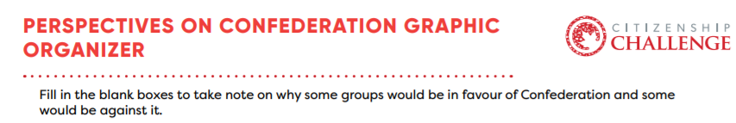
Reasons in favour of Confederation  (What were some reasons people wanted Confederation?) | Reasons against Confederation (What were some reasons people didn’t want Confederation?) | Outcome(s) in 1867  (What happened in regards to these reasons after Confederation? Was there compromise on some issues?)
To protect British North American from becoming part of the United States |  | Even though there were a few advocates of joining the United States, at Confederation, Canada became its own country and not part of the US
 | Some groups believed Confederation would take power away from the provinces and give it to the federal government | Power was distributed between the federal government and provincial governments, and the federal government committed to giving each region an equal voice

