Cases: Sexual Assault
Essentially, sexual assault is any kind of assault that is sexual in nature. While exploring the websites below, make notes defining sexual assault in all its forms and make notes on the role of consent as well as the specific limitations on using past sexual behaviour as evidence.
Review the pamphlet titled, "No Means No: Understanding Consent to Sexual Activity". It provides a good explanation of sexual assault and the role of consent as it applies to adults. Read through it carefully.
No Means No: Understanding Consent to Sexual Activity - http://www.legal-info-legale.nb.ca/en/no_means_no

Some aspects of sexual assault against children are treated in another document on the PLEIS NB site. Look under "Family Violence" for the pamphlet on child abuse (http://www.legal-info-legale.nb.ca/en/child_abuse_recognize_report_prevent)
Next, read the full text of the Criminal Code of Canada provisions on sexual assault. As you read, note in particular the provisions on consent, or lack of it, and the inadmissibility of evidence of previous sexual activity. Before these provisions, a victim's sex life could become the focus of the trial instead of the particular incident in question!

Cases: Homicide
Homicide is a general term referring to the killing of a human being. Culpability refers to blame. Non-culpable homicide is an accident or self-defence, and no blame is attached. Culpable homicide is murder, manslaughter or infanticide. Blame is definitely attached, and those who are blamed are punished.
Review what the Criminal Code says on homicide. Make notes identifying the different types of culpable homicide, their mens rea and actus reus and any special provisions of the law on each.
Next, examine the following case. Open a new Word document or grab a notebook and answer the questions provided. Once you have thought carefully and recorded your answer, review the "Expert Opinion" below the questions to read an instructor's analysis of the case. Compare it to your answers and update them as needed to make accurate study notes you can use later.

Homicide Case #1
Keith and Andrew grew up together. As teenagers, they grew apart, argued, fought, and competed for friends and attention. As adults working in the same company, they competed for promotions and sabotaged each other. Neither one could stand the other.
Andrew grew obsessed with the thought of eliminating Keith, whom he saw as the cause of all his problems. He plotted and planned and finally acted. One night at a local club, Andrew picked a fight with Keith. Unknown to Keith, Andrew had a knife with him. During the fight, Andrew repeatedly stabbed Keith. The bouncers broke up the fight and Keith was rushed to hospital.
Keith did not die right away. Prompt medical attention kept him alive for six months before he died as a result of the wounds. Andrew, originally charged with assault with a weapon causing bodily harm, was now charged with murder.
- List the key facts.
- Review the relevant law.
- Argue the prosecution.
- Is Andrew guilty of first degree murder? Why or why not?
- If the hospital hadn't taken good care of Keith and he died of massive infections because the wounds were not properly cleaned, would it affect the verdict? Explain.
- Expert Opinion
- 1. The facts relevant to the murder charge are:
  - Andrew "plotted and planned" to get rid of Keith.
  - Andrew picked a fight with Keith.
  - Andrew stabbed Keith repeatedly with a knife.
  - Keith was rushed to hospital but died six months later as a result of the wounds.

- 2. The law on murder indicates planned and premeditated homicide is first degree murder. As the facts indicate, this was planned and premeditated; this is the only portion of the law which is relevant. To prove this type of murder, evidence of premeditation must be introduced to show the required mens rea and it must be shown that someone was killed as a result of the actions of the accused, to prove the actus reus took place. The penalty for first degree murder is life in prison with parole possible after 25 years.

- 3. Andrew had a long history of conflict with Keith, which speaks to motive. However, the key here is that he had the mens rea as shown by his plotting and planning. The premeditation and advance planning is confirmed by the actions of bringing a knife then picking a fight with Keith so that he could use the knife. The fact Andrew did use the knife is not in doubt. The fight took place in a public place and was witnessed, specifically by the two bouncers who broke the fight up. They can testify to the actus reus. On the issue of causality, it is stated that Keith died as a result of the stab wounds. Six days or six months is irrelevant. Andrew acted and the result was that Keith died. He should be found guilty of first degree murder.

- 4. He is guilty. There is clearly mens rea. Planning, as shown by bringing the knife, indicates advance preparation so this was no spur of the moment act. The actus reus, killing Keith by stabbing him, took place in public in front of witnesses and was specifically seen by the bouncers. Causality is established by the fact that, despite dying six months later, Keith died as a result of the stab wounds inflicted by Andrew.

- 5. It would affect the verdict. If the cause of death was not the stab wounds but an infection caused by the hospital's carelessness then there was an intervening act, which broke the chain of causation. Keith would not have died as a direct result of Andrew's action in stabbing him but because of the hospitals carelessness in rendering medical treatment. Keith would be guilty of assault with a weapon causing bodily harm but not of murder because the actus reus of murder would be missing. He would not have killed anyone.

Cases: Homicide (Continued)
MODULE 2: CRIMINAL LAW

Homicide Case #2
Now, examine the following real-life situation, based on case summaries and judgments as stated in R. v. Latimer, [2001] 1 S.C.R. 3. https://www.canlii.org/en/ca/scc/doc/2001/2001scc1/2001scc1.html Open a new Word document or grab a notebook and answer the questions provided. Once you have thought carefully and recorded your answer, review the "Expert Opinion" below to read an instructor's analysis of the case. Compare it to your answers and update them as needed.
The accused, Robert Latimer, was charged with first degree murder following the death of his 12-year-old daughter, "T." She had cerebral palsy, was quadriplegic and her physical condition rendered her immobile. She was said to have the mental capacity of a four-month-old baby and could communicate only by means of facial expressions, laughter and crying.
T. was completely dependent on others. She suffered five to six seizures daily and was thought to experience a great deal of pain. She was spoon-fed, and her lack of nutrients caused weight loss. T. could have been fed with a feeding tube into her stomach, and option that would have improved her nutrition and health, and that might also have allowed for more effective pain medication to be administered. The accused and his wife rejected this option. When doctors recommended additional surgery, which he perceived as mutilation, the accused decided to take his daughter's life. He seated T. in the cab of his pick-up truck and inserted a hose from the truck's exhaust pipe into the cab. T. died from carbon monoxide poisoning.
The accused at first maintained that T had passed away in her sleep, but later confessed to having taken her life. The accused was found guilty of second degree murder and sentenced to life imprisonment without parole eligibility for 10 years; the Saskatchewan Court of Appeal upheld the conviction and sentence of the accused, but the Supreme Court of Canada ordered a new trial. In the second trial, the accused was again found guilty of second degree murder but the jury, despite the ten-year minimum in the law, recommended he be eligible for parole in one year. The trial judge granted a constitutional exemption from the mandatory minimum sentence and imposed a sentence of one year of imprisonment and one year on probation. The Court of Appeal upheld the conviction but reversed the sentence, imposing the mandatory minimum sentence of life imprisonment without parole eligibility for ten years. On appeal, the Supreme Court of Canada upheld the conviction and the ten-year sentence.
- List the key facts.
- Sometimes this type of occurrence is called euthanasia. There is no separate section of the Criminal Code specifically for euthanasia. It is currently treated as murder. Review the law on second degree murder.
- Why was Latimer found guilty of second degree murder and not first degree murder?
- Why did the jury in the second trial recommend he only serve one year? Why did the judge grant a constitutional amendment to impose this sentence?
- Why do you think the judgment was reversed on appeal?
- Expert Opinion
- 1.The key facts in this case are numerous because of the appeals and second trial and appeals process. They include:
  - Twelve-year-old T. was completely dependent. She had cerebral palsy, was quadriplegic and immobile, had the mental capacity of a four-month-old, was subject to frequent seizures, had to be spoon-fed, was poorly nourished and could communicate only by facial expressions, laughter and crying. T. was believed to be in a great deal of pain.
  - A feeding tube would have improved her nutrition and might have allowed better control of her pain.
  - T's parents rejected the option of a feeding tube.
  - Doctors wished to perform more surgery on T.
  - The accused regarded the proposal as mutilation.
  - The accused placed his daughter in the cab of his truck, inserted a hose from the exhaust and allowed her to die of carbon monoxide poisoning.
  - The accused first tried to say T had died in her sleep.
  - The accused later confessed.
  - The accused was found guilty and sentenced to life without parole eligibility for ten years.
  - The Saskatchewan Court of Appeal upheld the conviction and sentence.
  - The Supreme Court ordered a new trial
  - The second trial resulted in a guilty verdict but a sentence less than the minimum required by the law on second degree murder.
  - The Court of Appeal changed the sentence to meet the prescribed minimum.
  - The Supreme Court upheld the Court of Appeal.
- 2. Second degree murder is all murder that is neither first degree nor manslaughter. While ending the life of an individual in circumstances like this is often referred to as euthanasia, it is legally murder.

- 3. It is not first degree because there was no evidence of long-term advance planning and premeditation. No peace officer was killed and the death was not part of one of the crimes specified in the description of first degree murder. It was not manslaughter because there was no provocation or sudden loss of control. Yet it is still culpable homicide as a person was illegally deprived of her life. Consequently, Latimer was found guilty of second degree murder.

- 4. Without knowing each juror's private thoughts, one can only assume that they made this recommendation because they had sympathy for the pain Latimer suffered watching his daughter and because they felt these were unique circumstances that would not be repeated. In other words, they felt Latimer posed no threat to the community and would not repeat this offence. Punishment was in order but not to the extent prescribed by law. Advocates for the disabled took great offence at this attitude. They asked what right Latimer had to play God and take his daughter's life. His daughter had not asked to die. If this were allowed to go unpunished, a message would be sent that would endanger the life of every disabled person in the country.

- 5. The law clearly calls for a life sentence with no possibility of parole for ten years for second degree murder. The Appeals Court and the Supreme Court did not agree with the second trial judge that there were grounds for a constitutional exemption to the law and imposed the sentence required by law for the most serious crime in our Criminal Code: murder.

Discussion
The Latimer case that you considered in this lesson is a very controversial one. There is a moral as much as a legal issue at its heart. Is euthanasia acceptable in circumstances like Latimer's? Briefly state your opinion of the decision in the Latimer case and on the issue of euthanasia. Be sure to back up your opinion with reasons.
**Note: this content is all take from the Virtual Learning Course where students have an opportunity to ‘discuss’ topics with one another. You do not have that same advantage in this setting so you will only be assessed on the completeness of YOUR explanation/opinion/insight

Assignment: Impairment Case Study
Law 120 – Assignment
The accused, Richards, was charged with driving a motor vehicle while impaired by alcohol. Richards was out drinking with her fellow workers and was expected home at 8 p.m. When she had not returned by midnight, her husband went looking for her. He found her parked in a strange car with a man. He jumped on the car hood and smashed the window with his fist. He pulled the man out of the car and began fighting with him. In extreme fright, Richards started to drive the car to escape from her husband. He then chased her in his car and rammed her vehicle several times. The accused saw a police constable, stopped the car and ran towards him. She testified that she had not intended to drive but had to in order to escape being beaten. A subsequent breathalyser test showed Richards had a reading of .09. The court observed that the husband was 193 cm (6'4") tall, weighed 98 kg (215 pounds) and was very athletic. In contrast, his wife was a woman of slight build.
Use the guidelines listed below to analyse the case.
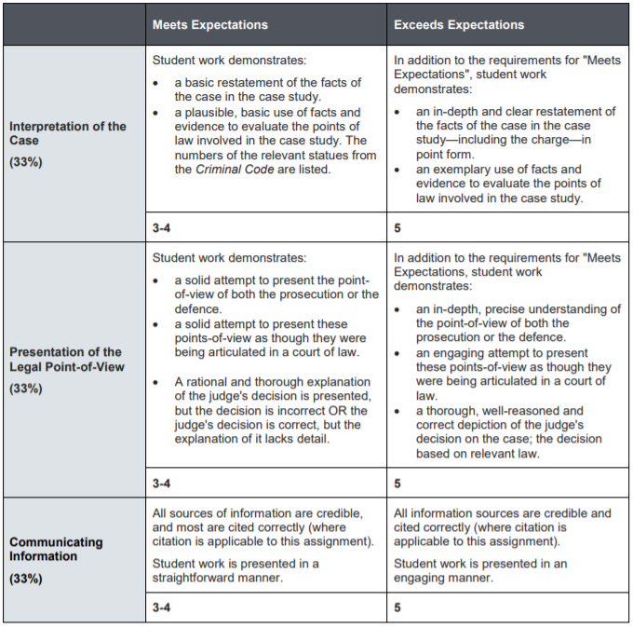
1. List the facts of the case in point form.
2. Explain the points of law relevant to both the defence and the prosecution. Refer to the Criminal Code as needed.
3. Argue the prosecution, attempting to prove guilt beyond a reasonable doubt. Argue as though you are the Crown prosecutor, speaking in court.
4. Argue the defence, demonstrating reasonable doubt, presenting a reasonable defence, or arguing a lesser charge. Write this as though you are the defence lawyer speaking in court. Hint: Consider arguing one of the standard defences you learned about in the course.
5. Render judgment stating your supporting reasons for accepting one argument over the other. Write this as though you are the judge in the trial.

