9. GOVERNMENT
ACTIVITY 17: HOW CANADA’S GOVERNMENT WORKS
This activity uses the How Canada’s Government Works Worksheet, available at the end of this document.
Systems of government can be very different from one another depending on what country you are in. Canada’s system of government is many things: it’s a federation, a constitutional monarchy, and a parliamentary democracy. In this section, you will learn about what these terms mean and how Canada’s system of government works.
- On your own, read the How Canada’s Government Works Worksheet (see below). Make note of any new vocabulary and write down definitions for these new words.
- Answer the comprehension questions on the worksheet by circling the correct answer.
- Email the answers to Mr. Johnston for correction.

ACTIVITY 18: FORMING PARLIAMENT
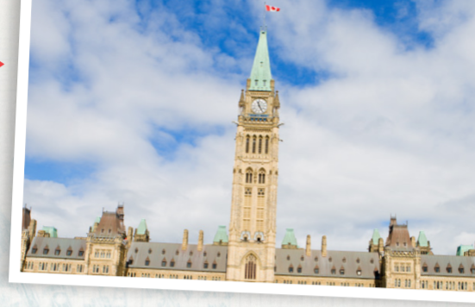
- You will need to have done the reading How Canada’s Government Looks before doing this activity. Look at the mock provincial election results below and answer the following questions for each election:
• Who has the constitutional right to form the next government?
• Which party’s leader will be premier?
• Is it a majority or minority government?
- In elections 2 and 3, which party holds more power? Explain why the Arctic Hare Party and the Tundra Party have great influence even though they do not have many seats. Hint: Think about how minority governments work.
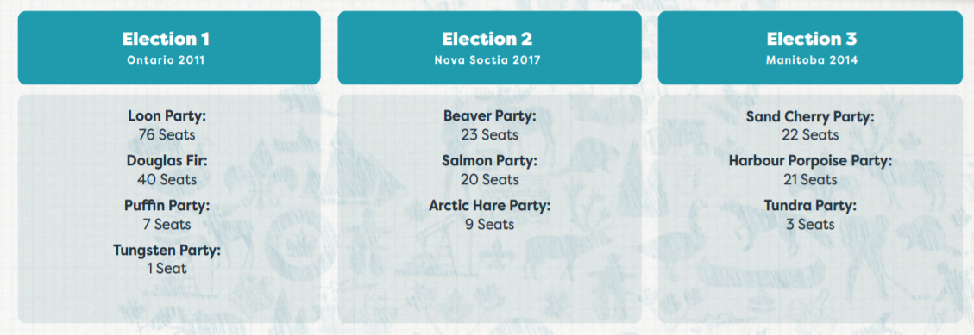
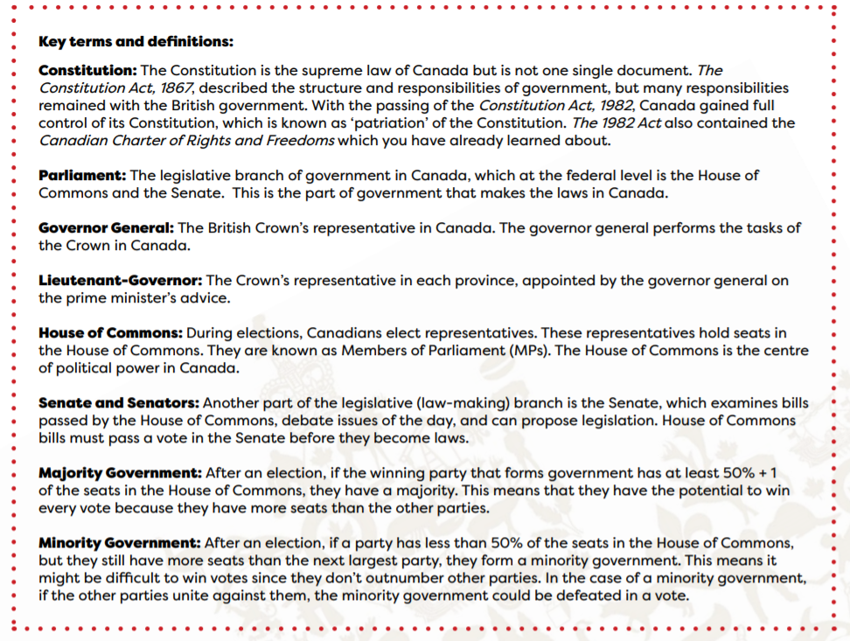
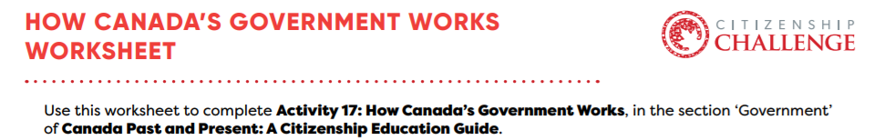

Canada is a parliamentary democracy, which means that Canadians elect the politicians who will represent them in parliament (government) and make laws and decisions on their behalf.
Canadians elect parliaments in every federal election, and assemblies every provincial election, as well as in the Yukon territory. During elections, Canadians vote for a candidate from their area that they want to represent them in parliament, called Members of Parliament, or MPs, who represent the people of their district, or riding. A riding is also known as a constituency. Nunavut and the Northwest Territories have what are called Consensus Governments, which means that Members of the Legislative Assembly are elected as independents and aren’t affiliated with parties.
At the federal level, parliamentary representatives sit in the House of Commons. The representatives often belong to political parties, which are organizations that have different policies and visions.
The party that has the most seats in Parliament forms the government. The leader of the party that forms the government becomes the prime minister in a federal election, or the premier in a provincial election. The other parties are known as ‘opposition parties’ and they review and improve laws as well as hold the government accountable.
The party that has the most seats in Parliament forms the government. The leader of the party that forms the government becomes the prime minister in a federal election, or the premier in a provincial election. The other parties are known as ‘opposition parties’ and they review and improve laws as well as hold the government accountable.
Canada’s system of government is also a federation, which means it has three levels with different responsibilities: the municipal (local) level deals with things directly relating to the community of a city or town; the provincial or territorial level deals with things relating to the province or territory; and the federal government deals with issues that relate to the whole country. (To learn more about the responsibilities of the orders of government, visit the Ontario Legislative Assembly website to play the Levels of Government Game.)
Some Indigenous communities have the right to self-government which means they control some of their own affairs such as education, health, and lands.
There are also 3 branches of government in Canada, meaning there are 3 sections of federal government that do different things.
- The legislative branch, called Parliament, makes laws. It is made up of the Queen (represented by the Governor General), the Senate, and the House of Commons. (In the provinces and territories, this is the Lieutenant-Governor or Commissioner and the legislative assemblies.)

- The executive branch is the decision-making branch that includes the Queen (represented by the Governor General), the Prime Minister, and the Cabinet Ministers. The Cabinet Ministers are MPs that the Prime Minister chooses to be in charge of a part of government (like the Minister of National Defence, Minister of Environment, etc.). This branch runs the government, makes policies, and implements laws created by the legislative branch.

- The judicial branch interprets and applies laws. This is the federal court system, and the court system of the provinces and territories. This branch ensures that the ‘rule of law’ is followed, which means that the law applies equally to everyone. (This is often represented by the scales of justice, which symbolize fairness in the judicial process.)

Comprehension questions
Circle the correct answer to each question or statement.
1. Canada has 3 orders (levels) of government that share power and responsibility. Which of the following is NOT an order of government?
a) Islander b) Provincial/Territorial c) Federal

2. The federal order of government deals with things that affect the whole country. Which of these is NOT a federal responsibility?
a) International trade b) National defence c) Garbage collection

3. The provincial/territorial order of government deals with things that affect their region. Which of these is NOT a provincial/territorial responsibility?
a) Education b) Healthcare c) Currency

4. The municipal order of government deals with community issues. Which of the following is NOT a municipal responsibility?
a) Libraries b) National parks c) Fire services

5. Indigenous governments are responsible for Indigenous communities that control their own affairs. This is called:
a) Shared responsibilities b) Restorative politics c) Self-government

6. Canada’s Head of State is:
a) British Monarch (Queen/King) b) the Senators c) the Prime Minister

7. Canada’s Head of Government is the:
a) Lieutenant-Governor b) Monarch c) Prime Minister

8. Political parties are:
a) Organizations that have different policies and visions b) Celebrations held after elections c) Groups that negotiate better wages and conditions with employers

9. Members of Parliament are chosen by:
a) the Monarch b) Canadians during elections c) the Prime Minister

10. Senators are chosen by:
a) the Monarch b) Canadians during elections c) the Prime Minister

11. Which branch of government is the Supreme Court of Canada a part of?
a) Legislative b) Judicial c) Executive

