10. RESPONSIBILITIES OF CITIZENSHIP
ACTIVITY 19: ACTIVE CITIZENSHIP
This activity uses the Active Citizenship Worksheet, available at the end of this document.
What are some ways that you can participate in Canada’s democracy? In Canada, civic engagement is more than just voting. There are many ways people living in Canada can take part in the democratic process. This is called being an active citizen and it is an important part of Canada’s democracy.
It is important to know that people who are not citizens have some of the same responsibilities as citizens. For example, people living in Canada who are not citizens can take important steps to help protect Canada’s natural environment.
- Some responsibilities of Canadian citizenship, such as paying taxes and filling out the census, are tasks that must be completed in a certain way. Others, like protecting the environment, can be done in many ways. What can you do to fulfill those responsibilities of citizenship? Use the Active Citizenship Worksheet to write down your ideas. You can consult the plain-language summary on Active Citizenship (https://www.thecanadianencyclopedia.ca/en/article/active-citizenship-plain-language-summary)on The Canadian Encyclopedia for ideas.

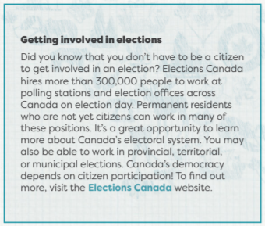
- If you are completing this activity in a classroom, discuss the meaning of active citizenship in a small group or class discussion. What does it mean to be an active citizen? What are some responsibilities of being a citizen in Canada? Next, work in pairs to complete the Active Citizenship Worksheet.

- You can become a more active citizen by having a positive impact on your community and Canada. Write a list of 5 to 10 things you can do to be more active in your community and in Canada. If you are completing this activity in a classroom, discuss as a class how someone can be a more active citizen.

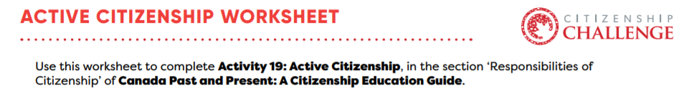
Responsibilities of citizenship | What can I do to fulfill this responsibility?
Protecting the environment | -I can recycle my plastics and papers
Volunteering in your community

Joining political parties and other organizations

Truth and Reconciliation with Indigenous Peoples

