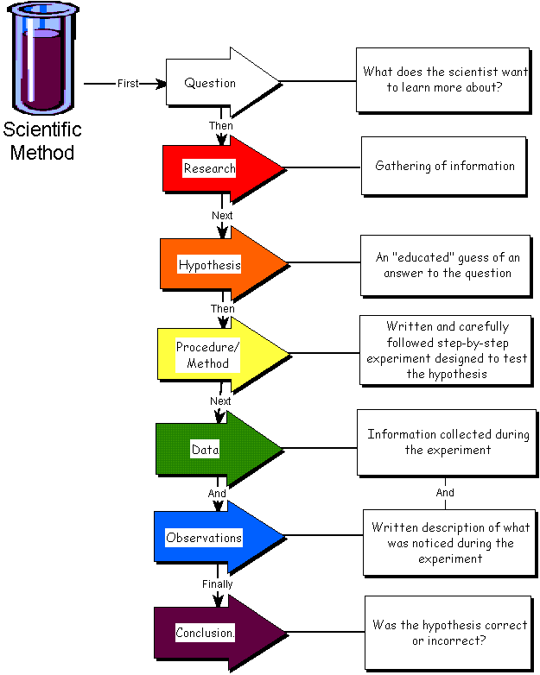

What are your variables, what did you change and what remained the same each time?

Dear Parents,

The Anglophone North School District STEM FEST is fast approaching. If your child is interested in participating in the STEM FEST this year, he/she may do so.  Participation is **optional**. Students may work on projects at home and templates (Scientific Method) will be provided for those who choose to participate. Students may also work with a friend or partner. The project will be shared in class and displayed for other classes in our school.

  If your child is doing a Science Project for the STEM FEST, he/she can bring the completed project to school Thursday, March 12th so they can be presented and displayed.

The district STEM FEST will be held Saturday March 21st at James M. Hill School. Participation is limited to 8 projects (grades 3-5) per school.

Please see the enclosed templates for scientific method which must be used in STEM FEST projects.

Mlle Duffy



**MakerSpace**

Any grade 3 - 5 students that are interested in working on a project idea in the **MakerSpace** after school on Tuesday's must submit an application through the *BHS ICE Centre* website

Students will be accepted depending on their project idea in a particular technology.  If there are too many students interested in one technology, some students will be asked to apply another week.  Students must have an idea to be accepted and all students must have a drive arranged for pickup at 4pm.

<https://www.bhsice.com/elementary-gr-3-5-maker-club.html>

Class List

(22 Students)

Kailyn

Samual

Addison

Karlie

Chloe

Brandee

Dixon

Allie

Chase

Erin

Thomas

Sophie

Ellie

Cohen

Ali

Garland

JP

Leah

Riley

Brenden

Ava

Keenan



Gym

Each Tuesday, Thursday and Friday 4/5D has gym. Please be sure to send gym clothes on these days as students are required to change for class.

Upcoming Dates:

February 14th: Pancake Breakfast

February 17th: Family Day (no school)

February 26th: Pink Shirt Day

March 2nd to 6th: March Break