Name ___________________________________________ Date ___________________

World War I Weapons
During World War I, a variety of weapons were used.
Rifle
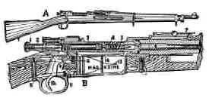
The main weapon used by British soldiers in the trenches was the bolt-action rifle. 15 rounds could be fired in a minute and a person 1,400 meters away could be killed.
Machine Gun
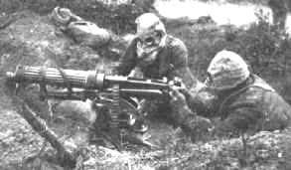
Machine guns needed 4-6 men to work them and had to be on a flat surface. They had the fire-power of 100 guns.
Large field guns had a long range and could deliver devastating blows to the enemy but needed up to 12 men to work them. They fired shells which exploded on impact.

Gas
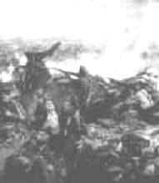
The German army was the first to use chlorine gas at the battle of Ypres in 1915. Chlorine gas causes a burning sensation in the throat and chest pains. Death is painful - you suffocate! The problem with chlorine gas is that the weather must be right. If the wind is in the wrong direction it could end up killing your own troops rather than the enemy.
Mustard gas was the most deadly weapon used. It was fired into the trenches in shells. It is colorless and takes 12 hours to take effect. Effects include: blistering skin, vomiting, sore eyes, internal and external bleeding. Death can take up to 5 weeks.

Zeppelin
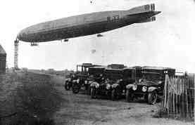
The Zeppelin, also known as blimp, was an airship that was used during the early part of the war in bombing raids by the Germans. They carried machine guns and bombs. However, they were abandoned because they were easy to shoot out of the sky.

Tank
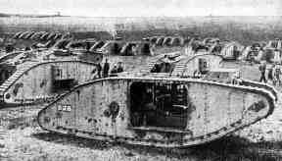
Tanks were used for the first time in the First World War at the Battle of the Somme. They were developed to cope with the conditions on the Western Front. The first tank was called 'Little Willie' and needed a crew of 3. Its maximum speed was 3mph and it could not cross trenches.
The more modern tank was not developed until just before the end of the war. It could carry 10 men, had a revolving turret and could reach 4mph.

Planes
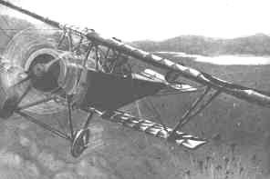
Planes were also used for the first time. At first they were used to deliver bombs and for spying work but became fighter aircraft armed with machine guns, bombs and some times cannons. Fights between two planes in the sky became known as 'dogfights'

Torpedoes
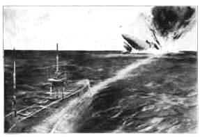
Torpedoes were used by submarines. The Germans used torpedoes to blow up ships carrying supplies from America to Britain.
The Germans torpedoed the passenger liner Lusitania on May 1st 1915 which sank with a loss of 1,195 lives. Americans were outraged and joined the war in 1917 on the side of the allies.

World War One – Weapons - Crossword
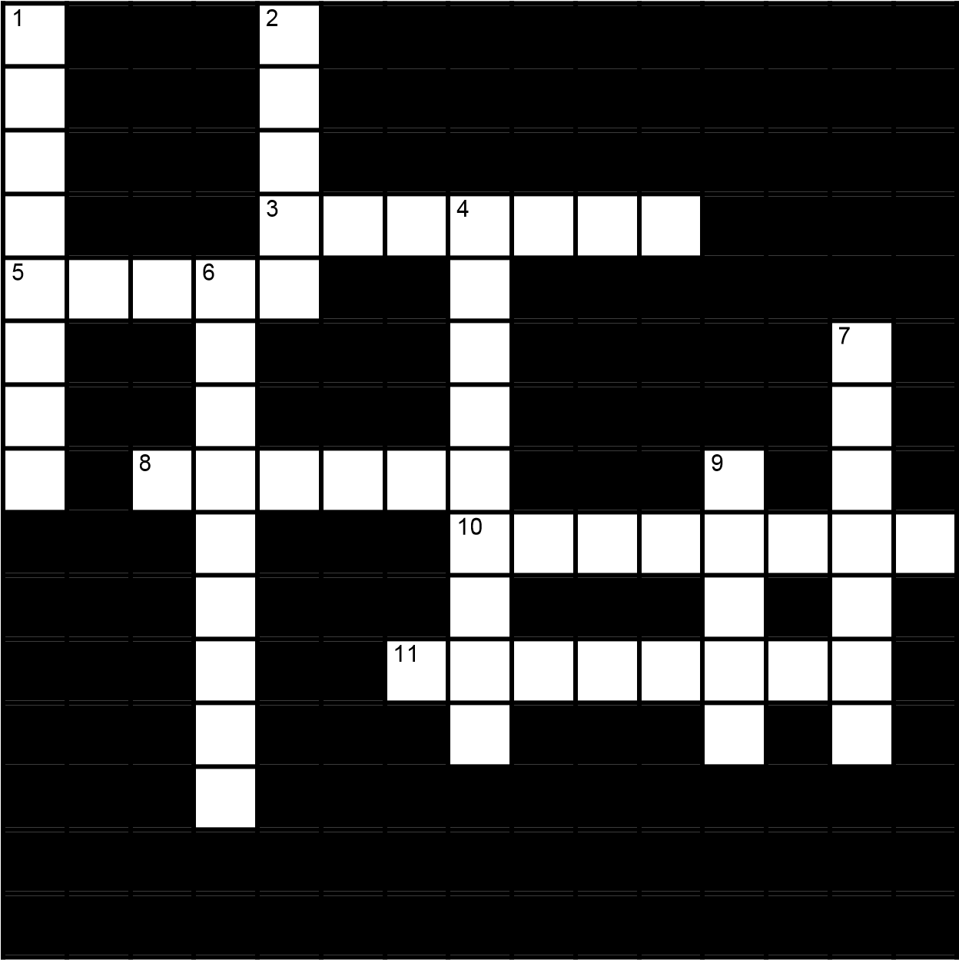 | Across  3 This colorless gas is deadly (7)  5 Used by all soldiers in World War One  (5)  8 Name of the first tank little ______ (6)  - A fight between two planes (8)  - Also known as Blimp (8)  Down  - This gas was first used at Ypres in 1915  (8)  - Tanks were first used at this battle (5)  4 These weapons were used by submarines  (9)  - This American liner was blown up (9)  - This gun needed 4 - 6 men to work it (7)  9 This type of gun fired shells (5)

Opinion Question
Which of these weapons do you think had the greatest impact on World War I? Why?

