Student Activity Sheet: The New Mosaic
Answer the following questions using “The New Mosaic” section of The Canadian Atlas Online at http://www.canadiangeographic.com/atlas/themes.aspx?id=settling&sub=settling_basics_mosaic&lang=En
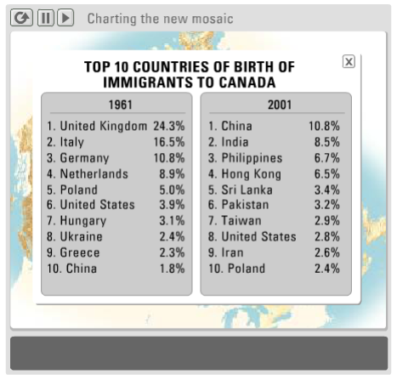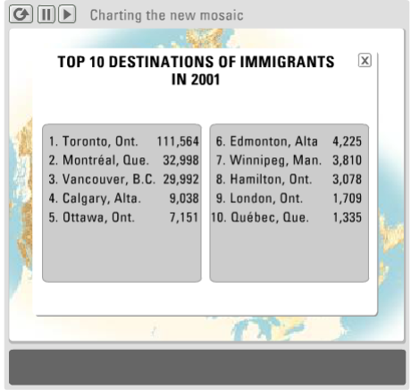

1. From the table “Top 10 Countries of Birth in Canada”, list the 3 countries that appear on both the 1961 and 2001 lists. (chart on the left above)
a) ___________________________________________________________________
b) ___________________________________________________________________
c) ___________________________________________________________________
2. Give one reason that those countries have stayed on the list for 40 years. (this is an inference; answer comes you’re your head…need to think about it)
______________________________________________________________________ ______________________________________________________________________
3. What is the main consequence of changing immigration patterns from the 1960’s to today? (again, an inference question; but you’ll get an idea of the answer in the first paragraph of the link at the start of this assignment) ______________________________________________________________________ ______________________________________________________________________ ______________________________________________________________________

4. Which three provinces receive the most immigrants? (use chart on the right above)
a) ___________________________________________________________________
b) ___________________________________________________________________
c) ___________________________________________________________________
5. Provide two reasons for immigrants choosing to go to those provinces. (inference question; think about what these provinces have to offer…sometimes the simplest answer is the correct one)
______________________________________________________________________ ______________________________________________________________________ ______________________________________________________________________ ______________________________________________________________________
6. Name three Push/Pull factors behind inter-provincial migration. (the thoughts for this might come from your own head, or the subheading “Interprovincial Migration” provided here http://www.canadiangeographic.com/atlas/themes.aspx?id=settling&sub=settling_basics_migration&lang=En)
a) ___________________________________________________________________
b) ___________________________________________________________________
c) ___________________________________________________________________

7. Look at the table “Top ten destinations of immigrants in 2001” and then look at the atlas section entitled “Where we live”( http://www.canadiangeographic.com/atlas/themes.aspx?id=where&lang=En). Can you find two reasons why immigrants to Canada want to live in cities?
______________________________________________________________________ ______________________________________________________________________ ______________________________________________________________________ ______________________________________________________________________
8. If you were a new immigrant to Canada, where would you want to live? Why? ______________________________________________________________________ ______________________________________________________________________ ______________________________________________________________________

