Federal and Provincial Courts
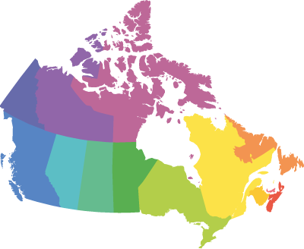
There are various types of courts in the Canadian court system, and each court has a different role to play in the judicial process. For instance, if a person is charged for stealing a CD player and goes to court, that person will begin their trial at the Provincial Court Trial Division. If there are grounds for an appeal, the case may go to the next level: The Provincial Superior Court or the Provincial Court of Appeal. In some cases, such as Darrell Gray's, it may even go to the Supreme Court of Canada.
On the following three screens, you will be provided with a general breakdown of the court system in New Brunswick.

Provincial Courts

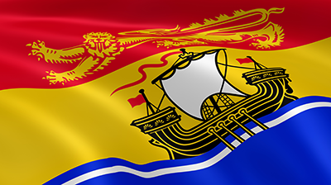
The Province has the responsibility for the constitution, maintenance and administration of all levels of courts in New Brunswick: the Court of Appeal; the Court of Queen's Bench, trial division and Family Division; the Probate Court and the Provincial Court of New Brunswick. The Court of Appeal is located in Fredericton. The Court of Queen's Bench has offices in eight judicial districts while the Probate Court has nine offices in the eight judicial districts. The Provincial Court has 14 permanent offices. Both the Court of Queen's Bench and the Provincial Court also hear matters at satellite locations.
- Court of Appeal: The Court of Appeal of New Brunswick is the highest-level court in the province. It consists of the Chief Justice and five other justices. This court sits permanently in Fredericton, but it may sit elsewhere at the discretion of the Chief Justice. As in the criminal courts, appeals can be heard at the Court of Appeal by a panel of three or more judges.

- Court of Queen’s Bench: The Court of Queen's Bench is New Brunswick's superior court. It deals with more serious crimes. The Court of Queen's Bench of New Brunswick consists of two divisions: the Trial Division and the Family Division. The Court of Queen's Bench has jurisdiction for both civil and criminal cases arising in the Province, except for those matters that are expressly excluded by statute (laws). The Court of Queen's Bench, Trial Division, exercises jurisdiction over indictable offences tried by judge and jury or by judge alone, civil cases and certain appeals from Provincial Court. The Chief Justice of the Court of Queen's Bench and the other justices also sit as judges of the Probate Court. The Probate Court has jurisdiction and power to establish the legal validity of wills, to grant administration of the estates of deceased persons, to recall or revoke grants and to supervise the administration and distribution of estates. The Court of Queen's Bench, Family Division, is the court responsible for child protection, adoption, divorce, inter-spousal rights and obligations and parent/child rights and obligations.

In New Brunswick, the Court of Queen's Bench is also called the Provincial Superior Court. Claims for amounts exceeding $20,000 (in New Brunswick) are heard at the Provincial Superior Court. These courts require the presence of lawyers, as the cases may be rather complex. Judges can try cases alone or with a jury; however, cases tried by judge and jury are not too common. When tried by a jury, the jury has only six members and the case is decided by majority vote, in contrast to criminal matters with a jury of twelve people.

Provincial Court of New Brunswick: The Provincial Court is the main criminal court of first instance. It is the court before which a prosecution matter is first brought to trial for all summary convictions (less serious) and indictable (more serious) offences in the Province. For trial and disposition of cases, certain indictable offences may, or must, be heard by the Court of Queen's Bench as required by the Criminal Code of Canada, but all proceedings for offences, from municipal by-laws to murder, commence in Provincial Court. The Provincial Court has been designated as the Youth Court under the Young Offenders Act and deals with persons between the ages of 12 and 17 who have been charged with summary convictions and indictable offences.

- Small Claims Court is an inexpensive way for people to settle disputes, as lawyers are not needed. In New Brunswick, these courts will hear cases involving amounts of $20,000.00 or below. This claim limit will vary depending on the province.

Federal Courts

Federal Court of Canada
The trial division of the Federal Court of Canada hears cases involving disputes between the federal government and its employees or disputes on federal income tax, patents and copyright issues. The appeals division of the Federal Court of Canada hears appeals on these matters.

Supreme Court of Canada
The Supreme Court of Canada hears appeals of national significance arising from the Federal Court of Canada and Provincial Courts of Appeal.

Self Assessment
Top of Form

Check Your Understanding: Canadian Courts
Can you remember the role of each type of court in Canada's legal system?
This self-assessment will not be graded, but you must have a strong understanding of these concepts before continuing with the course. Be sure to read the feedback on your responses!

Question#1: A court case will heard at a specific court, depending on the issue at hand. Examine the following issues and match the court where the case will be heard by selecting its number.
_____a child custody dispute  _____a routine break and enter  _____an appeal of sentence by a Court of Queen’s Bench judge in NB  _____the last appeal of a conviction based on a claim of violated rights  _____the first time a case is heard by judge and jury  _____joyriding charge against a 15-year old | 1. NB Court of Appeal  2. Court of Queen's Bench (Family Division)  3. Provincial Court  4. Court of Queen's Bench (Trials Division)  5. Supreme Court of Canada

Question #2: These courts may also be known as the Court of Queen’s Bench. These courts require the presence of lawyers as the cases may be rather complex. Cases can be tried by judge alone or by judge and jury, which is not too common. The jury has only six members and the case is decided by majority vote. Choose the best option below.
- Provincial Supreme Court
- Supreme Court of Canada
- NB Court of Appeal
- Small Claims Court
Question #3: This court hears appeals that have national significance. It is the final court of appeal.
- Provincial Supreme Court
- Supreme Court of Canada
- NB Court of Appeal
- Federal Court of Canada

Question #4: The trial division of this court hears appeals involving disputes between the federal government and its employees or disputes on federal income tax, patents and copyright issues.
- Federal Court of Canada
- Provincial Supreme Court
- NB Court of Appeal
- Supreme Court of Canada
Question #5: In New Brunswick, these courts will hear cases involving an amount below $20,000. This claim limit will vary depending on the province.
- Supreme Court of Canada
- NB Court of Appeal
- Provincial Court of Appeal
- Small Claims Court
Question #6: As in the criminal courts, this court hears appeals by a panel of three or more judges.
- Federal Court of Canada
- NB Court of Appeal
- Provincial Supreme Court
- Supreme Court of Canada

Assignment: Canadian Courts

Law 120 – Assignment

To complete this assignment, you must:

- Correctly label the diagram of the structure for Canadian courts below. You can either create a numbered list or table to label your responses with the correct number or fill it in by hand and scan a hard copy of this chart. (4 points)
- Briefly describe the purpose of each type of court on the diagram, including a description of the types of cases it hears. (12 points)

o Note that Number 6 contains two divisions, which you must name and describe separately.

o In addition to your course notes, be sure to visit the Department of Justice's Canada's Court System website and the Government of New Brunswick's Courts website for more information.

- On a map of New Brunswick, correctly label where each of the eight judicial districts for the Court of Queen’s Bench are located. (4 points)

