Happy Easter Grade 7! Hope you enjoyed this Easter with your families

I am posting work for Tuesday – Friday this week. You can take a pic or send it any way that you wish. Thanks to those who are keeping up with your math skills!

This week we are reviewing fractions, decimals and percents. You will need a calculator for your work at times.

Mental Math
Tuesday
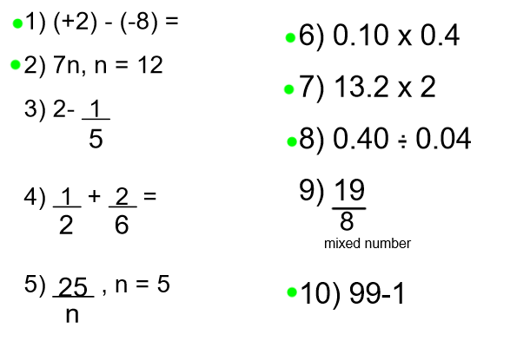

Wednesday
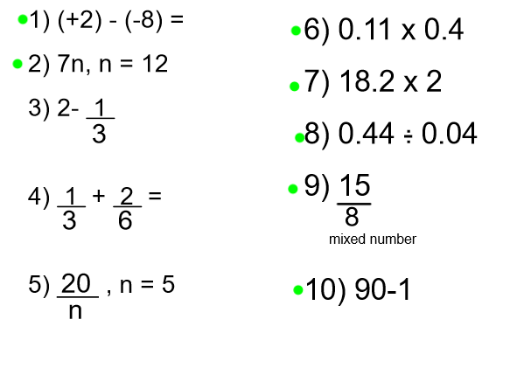
Thursday
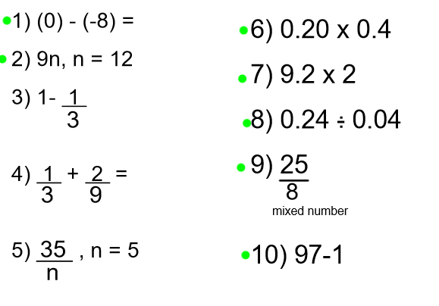

Friday
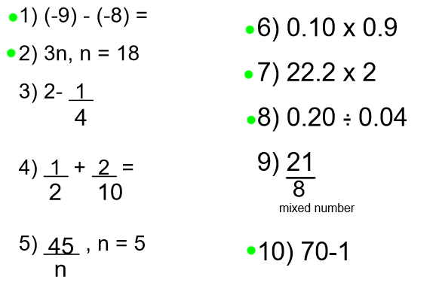

Weekly Work…
Watch the review video here:
http://files.pbslearningmedia.org/dlos/wnet/dlo5.html
Here are some activities to complete in this theme. Remember, complete a little or all
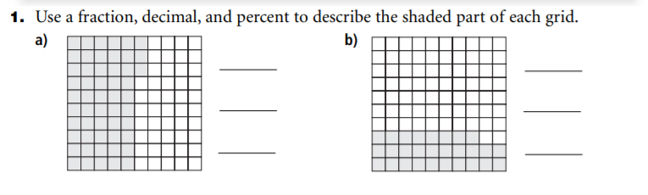

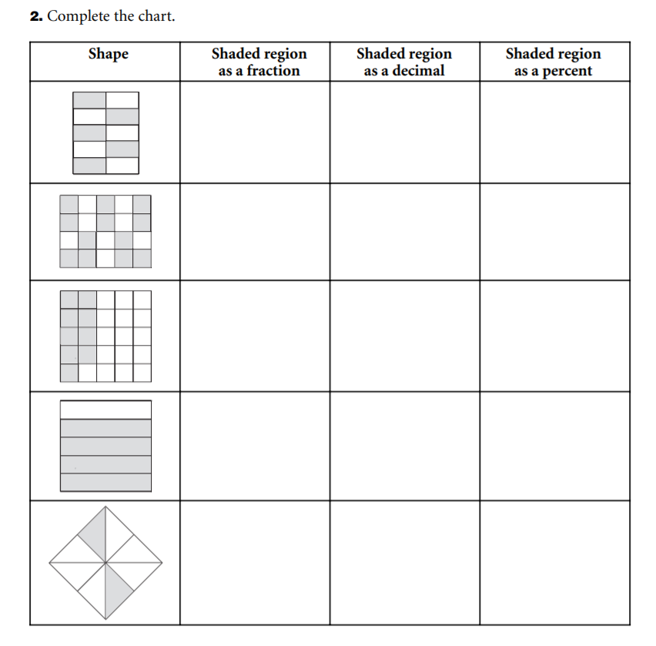

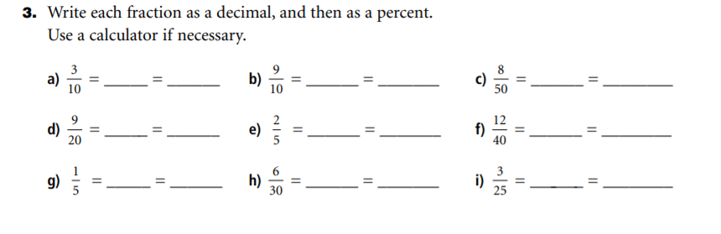
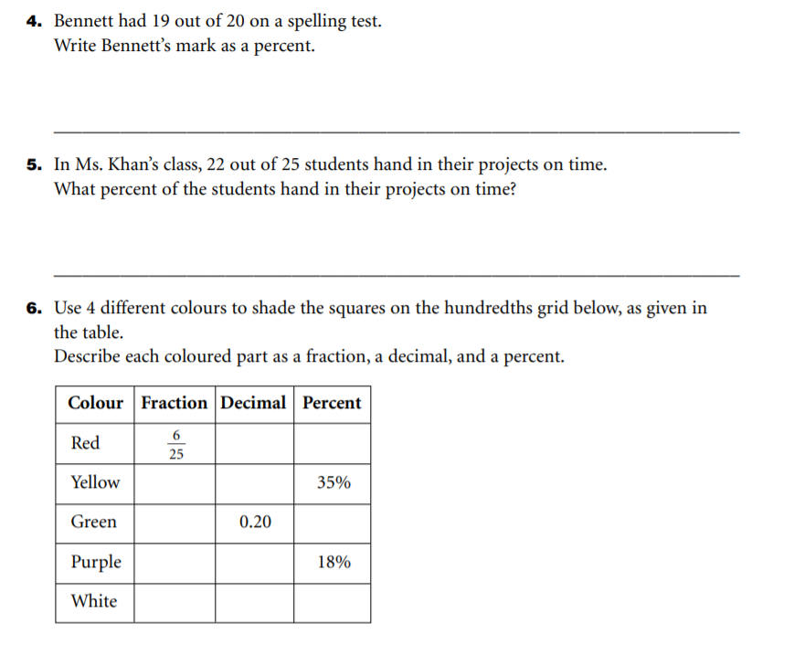
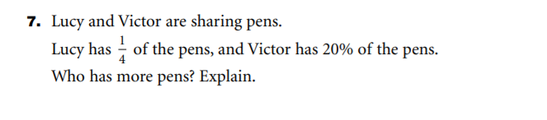
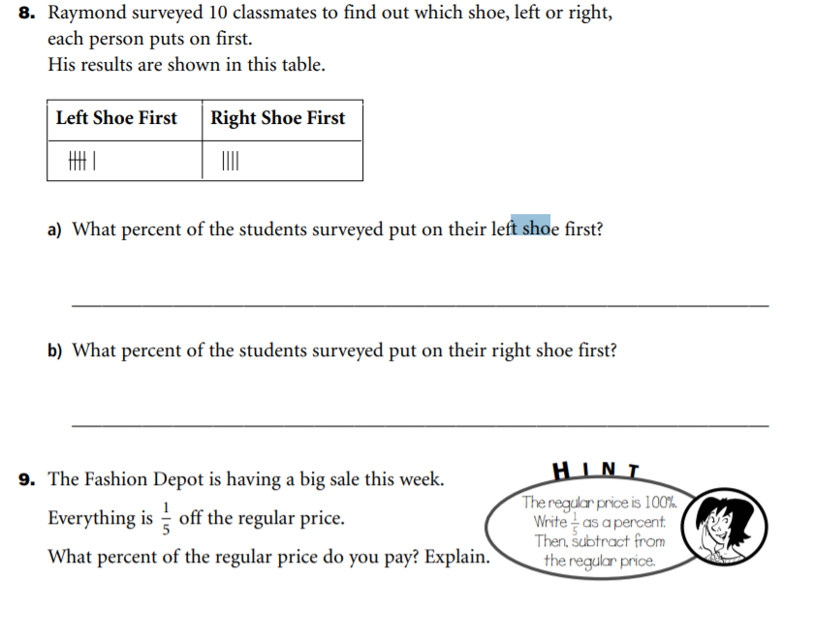
*If you want different work (challenging or easier, please email me and let me know!!!)
Have a good week!
Mrs. Moody

