April 26, 2020
Hello Grade 7!
I am going to keep moving today in our Math 7. For the students that followed along and completed the assigned work, thank you! If you are just visiting and going o try some Math- great We will still do our Mental Math, but we are going to move into “Parallelograms”. We will move slowly, so that you are able to remember vocabulary and the formula that you need for this outcome. *Please send me ANY questions about anything we are doing this week!
Monday – Intro to Parallelograms
Tuesday – Area formula practise
Wednesday – Area formula practise
Thursday – What if you have the Area and another dimension?
Friday – a “mini” assignment for review

*Remember, do what you are comfortable with. Do a little or it all, as long as you are doing something to keep your math skills fresh

Monday (mm)
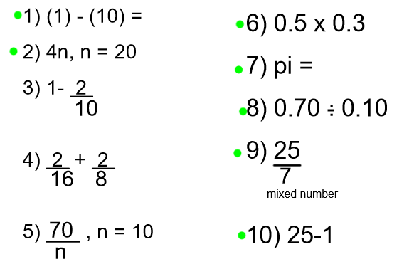

Tuesday (mm)
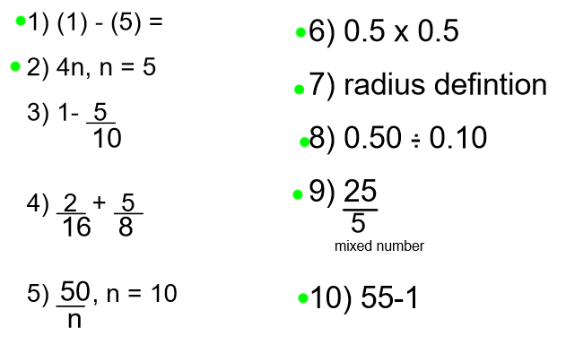
Wednesday (mm)
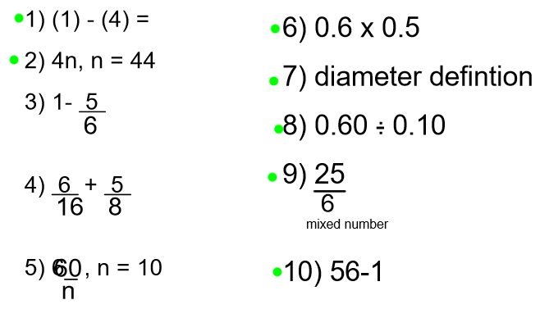

Thursday (mm)
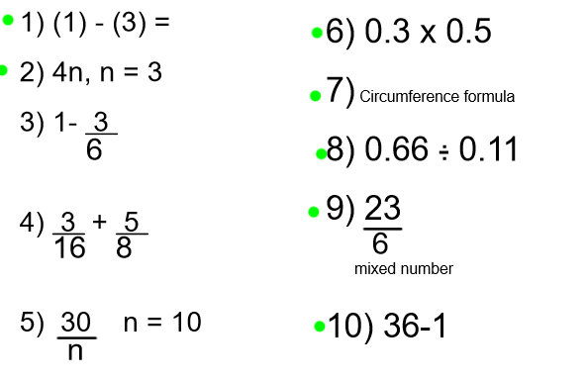

Friday (mm)
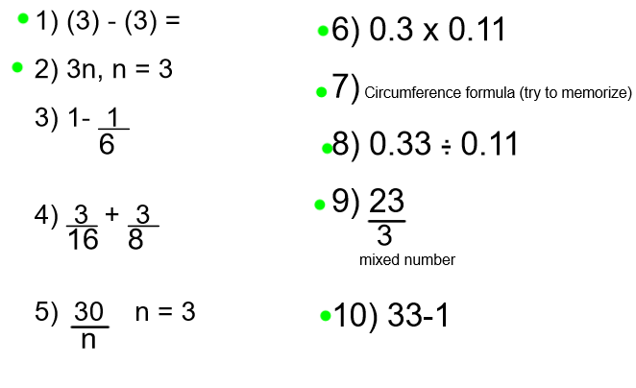

Monday – Finding the Area of Parallelograms

- Watch the following video:
https://m.youtube.com/watch?v=EcuzXwtamJc
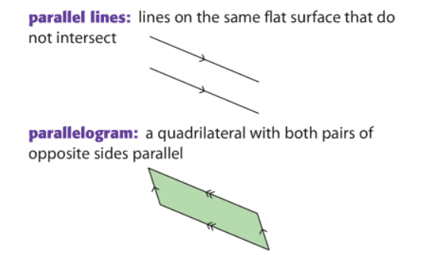

- Complete the following:

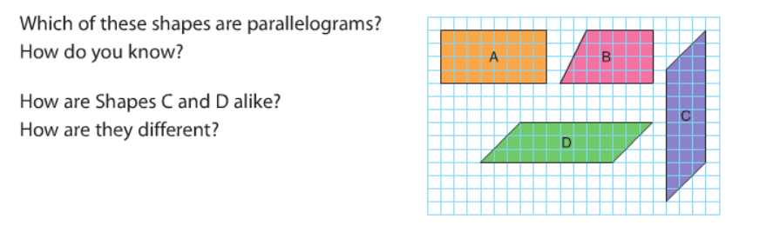
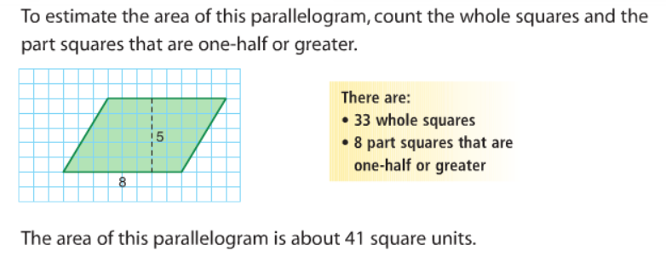

3)
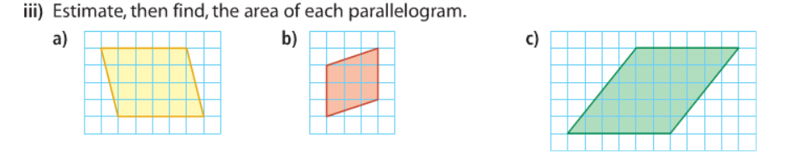

Tuesday:
- Review…what is a parallelogram?

- Intro to “Find the AREA of a Parallelogram”

Watch the following video for an Intro on Area of a Parallelogram
https://m.youtube.com/watch?v=PKzE3OWxDfQ

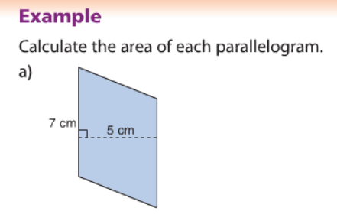
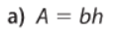
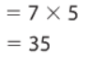

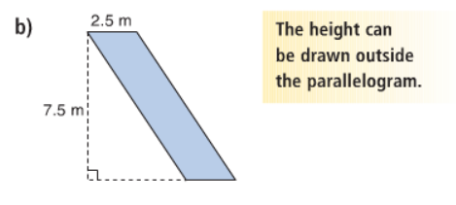
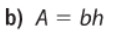
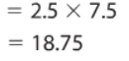
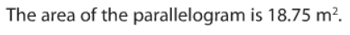

*Remember you HEIGHT ALWAYS comes from the 90º ( ) on the shape.

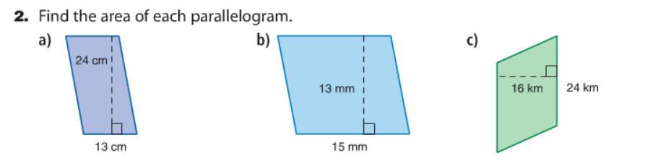

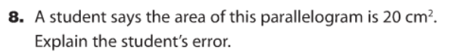

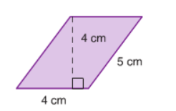

Wednesday
Complete the following:
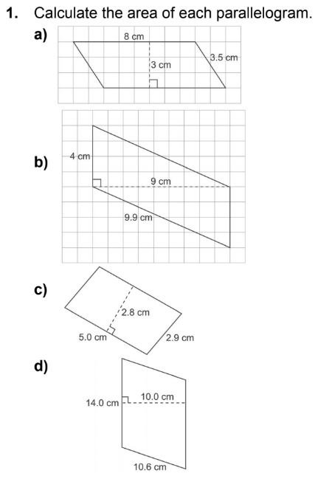

Thursday
You will have the area and a dimension (base OR height) of the parallelogram. Your task is to find a dimension NOT the Area. You will be dividing today. Watch the video carefully, you can always re-watch OR ask me
https://virtualnerd.com/pre-algebra/perimeter-area-volume/perimeter-and-area/area-formulas-examples/parallelogram-base-from-area-height

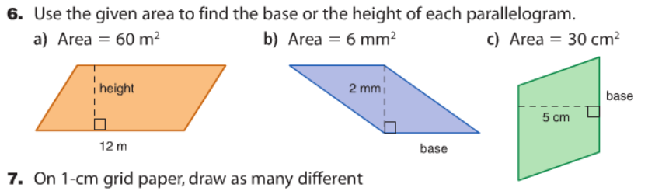

Finally Friday

Review: 1) Definition of a Parallelogram 2) Formula for Area of a Parallelogram
- What do you do if you have the Area and another dimension of a Parallelogram

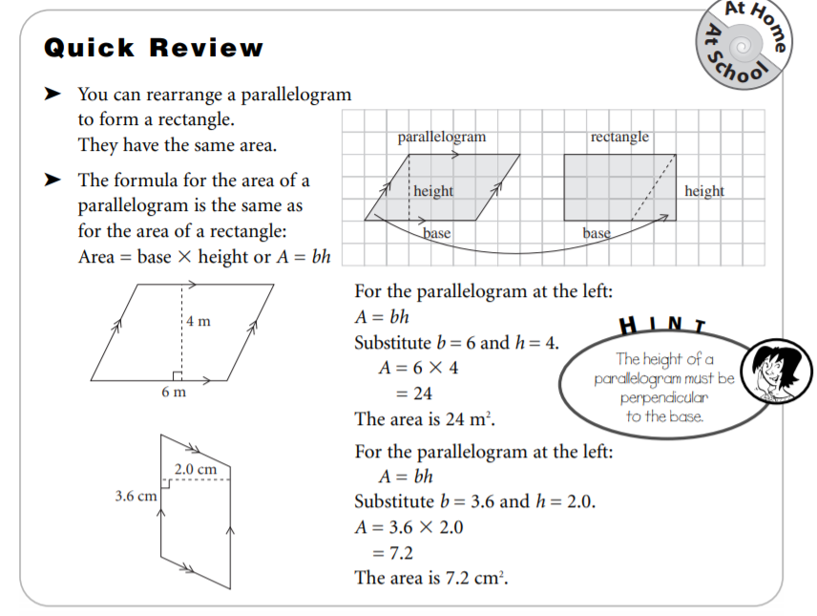

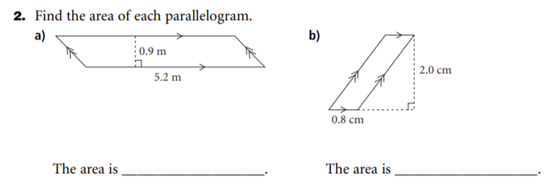

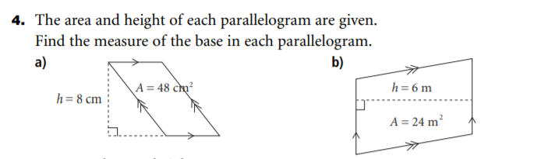

Challenge: Try it
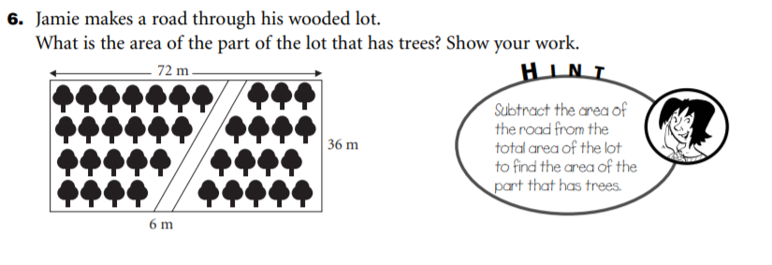

Thanks for all of your hard work in Math this week Things are looking up in our province, some restrictions have been relaxed! I hope you got to see some family and\or friends that you hadn’t seen for a while. We all have been doing our part in New Brunswick.
Have a great weekend,

Mrs. Moody

