April 19, 2020
Hello Grade 7!
I am going to move on today in our Math 7. We will still do our Mental Math, but we are going to move into “Investigating Circles”. We will move slowly, so that you are able to remember vocabulary and the formula that you need for this outcome. *Please send me ANY questions about anything we are doing this week!
Monday – focus on drawing circles (we will trace instead of using a compass) and understanding the difference between diameter and radius.
Tuesday – Discovering “Pi” by investigating some circles you will be drawing
Wednesday – Circumference of a Circle using the diameter OR radius
Thursday – Circumference of a Circle using the diameter OR the radius
Friday – a “mini” assignment for review

*Remember, do what you are comfortable with. Do a little or it all, as long as you are doing something to keep your math skills fresh

Monday (mm)
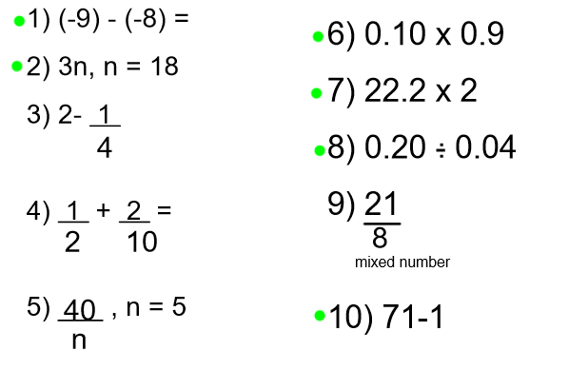

Tuesday (mm)
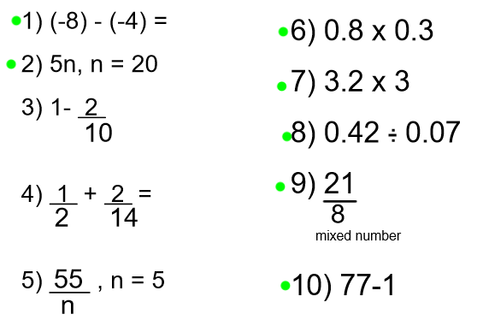

Wednesday (mm)
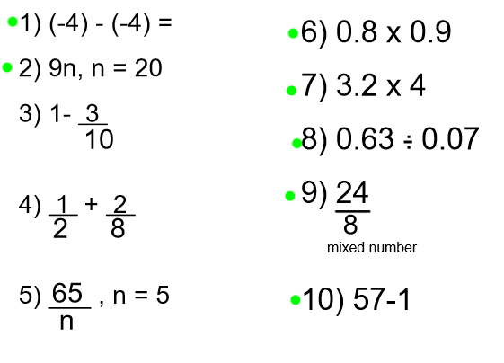
Thursday (mm)
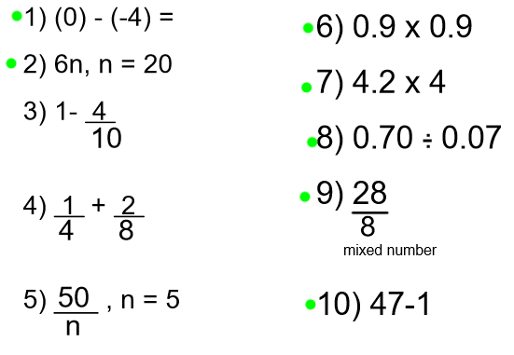

Friday (mm)
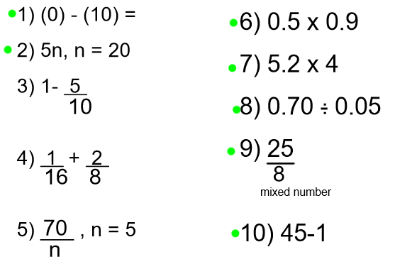

Monday – Intro to circles and vocab
- Find a circular object to trace (like a glass or a can). You will use this circle as you watch the video to label the following: 1) center (origin), 2) radius and 3) diameter.

- Watch the following video:
https://m.youtube.com/watch?v=O-cawByg2aA until 2:57 (for today)

- Complete the following:
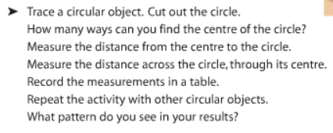

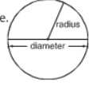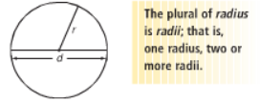

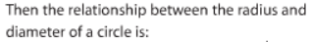
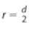 AND

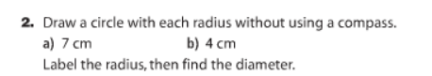

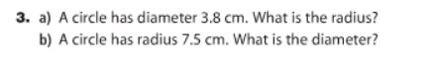

Tuesday:
- Review…
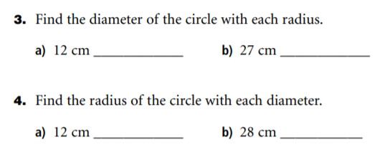

- Complete the following activity – individually or with someone in your house

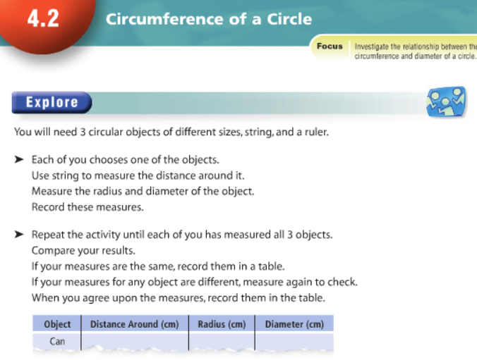

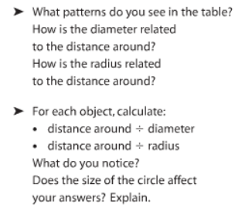

- Watch the video:
https://m.youtube.com/watch?v=O-cawByg2aA start at 2:58
**write down the definition of an irrational number,

Wednesday
Review:
Is pi () an irrational number? How do you know?
Remember, an irrational number:

- Watch the video
https://m.youtube.com/watch?v=eiHWHT_8WrE

- *So, there are 2 things you have to remember about finding the circumference (the distance around the circle):
* If you have the diameter, use this formula:

*If you have the radius, use this formula:

**If you are given the Circumference and you NEED to find the DIAMETER of the circle, you just have to use this formula:
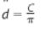
*What would you do to find the RADIUS?
(divide the diameter by 2)
- Complete the following questions, but please do the work “exactly” like the examples I gave you. You will have to follow this process all though your school career

Example:

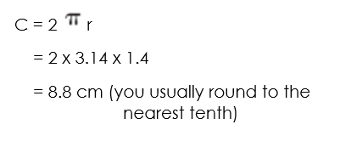

Complete the following:
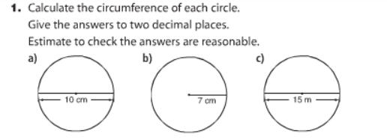

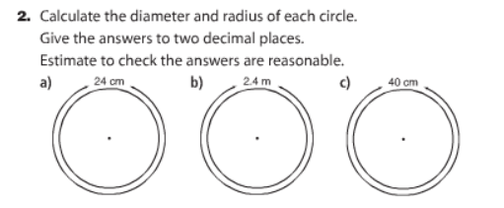

?

Thursday

Review:
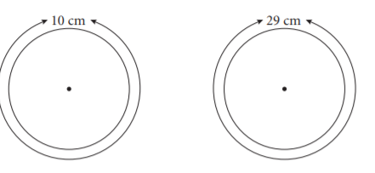

Re - watch the videos if needed or use this review, continue with the following questions:

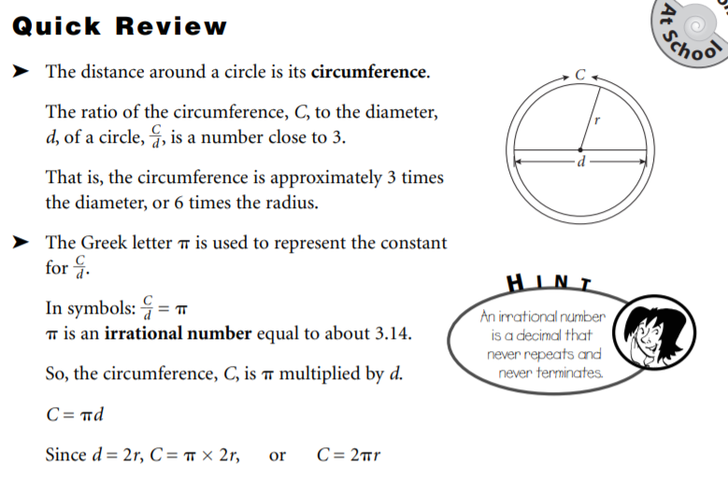

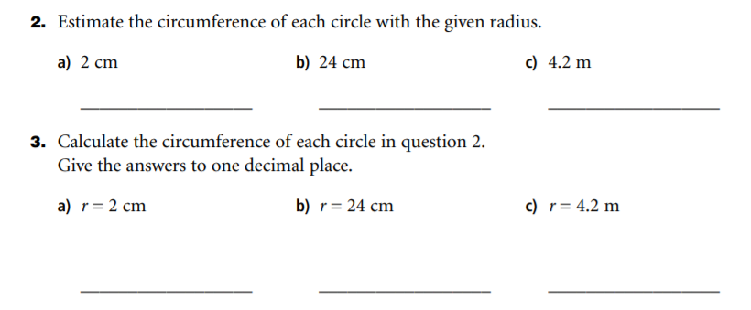

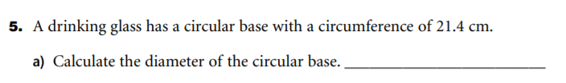

Finally Friday
Review (if needed) complete this assignment
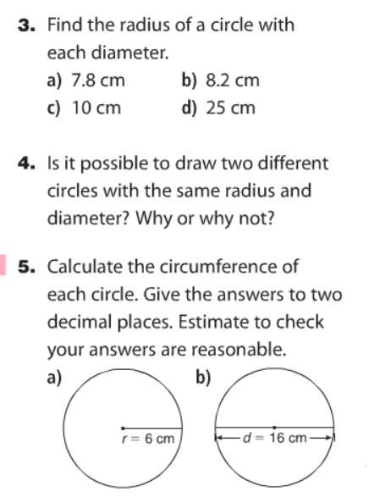
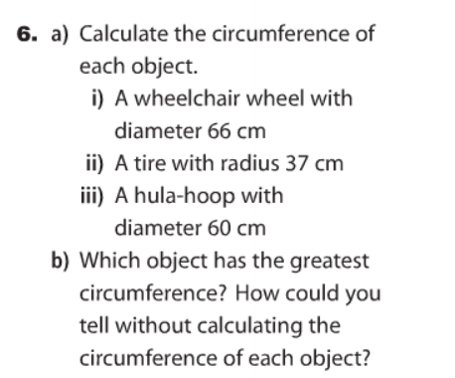

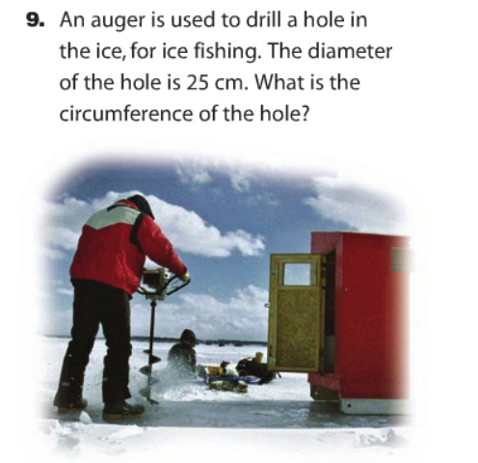
Thanks for all of your hard work in Math this week I am hoping you and your families are well and healthy at home! Have a great weekend, Mrs. Moody

