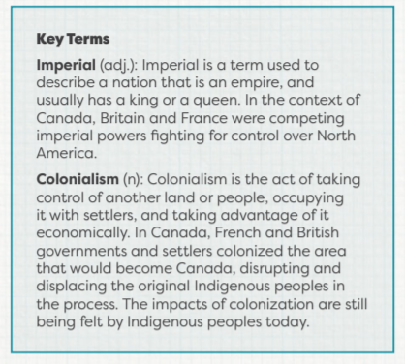
2. BEFORE CONFEDERATION In this section, you will learn about some important events from before Confederation that contributed to shaping post-Confederation Canada. The term “before Confederation” describes Canada in the years before 1867 and “post-Confederation” means Canada after 1867. From the early 1600s to the mid-1800s, the fur trade was an important part of the commercial economy of what would become Canada. Desire for beaver furs drove European colonization of North America. The fur trade also led to encounters with Indigenous peoples as Europeans tried to take control of land and resources. Britain and France were rival imperial powers in Europe, and this competition spread to North America, which both countries tried to control. Events such as the Seven Years’ War, the Acadian Deportation, and the passing of the Quebec Act show how the two countries competed for land and resources. Britain eventually took control, exerting political and cultural dominance over the land and people in it.
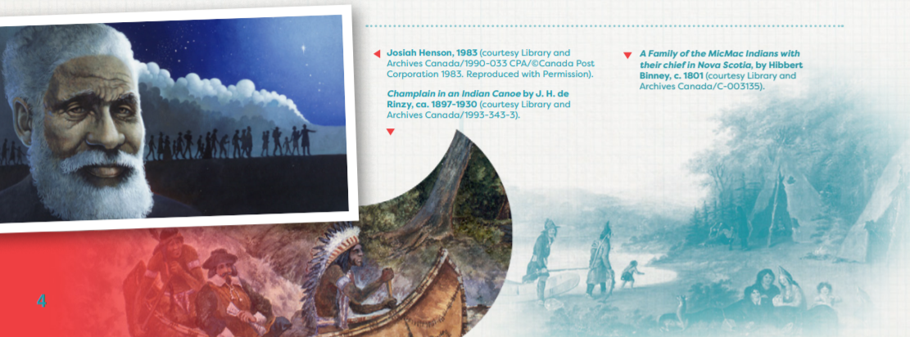

ACTIVITY 3: THE FUR TRADE
1. The beaver is an important symbol of Canada, but why do you think this is the case? Write down your thoughts. Discuss.
2. Next, read the Fur Trade in Canada (https://www.thecanadianencyclopedia.ca/en/article/fur-trade-in-canada-plain-language-summary) plain language summary available on The Canadian Encyclopedia. As you read, think about why the fur trade is important to Canadian history. Take notes about things you think are important so you can look at them later. If you have any vocabulary questions, make a list and ask me via email.
3. When you finish the reading, use the Fur Trade Worksheet to rewrite each sentence to make it correct. Use the information you learned from the reading to complete this. This activity uses the Fur Trade Worksheet, attached below in this document.
4. Next, review the questions below. Make point-form notes for your responses and return them to me along with your responses to the Fur Trade Activity below:
• The fur trade changed the lives of Indigenous peoples in many ways. How do you think their lives changed? Make a list of three or four big changes.
• The Métis are sometimes called “the children of the fur trade.” Why do you think people say this?
• Why is the beaver the symbol of Canada? Do you think it’s a good symbol for this country?
• This reading ends in the 1870s. What do you think happened next? Do you think the fur trade continued to grow? Did the French or the English become more powerful in North America?
ACTIVITY 4: THE SEVEN YEARS’ WAR
- The Seven Years’ War had a major influence on the history of Canada. Working independently make some guesses and predictions:
• Who do you think won the war?
• What happened to French settlers after the war?
• What role do you think Indigenous peoples played in the war?
• Is this war still important in Canada today?
2. Next, read the Seven Years’ War plain-language summary on The Canadian Encyclopedia (https://thecanadianencyclopedia.ca/en/article/the-seven-years-war-plain-language-summary). Complete the Seven Years’ War Notes section of the Seven Years’ War Worksheet found at attached to this document.
3. Return to your guesses from Step 1. Which guesses were correct? Which were incorrect? Why do you think the Seven Years’ War is still important for Canada today? How do you think the change from French to British rule affected the people there? How do you think the war affected Indigenous peoples? Discuss in a paragraph what you learned.
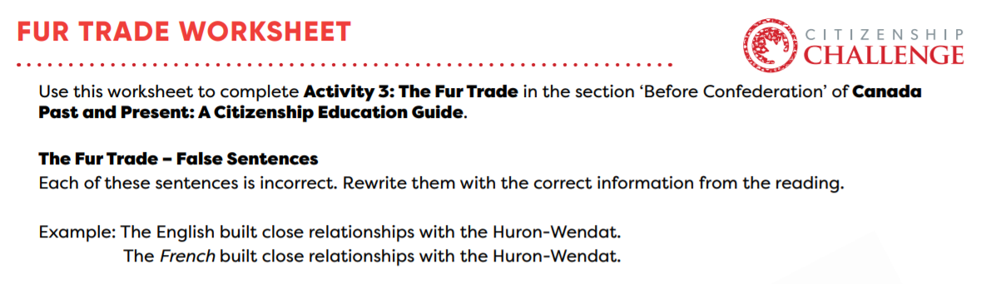
1) Indigenous peoples traded goods to the French and British for beaver furs.
______________________________________________________________________________________________________________________________________
2) Many Indigenous men married English women.
______________________________________________________________________________________________________________________________________
3) The French allied themselves with the Haudenosaunee Confederacy.
______________________________________________________________________________________________________________________________________
4) Coureurs des bois were licensed traders from New France.
______________________________________________________________________________________________________________________________________
5) European fur traders wanted beaver tails to make hats.
______________________________________________________________________________________________________________________________________
6) The French created the Hudson’s Bay Company.
______________________________________________________________________________________________________________________________________

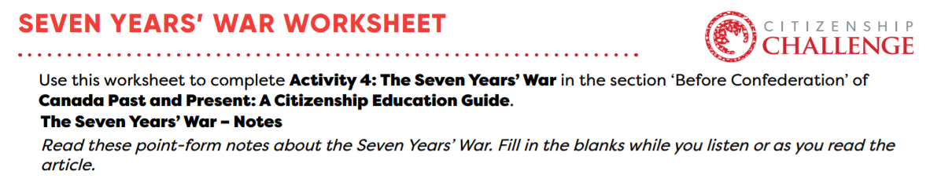
1) Background information
The Seven Years’ War started in___________________. The Seven Years’ War was fought in Europe, India, and ___________________, between ___________________ and France. One of the main causes was their competition for ___________________ and ___________________. In North America, both sides had ___________________ allies.
2) Main events
The ___________________ won many battles early in the war like those at Fort __________________ and Fort ___________________. France had complete control of the ___________________ for a while. The British and their allies began to win the war in ___________________. In 1759, Britain won many victories, including at the ___________________. A year later, the British and their Indigenous allies won an important victory in ___________________.
3) Results of the war
The ___________________ gave up control of Quebec, Ile Royale, the Great Lakes basin and some colonies in what is now the United States, to ___________________. France got ___________________ back and was allowed to keep ___________________. Because of the war, ___________________ became the leading ___________________ power in North America. Canada has a ___________________ monarch, but ___________________ founding peoples.
4) Two big effects:
1 – British North America had English and French settlers. The English did not allow Catholics to get jobs with the ___________________. In 1775, a new law, the ___________________ Act, gave people in Quebec freedom of religion and the right to use some French laws.
2 – New relationships developed between the British and Indigenous peoples. The Royal Proclamation of ___________________ stated that the land in North America belonged to the Indigenous people who lived on it. Only the British government could buy land or make ___________________ with Indigenous peoples.

