Digital Vision Board Project

Directions:
You are going to create a personal digital vision board. As you have learned, a vision board is where you display images that represent whatever you want to be, do or have in your life. You previously completed a vision board outline with items to include on your vision board. Use this document to help you complete your board.
You must include all the requirements listed below on your digital vision board:
Requirements:
- Your name or title for board.
- 3 Goals
- 3 Inspiring items
- 3 Special meaning items
- 3 Visualization on your feelings
- 3 Personal items
- At least 5 pictures, and 2 shapes
- Nice fonts, font sizes, and colors.
- Board should look professional and organized.
Now it is time to create your digital vision board. Follow the instructions below.

Learning How To Use Canva
http://canva.com
- Create A Login | 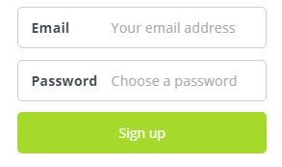
- The site will ask you multiple questions to help you create your board.  - Scroll to the bottom of the page and select 1’none of these apply”, then select “skip” on the next page. | 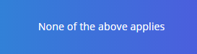
- Now Select the Photo Collage options to start creating you board.  - Then select a photo collage of your choice. | 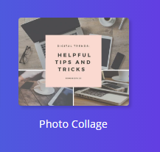
- To learn how to use Canva explore the design application page and view this webpage. | https://support.canva.com/getting-started-3/
- Start creating your digital storyboard. | 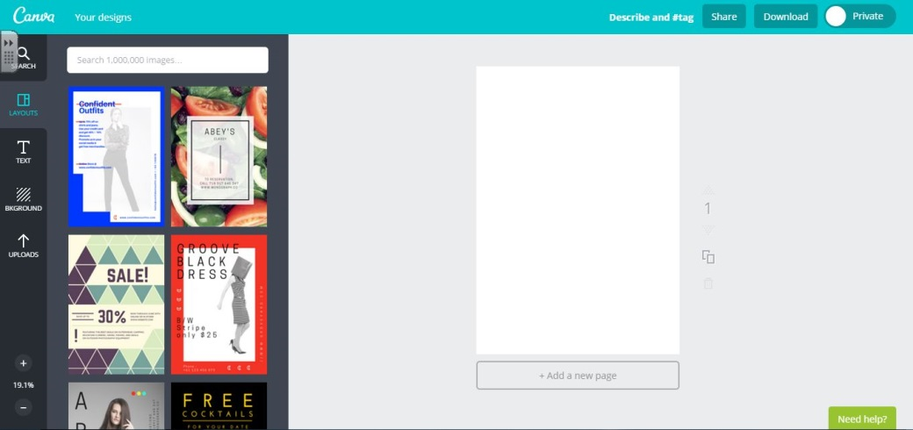
- Need extra help? Click on the need help button.

Vision Board Examples
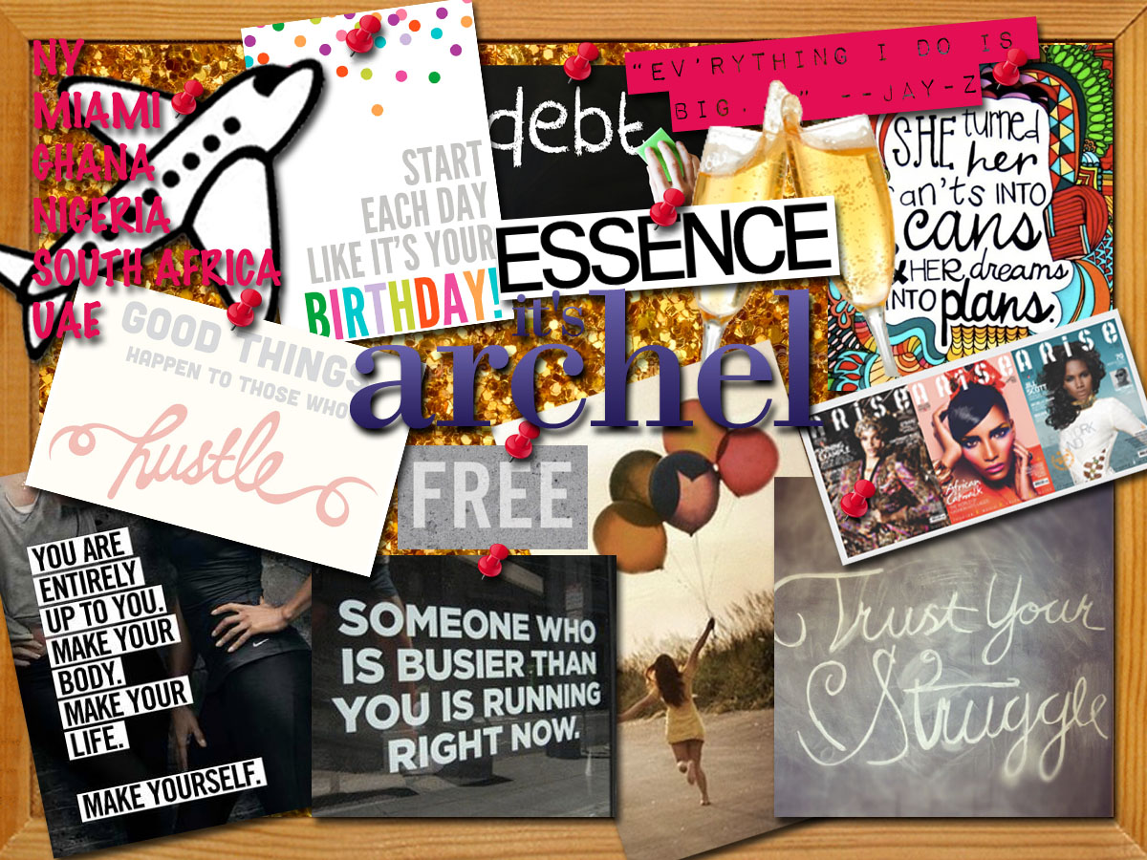

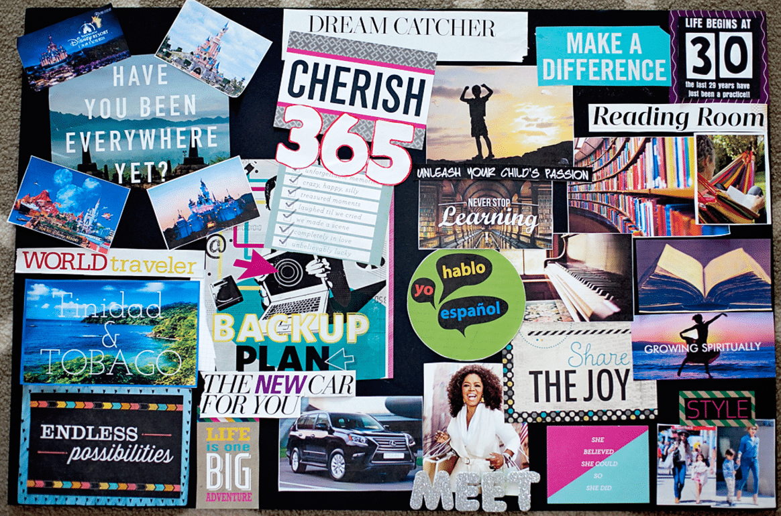

Ready To Turn In?

- Open up the Snipping Tool. | 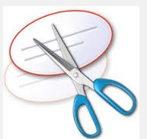
- Take a picture of your vision board. | 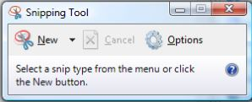
- Save it to your H drive and google drive. Share it

