Changing ideas about the universe

The space shuttle was made to take astronauts and cargo to and from Earth orbit. (Used to launch satellites into space and sometimes used as a science laboratory while orbiting earth)

The Space Shuttle Challenger disaster occurred on January 28, 1986, when Space Shuttle Challenger broke apart 73 seconds into its flight, leading to the deaths of its seven crew members. The spacecraft disintegrated over the Atlantic Ocean, off the coast of central Florida

The Space Shuttle Columbia disaster occurred on February 1, 2003, when shortly before it was scheduled to conclude its 28th mission, the Space Shuttle Columbia disintegrated over Texas and Louisiana during re-entry into the Earth's atmosphere,
resulting in the death of all seven crew members

The Hubble Space Telescope was created to capture detailed images or objects that are too far away to be viewed with conventional telescopes. The Hubble's instruments create images that are far superior to those of terrestrial observatories, which suffer from the effects of atmospheric distortion. (Went in orbit in1990)

Cosmology – is the study of the changes in our universe

Stars
- Stars evolve from clouds of gas and dust and follow a predictable series of stages: they begin, develop and end.
- Our sun is a star
- Stars are a lot further away than any of our plantes

The Sun – An important star

- closest star

- brightest object in the sky

- The sun has been producing energy for about 5 billion
years already, and they predict that it will produce
energy for another 5 billion years before it runs out of
fuel.

The Sun produces energy by a process called nuclear fusion. In the Sun's core, there is so much pressure and temperature that 2 hydrogen atoms fuse together to form 1 helium atom. This process produces large amounts of energy in the form of heat, light and other forms.

Solar Flares

A flare is defined as a sudden, rapid, and intense variation in brightness. A solar flare occurs when magnetic energy that has built up in the solar atmosphere is suddenly released in the form of radiation.

Solar flares cause the Northern Lights & interference with radio transmissions, satellites, transformers.

We know that gravity is the force of attraction that pulls objects towards each other. The more mass an object has, the more attractive force it exerts.
- The sun has __Stronger___ gravity than earth
- Force does get smaller as the distance between objects increase

Nebula
The Cat's Eye, the nebula, is a large cloud of dust and gas, mostly helium and hydrogen. It is the starting point for all stars.

Supernova
A supernova is a very bright explosion that marks the end of a large star. It is rare.

Neutron Star
When a star about 10 time the mass of the Sun dies, the remaining core is a neutron core
- - Neutron star is an extremely dense star composed of neutrons. The neutrons are so tightly packed with no space between them that a cupful of neutron star would have
- a mass of millions of kilograms.
Black hole
Extremely large stars can turn into black holes.
- Black hole is a small, very dense object with a force of gravity so strong that nothing can escape from it, not even light can be radiated away from its surface.
- It is not a hole but a huge amount of matter packed into a sphere only a few kilometers across.

Red giants - a star near the end of its life that becomes larger and redder as it runs out o f hydrogen fuel.

Red Supergiant - a star with a mass 10 times or larger than the Sun's near the end of its life, that becomes larger and redder as it runs out of hydrogen fuel.

White dwarf - a small star created by the remaining material when a red giant dies out.

Life of a star

NebulaAverage star (sun size) Red giant White Dwarf

Nebula Massive star (10 Times larger than sun) Red Super Giant Supernova Neutron star
OR
Black hole (Massive star)

Apparent magnitude: Refers to the brightness of a star as it appears to us.

Absolute magnitude: Refers to the actual amount of light given off by a star.

The Sun produces energy by a process called nuclear fusion. In the Sun's core, there is so much pressure and temperature that 2 hydrogen atoms fuse together to form 1 helium atom. This process produces large amounts of energy in the form of heat, light and other forms.

The sun is the closest star. It is the brightest object in the sky. The sun has been producing energy for 5 billion years and is predicted to produce energy for another 5 billion years.

A flare is defined as a sudden, rapid, and intense variation in brightness (Northern Lights). A solar flare occurs when magnetic energy that has built up in the solar atmosphere is suddenly released in the form of radiation.

Parts of the sun are below (The part of the sun that is visible during an eclipse is the chromosphere)
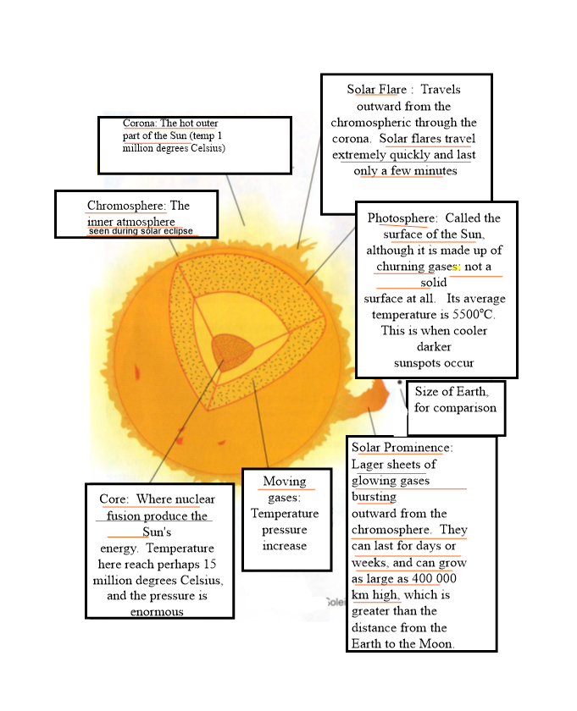
Gravity is the force of attraction that pulls objects towards each other. The more mass an object has, the more attractive force it
exerts. (The Sun has more gravity than earth)

How the universe formed
At one point, all the matter of the entire universe was packed together into one small, extremely compact, hot (100 million degrees Celsius) mass under enormous pressure.
Then
BANGO!!!

The Big Bang occurred in which all this mass and pressure emerged. This occurred 10 to 15 billion years ago.

Three main stages of the formation of the solar system
Step 1:
Gravity caused components of the rotating nebula to join together. As the nebula rotated
it flattened out.

Step 2:
As the nebula flattened out a bulge formed towards the center, known as the sun today.
Cooler material further from the sun began to form chunks.

Step 3:
The heavy materials such as rock and iron were not light enough to be blown out. As chunks of solid matter circled the Sun, they eventually collided with one another and grew in size until the Terrestrial Planets were formed.

Light is a form of energy travelling as a wave. Each color has a wavelength, which is the length of one wave. Red has the longest and violet the shortest.
ROY G. BIV

The universe is always expanding due to evidence of the red shift

