The Importance of Prenatal Care
Millions of American women give birth every year, and nearly a third of them will have some kind of pregnancy-related complication. Those who don't get proper prenatal care run the risk that such complications won't be detected or won't be dealt with soon enough. And that can lead to potentially serious consequences for both the mother and her baby.
That's why it's so important to start prenatal care as early as possible — ideally, before a woman even becomes pregnant. Of course, this isn't always possible or practical. But the sooner in pregnancy good care begins, the better for the health of both moms and their babies.
Remember, your health care provider is there to support you throughout your pregnancy. Your prenatal appointments are an ideal time to discuss any questions or concerns — including things that might be uncomfortable or embarrassing.

Prenatal Care Before Pregnancy
Prenatal care should start before you get pregnant. If you're planning a pregnancy, see your health care provider for a complete checkup. Routine testing can make sure you're in good health and that you don't have any illnesses or other conditions that could affect your pregnancy. If you've been having any unusual symptoms, this is a good time to report them.
If you're already being treated for a chronic condition, such as diabetes, asthma, hypertension (high blood pressure), a heart problem, allergies, lupus (an inflammatory disorder that can affect several body systems), depression, or some other condition, you should talk to your doctor about how it could affect a pregnancy.
In some cases, you may need to change or stop certain medicines — especially during the first trimester (12 weeks) — to reduce risk to the fetus. Or, you may need to be even more careful about managing your condition. For example, women with diabetes must take extra care to keep their blood glucose levels under control — both before they begin trying to conceive and during pregnancy. Abnormal levels increase the risk of birth defects and other complications.
This is also a good time to talk with your health care provider any habits that could pose a risk to your baby, such as drinking alcohol or smoking. Ask about taking a prenatal vitamin that contains folic acid, calcium, and iron.
It's especially important for women who plan to become pregnant to take vitamins with folic acid because neural tube defects (problems with the development of the spine and nervous system) happen in the first 28 days of pregnancy, often before a woman even knows she's pregnant.
If you or your partner have a family history of a significant genetic disorder and think either of you may be a carrier, genetic testingmay be wise. Talk this over with your health care provider, who can refer you to a genetic counselor if necessary.

If you find out that you're pregnant before you do any of this, don't worry. It's not too late to get the care that will help to protect your health and that of your baby.

Prenatal care: The first visit
You should call to schedule your first examination during the first 6 to 8 weeks of your pregnancy, or when your menstrual period is 2 to 4 weeks late. Many health care providers will not schedule the first visit before 8 weeks, unless there is a problem.
Medical history
Your health care provider will ask many questions, including details about:
- Your menstrual cycle
- Use of birth control
- Past pregnancies
- Your personal medical history
- Your family medical history
- Medication use, including prescription and over-the-counter medications or supplements
Be sure to mention even sensitive issues, such as domestic abuse, abortion or past drug use. Remember, the information you share will help your health care provider take the best care of you — and your baby.
If there's any part of your medical history that you don't want to share with your partner or other loved ones, mention it to your health care provider privately.
Due date
Few women actually give birth on their due dates. Still, establishing your due date — or estimated date of delivery — is important. An accurate due date allows your health care provider to monitor your baby's growth and the progress of your pregnancy, as well as schedule certain tests or procedures at the most appropriate time.
To estimate your due date, your health care provider will likely count ahead 40 weeks from the start of your last period — or add seven days to the first day of your last period and then subtract three months.
If there's any question about your due date — if you don't know the date of your last period or your periods are irregular, for example — your health care provider might recommend an early ultrasound to help confirm the date.
Physical exam
Your health care provider will check your weight, height and blood pressure. He or she will listen to your heart and assess your overall health.
Your health care provider might examine your vagina and the opening to your uterus (cervix) for any infections or abnormalities. Changes in the cervix and in the size of your uterus can help confirm the stage of your pregnancy.
You might need a Pap test to screen for cervical cancer as well, depending on how long it's been since your last screening.
Lab tests
At your first prenatal visit, blood tests might be done to:
- Check your blood type. This includes your Rh status. Rhesus (Rh) factor is an inherited trait that refers to a specific protein found on the surface of red blood cells. Your pregnancy needs special care if you're Rh negative and your baby's father is Rh positive.
- Measure your hemoglobin. Hemoglobin is an iron-rich protein found in red blood cells that allows the cells to carry oxygen from your lungs to other parts of your body, and to carry carbon dioxide from other parts of your body to your lungs so that it can be exhaled. Low hemoglobin is a sign of anemia — a lack of healthy red blood cells.
- Check immunity to certain infections. This typically includes rubella and chickenpox (varicella) — unless proof of vaccination or natural immunity is documented in your medical history.
- Detect exposure to other infections. Your health care provider might suggest blood tests to detect various other infections, such as hepatitis B, toxoplasmosis, syphilis, gonorrhea or chlamydia. You might also be offered a test to check for HIV, the virus that causes AIDS.
A urine sample might be tested for signs of a bladder, urinary tract or kidney infection.
Lifestyle issues
Your health care provider will discuss the importance of proper nutrition and prenatal vitamins. Your first prenatal visit is a good time to discuss exercise, sex during pregnancy and other lifestyle issues. You might also discuss your work environment and the use of medications during pregnancy.
If you smoke, ask your health care provider for suggestions to help you quit.
Screening tests for fetal abnormalities
Prenatal tests can provide valuable information about your baby's health. Your health care provider might offer ultrasound, blood tests or other screening tests to detect fetal abnormalities.

Routine Pre-natal Checkups
If you're healthy and there are no complicating risk factors, you can expect to see your health care provider:
- every 4 weeks until the 28th week of pregnancy
- then every 2 weeks until 36 weeks
- then once a week until delivery
- These routine prenatal visits — will probably be shorter than the first. Your health care provider will check your weight and blood pressure, and you'll discuss your signs and symptoms. The size and shape of your uterus may also be measured, starting at the 22nd week, to determine whether the fetus is growing and developing normally.
- Near the end of the first trimester — by about nine to 12 weeks of pregnancy — you might be able to hear your baby's heartbeat with a small device that bounces sound waves off your baby's heart
- During one or more of your visits, you'll provide a small urine sample to be tested for sugar (glucose)and protein. Protein may indicate preeclampsia, a condition that develops in late pregnancy and is characterized by a sudden rise in blood pressure and excessive weight gain, with fluid retention and protein in the urine.
  - Glucose screening usually takes place at 12 weeks for women who are at higher risk of having gestational diabetes (diabetes that occurs during pregnancy). That includes women who: have previously delivered a baby that weighed more than 9 pounds (4.1 kilograms), have a family history of diabetes, are obese.
All other pregnant women are tested for diabetes at 24 to 28 weeks. This test involves drinking a sugary liquid and having a blood glucose test (which involves having blood drawn) after an hour. If the sugar level in the blood is high, further testing might be done to diagnose gestational diabetes.

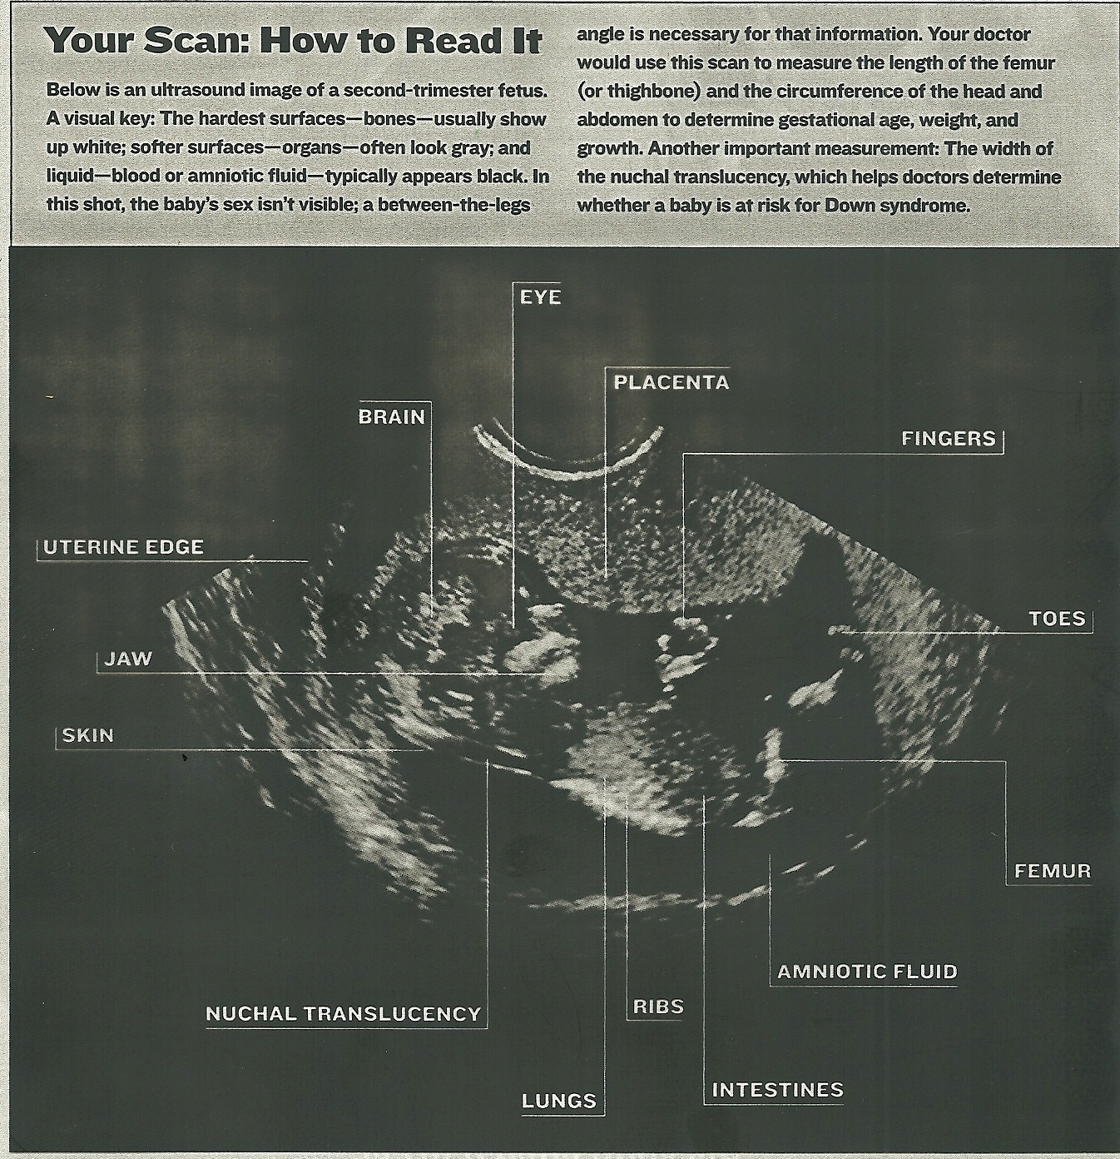
Ultrasound (also called a sonogram, sonograph, echogram, or ultrasonogram): You'll likely have at least one ultrasound examination to make sure the pregnancy is progressing normally and to verify the expected date of delivery. Usually, an ultrasound is performed at 18 to 20 weeks to look at the baby's anatomy, but can be done sooner or later and sometimes more than once. An ultrasound poses no risk to you or your baby. When the ultrasound is done, a technician will coat your abdomen with a gel and then run a wand-like instrument over it. High-frequency sound waves "echo" off your body and create a picture of the fetus on a computer screen.
Ultrasound scanning is used to:
- determine whether the fetus is growing at a normal rate
- record fetal heartbeat or breathing movements
- see whether you might be carrying more than one fetus
- identify a variety of abnormalities that might affect the remainder of the pregnancy or delivery

