Prenatal nutrition and weight gain

Pregnancy weight gain: What's healthy?
From promoting your baby's development to paving the way for post-pregnancy weight loss, here's why pregnancy weight gain matters.
By Mayo Clinic Staff
Like it or not, eating for two isn't a license to eat twice as much as usual. Use healthy lifestyle habits to manage your pregnancy weight gain, support your baby's health and make it easier to shed the extra pounds after delivery.

Pregnancy weight-gain guidelines
There's no one-size-fits-all approach to pregnancy weight gain. How much weight you need to gain depends on various factors, including your pre-pregnancy weight and body mass index (BMI). Your health and your baby's health also play a role. Work with your health care provider to determine what's right for you.
You should gain weight gradually during your pregnancy, with most of the weight gained in the last 3 months. Many doctors suggest women gain weight at the following rate:
- 1 to 4 pounds total during the first 3 months (first trimester) You can do this with an extra 150 to 200 calories a day, about the amount in 6 ounces (170 grams) of low-fat fruit yogurt.
- Steady weight gain is more important in the second and third trimesters — especially if you start out at a healthy weight or you're underweight. This often means gaining 3 to 4 pounds (about 1.4 to 1.8 kilograms) a month until delivery. An extra 300 calories a day — half of a sandwich and a glass of skim milk — might be enough to help you meet this goal.
- When you're overweight
- Being overweight before pregnancy increases the risk of various pregnancy complications, including gestational diabetes and high blood pressure. Although a certain amount of pregnancy weight gain is recommended for women who are overweight or obese before pregnancy, some research suggests that women who are obese can safely gain less weight than the guidelines recommend. In women who have a BMI greater than 35, a weight loss of less than 11 pounds (5 kilograms) appears to have more benefits than risks and might not increase the risk of having a small-for-gestational-age infant.
- Work with your health care provider to determine what's best in your case and to manage your weight throughout pregnancy.

- When you're underweight
- If you're underweight, it's essential to gain a reasonable amount of weight while you're pregnant. Without the extra weight, your baby might be born earlier or smaller than expected.
Pre-pregnancy weight | Recommended weight gain
Underweight (BMI < 18.5) | 28 to 40 lbs. (about 13 to 18 kg)
Normal healthy weight (BMI 18.5 to 24.9) | 25 to 35 lbs. (about 11 to 16 kg)
Overweight (BMI 25 to 29.9) | 15 to 25 lbs. (about 7 to 11 kg)
Obese (BMI 30 or more) | 11 to 20 lbs. (about 5 to 9 kg)

When you're carrying twins or other multiples
If you're carrying twins or other multiples, you'll likely need to gain more weight. Again, work with your health care provider to determine what's right for you.
Consider these general guidelines for pregnancy weight gain if you're carrying twins:
Pre-pregnancy weight | Recommended weight gain
Normal weight (BMI 18.5 to 24.9) | 37 to 54 lbs. (about 17 to 25 kg)
Overweight (BMI 25 to 29.9) | 31 to 50 lbs. (about 14 to 23 kg)
Obese (BMI 30 or more) | 25 to 42 lbs. (about 11 to 19 kg)

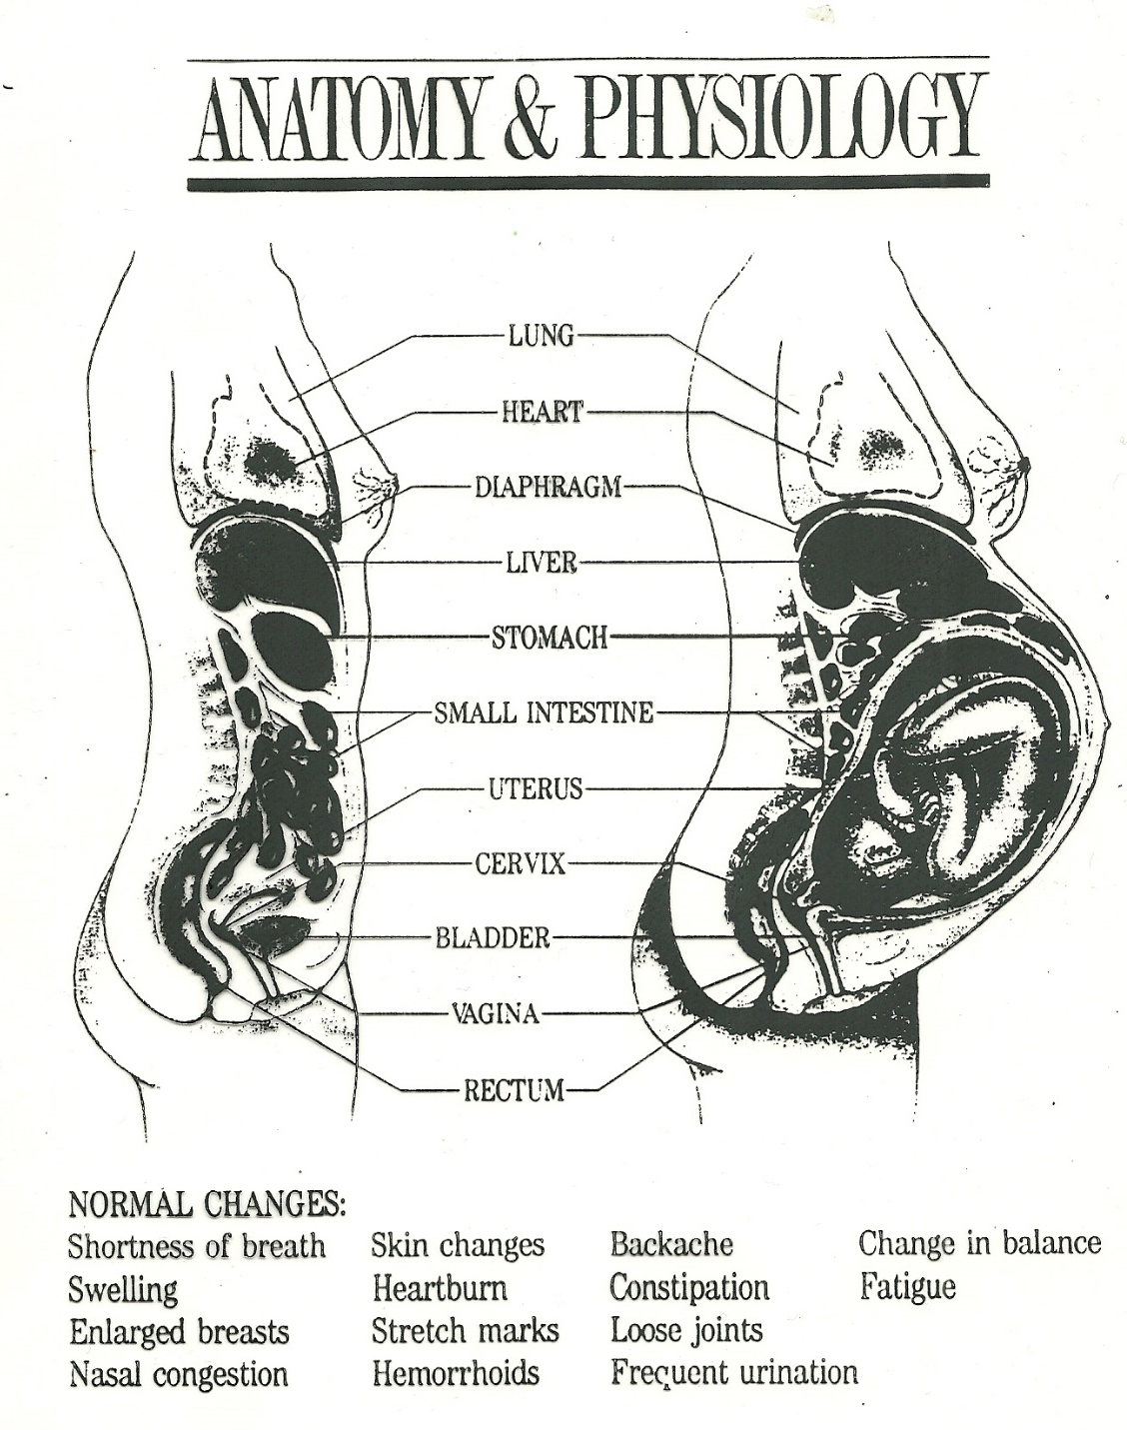

Where does pregnancy weight gain go?
- Baby: 7 to 8 pounds (about 3 to 3.6 kilograms)
- Larger breasts: 2 pounds (about 1 kilogram)
- Larger uterus: 2 pounds (about 1 kilogram)
- Placenta: 1 1/2 pounds (about 0.7 kilogram)
- Amniotic fluid: 2 pounds (about 1 kilogram)
- Increased blood volume: 3 to 4 pounds (about 1.4 to 1.8 kilograms)
  - Picture a half gallon container of milk. This is how much extra blood your body makes.
- Increased fluid volume: 3 to 4 pounds (about 1.4 to 1.8 kilograms)
- Fat stores: 6 to 8 pounds (about 2.7 to 3.6 kilograms)
Prenatal Nutrition
A balanced, nutritious diet during pregnancy is important to maintain your health and nourish your fetus. Be sure to increase your daily caloric intake by 300 calories after you become pregnant.
The average woman needs 2,200 calories a day and 2,500 when she is pregnant. If she is carrying twins, her need increases to 3,500 calories, and for triplets or more, she needs 4,500 calories.¹ Talk to your doctor or a dietitian about your daily calorie needs because your needs depend on your height, weight, and activity level.
Your doctor may give you a nutrition plan to follow throughout pregnancy and whilebreast-feeding. You may also receive a prescription for a vitamin and mineral supplement or a list of recommended nonprescription supplements.

The advice is different for those who were overweight or underweight before becoming pregnant.
Follow your Daily Food Plan for Moms to choose the right amounts from each food group. In addition, visit your health care provider regularly so they can check on your weight gain.
It would be easy to add calories to your diet with junk food, but this won't give your baby the nutrients he or she needs. It's more important to avoid overeating and make nutrient-rich choices. Consider these suggestions:
Trade white bread and pasta for the whole-grain variety.
Choose a salad with low-fat dressing and black beans instead of a burger and fries.
Eat sliced fruit instead of a cookie.
Working with your health care provider
“Extras” are added sugars and solid fats in foods like soft drinks, desserts, fried foods, cheese, whole milk, and fatty meats. Look for choices that are low-fat, fat-free, unsweetened, or with no-added-sugars. They have fewer “extras.”
Your health care provider will keep a close eye on your weight. Do your part by eating a healthy diet and keeping your prenatal appointments. To keep your pregnancy weight gain on target, your health care provider might offer suggestions for boosting calories or scaling back as needed.
Eating a variety of foods can help you get all the nutrients you need. Your body needs protein, carbohydrate, and fats for energy. Good sources of nutrients are:
- Unsaturated fats like olive oil and canola oil, nuts, and fish.
- Carbohydrate from whole grains, fruits, vegetables, legumes (peas, beans, and lentils), and low-fat milk products.
- Lean protein such as all types of fish, poultry without skin, low-fat milk products, and legumes.
Eating healthy foods during pregnancy is good for your overall health and for the health of your baby. You may already have a healthy diet, or you may need to make some changes to eat healthier.
It's also important to eat plenty of fruits and vegetables. These not only give you necessary nutrients but also help you get fiber. Planning your meals can help you add healthy foods to your diet.
Folic acid
Folic acid is a B vitamin. Taking folic acid before and during early pregnancy reduces the chance of having a baby with a neural tube defect or other birth defects.

Women of childbearing age should get 0.4 mg (400 mcg) to 0.8 mg (800 mcg) of folic acid from fortified food, supplements, or a mix of food plus supplements.2 This amount is found in most once-a-day multivitamins.
Women who are pregnant with twins or more should take 1 mg (1000 mcg) of folic acid daily.3
Women who have a family history of neural tube defects, who have had a baby with a neural tube defect, or who are on medicines for seizures should take additional folic acid: a daily dosage of 4 mg (4000 mcg) of folic acid is recommended. Do not try to reach this amount of folic acid by taking more multivitamins, because you could get too much of the other substances that are in the multivitamin.4
Iron
You will need twice as much iron in your second and third trimesters as you did before pregnancy. This extra iron supports the extra blood in your system and helps with the growth of the placenta and the fetus. Your iron requirements are slight during the first trimester of pregnancy, and taking iron supplements in the first trimester may aggravate morning sickness.

After the first trimester, take a daily supplement containing 30 mg of iron (most prenatal vitamins include iron). A woman with a multiple pregnancy is advised to take 60 mg to 100 mg of iron daily.3 Iron supplements can cause an upset stomach and constipation. Taking your iron at bedtime may decrease the chance of stomach upset. Your body absorbs iron best in small amounts when you eat it with vitamin C, so you may want to take your iron throughout the day.

Calcium
Calcium is needed for the development of the fetus's skeleton. You can get enough calcium in your diet by eating or drinking 4 servings from the dairy (milk) group each day. Good sources of calcium from nonmilk sources include:

Greens (such as mustard and turnip greens), bok choy, kale, and watercress.
Broccoli and cauliflower.
Tofu that is "calcium-set."
Corn tortillas made with lime.
Calcium-fortified orange juice.

http://www.webmd.com/baby/tc/nutrition-and-weight-gain-during-pregnancy-topic-overview?page=2

