Napoleon Resume and Job Application
1769-1821

Name:______________________________________ Date:__________

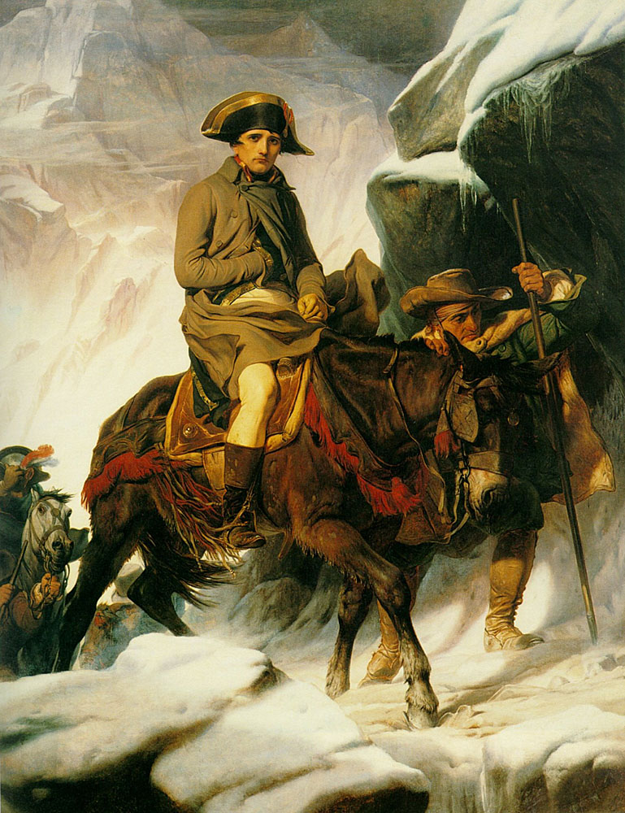
The United Federation of Conquerors is accepting applications from military leaders all throughout the world for the coveted position of Chairman of the Board of the United Federation of Conquerors. The position and title warrants a Chairman who is responsible, capable and who has demonstrated success in conquest and leadership. The United Federation of Conquerors is expecting applications from many of the greatest conquerors of all time including Genghis Khan, Alexander the Great, and Darius of Persia.

Your assignment:

You must assist Napoleon Bonaparte in his quest for this coveted title.
You will develop a:

- RESUME for Napoleon (example on back). You must make this resume interesting and appealing. You may add a section for hobbies/ interests/ awards/ achievements. You must find relevant and accurate supporting information for each section addressed in the example on the back.
- COVER LETTER from Napoleon to the United Federation of Conquerors (example attached). Your cover letter should be at least 3 paragraphs long and include a description of how you found out about the position and why you want it, why you are qualified (you can use highlights from your resume here) and where you can be reached in the event that the selection committee requires further information about you. You should also express your qualifications relative to the character of one of the other conquerors mentioned above. Your letter should also express Napoleon's enthusiasm for the opportunity to serve as Chairman!

***************************************************************************************************

This assignment naturally includes some creative license in your part but should be grounded in historic fact (at least representing the background and accomplishments of Napoleon Bonaparte).

 | (4) Excellent | (3) Proficient | (2) Partial | - Minimal
Evaluate Napoleon’s government’s effect on the people he ruled. | Clearly analyzes 3-4 of Napoleon’s government’s effects on the people he ruled. | Clearly analyzes 2-3 of Napoleon’s government’s effects on the people he ruled. | Mentions or lists some of Napoleon’s government’s effects on the people he ruled. | Mentions or lists one or fewer of Napoleon’s government’s effects on the people he ruled.
Analyzes how Napoleon shaped world history. | Cover letter analyzes how Napoleon shaped world history with specific examples of his lasting effect. | Cover letter explains how Napoleon shaped world history with specific examples of his lasting effect. | Cover letter lists how Napoleon shaped world history with some specific examples of his lasting effect. | Little to no mentioning or analysis of how Napoleon shaped world history.
Analyzes how Europe changed and how it stayed the same during Napoleon’s rule. | Resume illustrates major battles and events from the Napoleonic period and analyzes how they changed Europe or kept it the same. | Resume illustrates major battles and events from the Napoleonic period and explains how they changed Europe or kept it the same. | Resume merely lists major battles and events from the Napoleonic period and does not explain how they changed Europe or kept it the same. | Little to no mentioning or analysis of how Europe changed or stayed the same during the Napoleonic period.

Sample Resume Format

Napoleon Bonaparte
The Palace of the Tuileires
Paris, France
1-800-LITTLE-RULER
OBJECTIVE:

- A short statement (no more than two lines) in clear, specific language describing why Napoleon should be the Chairman of the Board of the United Federation of Conquerors.

EDUCATION:

- Name of certificate/degree received and year/month awarded
- Name of school(s) (location if not apparent from name)
- Major scholarships/ awards/ honors received

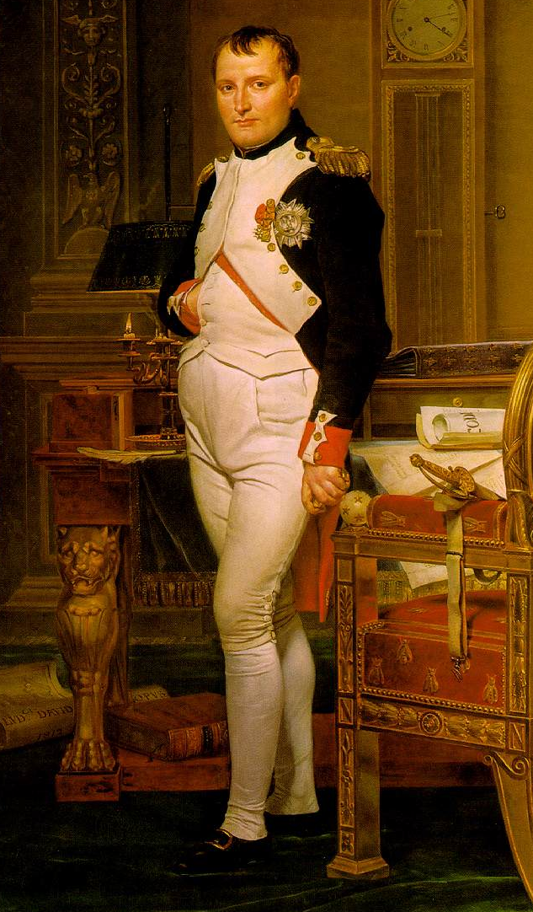
WORK EXPERIENCE

- Current job responsibilities in past tense
- Past job responsibilities in past tense
- Major Battles and Conquests
- LIST IN ORDER

ACCOMPLISHMENTS:

- Effects his rule had on the people he governed.
  - Can be positive and negative.
- Major Events that Shaped World History.
  - Can compare Europe before and after Napoleon’s reign.
- Solid analysis of results
- Examples

ACTIVITIES:

- Name of organization/armies have been part of.
- Brief description of role you played
- Dates of involvement
- Accomplishments

SKILLS:

- One or two word description of skill and skill level
- Correctly spelled names of any weapons, software programs, hardware or other equipment that you can operate

INTERESTS:

- Brief description of specific personal interests

Sample Letter Format

Napoleon Bonaparte
The Palace of the Tuileires
Paris, France
1-800-LITTLE-RULER
Napoleonthegreat04@hotmail.com

Today's date

Selection Committee
Rulers of the World
United Federation of Conquerors
100 E. Conquers Drive
Blackville, NB
E9B 1Y4

Dear Selection Committee,

Start your letter with a grabber- a statement that established a connection with your reader, a probing question, or a quotable quote. Briefly say what job you are applying for.

The mid-section of your letter should be one or two short paragraphs that make relevant points about your qualifications. You should not just summarize your resume! You may incorporate a column or bullet format here.

Your last paragraph should initiate action by explaining what you will do next (e.g., call the employer) or instigate the reader to contact you to set up an interview. Close by saying "thank you".

Sincerely yours,

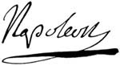

Napoleon I of France
Enclosure: resume

