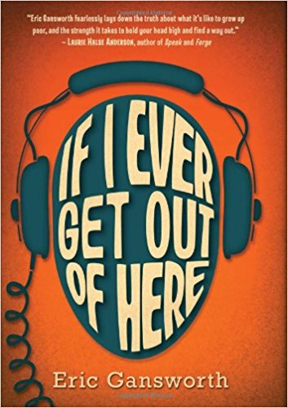 If I Ever Get Out of Here
by Eric Gansworth
Lewis "Shoe" Blake is used to the joys and difficulties of life on the Tuscarora Indian reservation in 1975: the joking, the Fireball games, the snow blowing through his roof. What he's not used to is white people being nice to him -- people like George Haddonfield, whose family recently moved to town with the Air Force. As the boys connect through their mutual passion for music, especially the Beatles, Lewis has to lie more and more to hide the reality of his family's poverty from George. He also has to deal with the vicious Evan Reininger, who makes Lewis the special target of his wrath. But when everyone else is on Evan's side, how can he be defeated? And if George finds out the truth about Lewis's home -- will he still be his friend?
Acclaimed adult author Eric Gansworth makes his YA debut with this wry and powerful novel about friendship, memory, and the joy of rock 'n' roll.

