Chapter 8 Covalent Bond
Terms:
a. Covalent bond--the bond that holds atoms together that are SHARING electrons
b. Molecule--a neutral group of atoms joined together by covalent bonds.
c. Diatomic molecule--a molecule consisting of two atoms
d. Molecular compound-- a compound composed of molecules.
e. Molecular formula--a chemical formula of the molecular compound
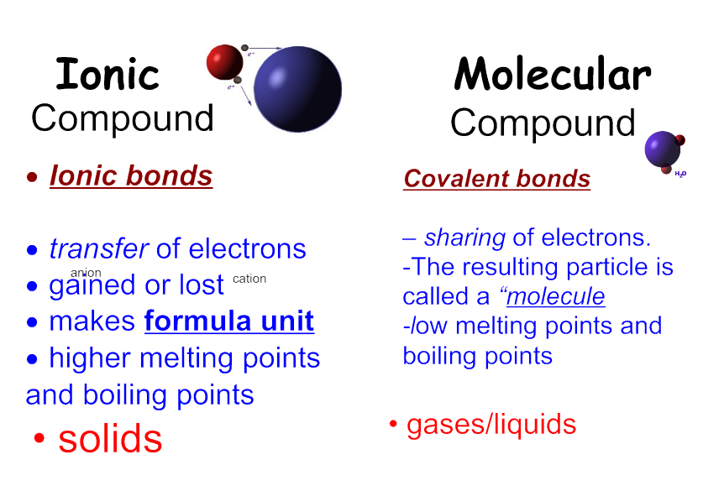

Answer the following as True or False

a. All molecular compounds are composed of atoms of two or more different elements.

b. All compounds contain molecules.

c. No elements exist as molecules.

d. Most molecular compounds are composed of two or more nonmetallic elements.

e. Atoms in molecular compounds share electrons.

f. Molecular compounds tend to have higher melting points than ionic compounds.
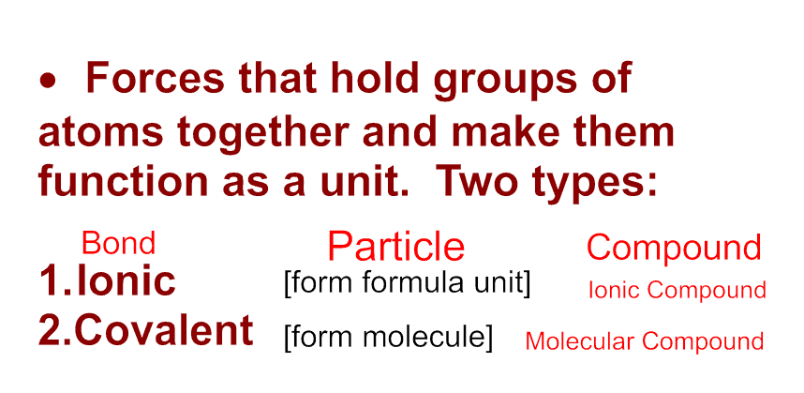
Bonds are…

Covalent bonds
- Nonmetals hold on to their valence electrons.
- They can’t give away electrons to bond.But still want noble gas configuration.
- Get it by sharing valence electrons with each other = covalent bonding
- By sharing, both atoms get to count the electrons toward a noble gas configuration.

Electron Configuration for
oxygen

neon

Covalent bonding

Write the electron configuration for fluorine.

We can represent the outer electrons using
a electron dot diagram:[shows the arrangement of valence electrons in an
atom]
- Fluorine has seven valence electrons (but would like to have 8)

Octet Rule: A maximum of eight electrons can occupy orbitals in the valence level of an atom.

Noble gases are unreactive, therefore, having eight electrons in a valence level is a stable structure.

