Parts of the sun
What is each part and be able to label the diagrams?
Corona
Solar Flare
Chromosphere
Photosphere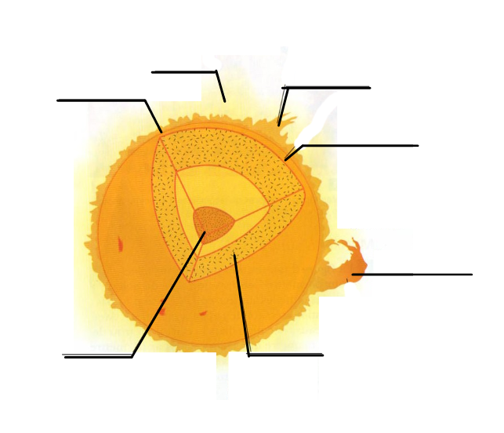
Solar Prominence
Moving Gases
Core

Gravity definition,
Gravity on the sun, and Earth, how do they compare
The theory of the big bag (Know the steps on how it was created)

Light is a form of energy that travels in ________________
What does R G BIV have to do with length? Which is the longest and which is the shortest?

