Space

What can we see in the sky

Firstly, the universe is everything that exists, including all matter and energy everywhere. The study of what is beyond the Earth is called astronomy.

Stars can take the form of Gods, animals, etc. Groups of stars that seem to form shapes or patterns are called constellations. These stars are far from one another. Constellations have been used as calendars, direction finders, etc.

Vocabulary
- Astronomer - a person who studies the sky

- Hemisphere - half of the Earth

- Light-year - the distance light travels in one year
(9,458,000,000,000 kilometers)

- Magnitude - a number that describes how bright a star
appears. Smaller numbers mean brighter stars.

Name the correct order of the planets: Start with the planet that is next to the sun
My Very Excited Mother Just Served Us Nachos
Mercury Venus Earth Mars Jupiter Saturn Uranus Neptune
______________________________________________________________________________

Our solar system consists of the sun and everything that travels around it.

Planets and moons do not emit their own light. They are nonluminous. (We see them because light of the sun reflects off them)

A star is matter that emits huge amounts of energy.
A planet is matter that revolves around a star.
- Check out table 1 on page 402 to see what the differences are between planets and stars (MUST KNOW)

Types of Earth's motions
- The Earth is spinning.
- The Earth travels around the Sun.

- Earth Spinning
  - Earth spins on an imaginary axis

  - Axis- An imaginary line from the north pole to the south pole.

  - Rotation- The movement of an object around its axis.
    - As the Earth rotates on its axis, the part of the Earth facing the Sun is experiencing day, and the part away from the Sun is experiencing night.

- Earth Revolving
  - Revolution- The movement of an object around another.
    - The Earth and the other planets revolve around the Sun. It takes the earth 1 year to revolve around the sun.

    - Orbit- The path planets take as they revolve around the Sun.

The period of time for one revolution around the Sun is called an orbital period.

What are the reasons, for the seasons?
- The Revolution of the Earth and the tilt of the Earth both cause the Earth to have Seasons.
- During the Summer, we receive the Sun's energy directly.
- During the Winter, we receive the Sun's energy at an angle.

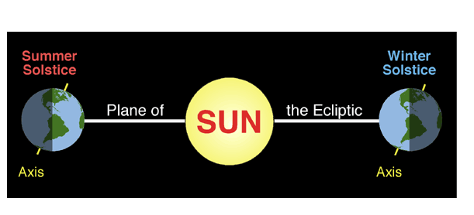

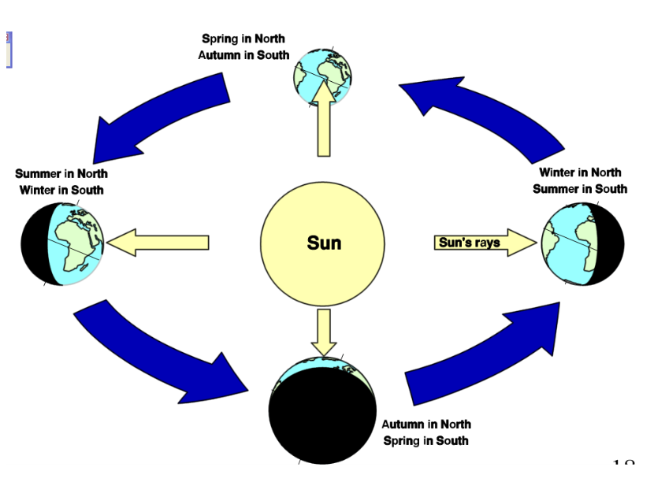

Our Solar System
- Our solar system is made up of eight planets, with the sun at the center. The planets revolve around the sun on paths called orbits. The time it takes to make one orbit around the sun is called the orbital period.

- The planets are made up of different combinations of chemical elements. The four common elements are; hydrogen, helium, oxygen and carbon.

- Each planet in the solar system is unique. The planets differ in their size, motion, and temperature, in the substances they are made of, and in their gravitational field strength.

What makes a Planet a planet?
For an object to be a planet, it needs to meet these three requirements defined by the IAU:
- It needs to be in orbit around the Sun

- It needs to have enough gravity to pull itself into a spherical shape

- It needs to have "cleared the neighborhood" of its orbit
  - As planets form, they become the dominant gravitational body in their orbit in the Solar System. As they interact with other, smaller objects, they either consume them, or sling them away with their gravity.
    - Pluto is only 0.07 times the mass of the other objects in its orbit and therefore does not have a high enough gravitational force to be considered a planet. Therefore, Pluto is a Dwarf planet.

Inner vs. Outer Planets

- The 4 closest planets to the sun are Mercury, Venus, Earth and Mars. They all have many common characteristics. They are called the terrestrial planets or inner planets. They are made of rock and metal.

- The 4 other planets (Jupiter, Saturn, Uranus and Neptune) are far away in space. They are called the outer planets. We can also call them the gas giants, because they are made up of mostly hydrogen and helium and they are big.
Read
pages 424 – 428
- Copy down 4 point about each planet, these will be your notes

Planets

Mercury
- Closest planet to the sun

- No atmosphere therefore temperature ranges from -180ºC to 400ºC

- Contains craters caused colliding rocks

- Too close to the sun and therefore is rarely visible in at night

- No moons

Venus
- Has a thick atmosphere made of Carbon Dioxide, and Nitrogen.

- Hottest planet due to the greenhouse effect

- Only planet that rotates backwards compare to the other planets

- Brightest object in the night sky with exception of the sun and moon

- no moons

Earth
- Atmosphere is made of Nitrogen, Oxygen, and water vapor. Slight greenhouse effect

- Temperature ranges from -85ºC to 65ºC

- The surface is made up of 70% water

- One moon

Mars

- Called the "Red Planet" because of rusty soil

- Mars’ atmospheric components consist of carbon dioxide, nitrogen and argon

- Explored with space probes

- Once contained glaciers and water

- Two moons

Jupiter
- Largest planet

- Has the greatest mass

- Can be seen in the night sky

- Has a huge hurricane that is known as the "Great Red Spot"

- Has approximately 55 moons

Saturn
- Second largest planet

- least dense
- Has rings that contain particles of ice rocks the size of dust to the size of a mountain
*Has approximately 66 moons

Uranus
- Rotates on a horizontal axis

- atmosphere is mostly hydrogen, with some helium & methane

- Coldest planet

- About 27 moons

- Also have rings

Neptune
- Known as the "Ice Giant"
- Atmosphere contains Hydrogen and helium
- Approximately 13 moons

Objects in space

Satellites are natural objects that revolve around planets
-The moon is the earth’s natural satellite
The first human-made object to reach the surface of the Moon was the Soviet Union's Luna 2 mission on 13 September 1959.

The United States' Apollo 11 was the first manned mission to land on the Moon on 20 July 1969. There have been six manned landings (between 1969 and 1972) and numerous unmanned landings

Asteroids are made up of thousands of small rocky objects.
- Asteroid belt is the ring of asteroids. There is an asteroid belt found between Mars and Jupiter.

meteoroid is a lump of rock or metal that is trapped by the earth's gravity and pulled down through Earth's atmosphere.

- A bright streak of light across the sky is a meteor.
- If the object hits the earth before vaporizing it is a meteorite.

Comet is a chunk of frozen matter that travels in a very long orbit around the sun. (DRAW Picture) FROM BOARD

Comets' tails are caused when the comets get close to the Sun. The outer layers of ice turn into gases that are pushed away from the Sun by the solar winds. These gases glow brightly.

A galaxy is a huge collection of gas, dust, and hundreds of planets, billions of stars and moons.

The space shuttle was made to take astronauts and cargo to and from Earth orbit. (Used to launch satellites into space and sometimes used as a science laboratory while orbiting earth)

The Space Shuttle Challenger disaster occurred on January 28, 1986, when Space Shuttle Challenger broke apart 73 seconds into its flight, leading to the deaths of its seven crew members. The spacecraft disintegrated over the Atlantic Ocean, off the coast of central Florida

The Space Shuttle Columbia disaster occurred on February 1, 2003, when shortly before it was scheduled to conclude its 28th mission, the Space Shuttle Columbia disintegrated over Texas and Louisiana during re-entry into the Earth's atmosphere,
resulting in the death of all seven crew members

Cosmology – is the study of the changes in our universe

Stars
- Stars evolve from clouds of gas and dust and follow a predictable series of stages: they begin, develop and end.
- Our sun is a star
- Stars are a lot further away than any of our plantes

We know that gravity is the force of attraction that pulls objects towards each other. The more mass an object has, the more attractive force it exerts.
- The sun has __Stronger___ gravity than earth
- Force does get smaller as the distance between objects increase

Nebula
The Cat's Eye, the nebula, is a large cloud of dust and gas, mostly helium and hydrogen. It is the starting point for all stars.

Supernova
A supernova is a very bright explosion that marks the end of a large star. It is rare.

Neutron Star
When a star about 10 time the mass of the Sun dies, the remaining core is a neutron core
- - Neutron star is an extremely dense star composed of neutrons. The neutrons are so tightly packed with no space between them that a cupful of neutron star would have
- a mass of millions of kilograms.
Black hole
Extremely large stars can turn into black holes.
- Black hole is a small, very dense object with a force of gravity so strong that nothing can escape from it, not even light can be radiated away from its surface.
- It is not a hole but a huge amount of matter packed into a sphere only a few kilometers across.

Red giants - a star near the end of its life that becomes larger and redder as it runs out o f hydrogen fuel.

Red Supergiant - a star with a mass 10 times or larger than the Sun's near the end of its life, that becomes larger and redder as it runs out of hydrogen fuel.

White dwarf - a small star created by the remaining material when a red giant dies out.

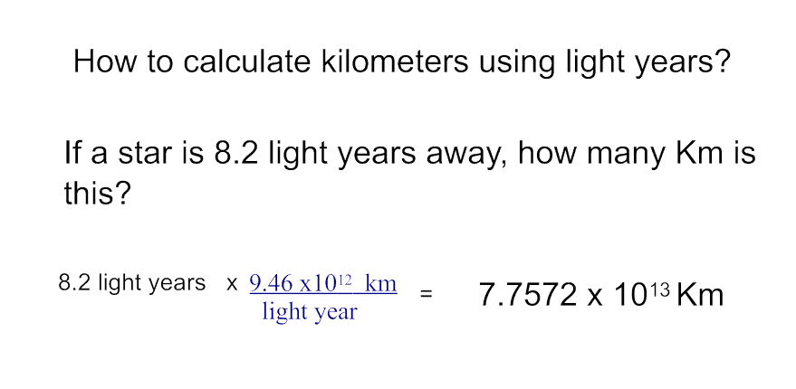

The Sun produces energy by a process called nuclear fusion. In the Sun's core, there is so much pressure and temperature that 2 hydrogen atoms fuse together to form 1 helium atom. This process produces large amounts of energy in the form of heat, light and other forms.

Parts of the sun are below (The part of the sun that is visible during an eclipse is the chromosphere)

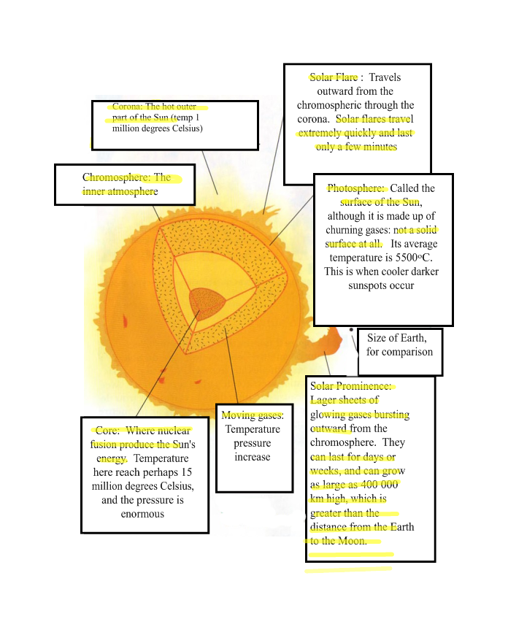
Gravity is the force of attraction that pulls objects towards each other. The more mass an object has, the more attractive force it
exerts. (The Sun has more gravity than earth)

At one point, all the matter of the entire universe was packed together into one small, extremely compact, hot (100 million degrees Celsius) mass under enormous pressure.
Then
BANGO!!!

The Big Bang occurred in which all this mass and pressure emerged. This occurred 10 to 15 billion years ago.

Three main stages of the formation of the solar system
Step 1:
Gravity caused components of the rotating nebula to join together. As the nebula rotated
it flattened out.

Step 2:
As the nebula flattened out a bulge formed towards the center, known as the sun today.
Cooler material further from the sun began to form chunks.

Step 3:
The heavy materials such as rock and iron were not light enough to be blown out. As chunks of solid matter circled the Sun, they eventually collided with one another and grew in size until the Terrestrial Planets were formed.

Light is a form of energy travelling as a wave. Each color has a wavelength, which is the length of one wave. Red has the longest and violet the shortest.
ROY G. BIV

