William Shakespeare
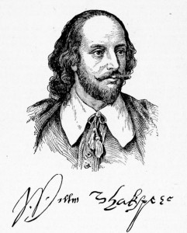

Shakespeare is renowned as the English playwright and poet whose body of works is considered the greatest playwright in the history of English literature.
Surprisingly for the world's greatest playwright, we actually know very little about Shakespeare's life. What few details we have come from church records, land titles and the written opinions of others. Very little is known about young Shakespeare.
We know that Shakespeare was baptized on April 26, 1564 and it is assumed that he was born on April 23, 1564. We also know that in 1582 at age eighteen, Shakespeare married Anne Hathaway, an older woman who was twenty six at the time. Shakespeare left Stratford for London to make his fortune roughly fours years later.
Shakespeare headed to London sometime in 1586; there already was an established community of playwrights. By 1595, Shakespeare was sufficiently successful to be named as one of the more senior members of the Lord Chamberlain's men, an acting company that performed frequently before court. This was no small honor; this prominent theatre company later became the royal company called the King's Men, making Shakespeare an official playwright to the King of England.
By 1596, Shakespeare was so successful as a playwright that his family was finally granted a Coat of Arms which, amongst other things, allowed Shakespeare to call himself a "gentleman". Shakespeare's fortunes were also improving during this time; in 1597, he purchased the second largest house in Stratford which he called New Place and began buying up land around Stratford. One year later, Shakespeare became a ten percent owner of the new theatre in London, the famous Globe Theatre, where so many of his plays would later be performed. By 1611, Shakespeare retired, returning to Stratford and, in 1616, Shakespeare died, famously bequeathing his second-best bed to his wife, often seen as a sign that his marriage may not have been very happy.
It might surprise readers to know that many of Shakespeare's plays, especially in the experimental period were hardly original, borrowing plot features from earlier plays. Likewise with his history plays, Shakespeare compresses events and does not follow history too closely to add to the drama. However, borrowing plots and taking liberties with historical facts was not uncommon in Shakespeare's time and his skill for language, imagery, pun and his creative adaption of myth and history have set Shakespeare apart as arguably the greatest playwright of all time.



