Nutrient Analysis
This analysis cannot be completed without your having access to the Food Focus 3.4 software program. The computer that you are using for your online course should have that program installed on your local drive, not in Programs. If it has not yet been installed in that location, remind your LF to have a technician download it onto your computer right away. Having the program installed on your local drive will allow you to export your food lists in a spreadsheet rather than having to copy the data into a table. This will save you a lot of time.

In order to attempt this activity, you must have first already submitted and received feedback on your 3-Day Food Recall. Be sure to make any suggested changes to your food recall before beginning this Nutrient Analysis. Be sure to read the second page of this document for very important help with the Food Focus program.

Using Food Focus 3.4

Check to see where Food Focus is installed. Ask your LF to request that it be installed on your local drive. (In my case, it is the C drive.) View the Food Focus tutorial video link in the Unit 2 page 6 content notes. You will have to view the tutorial two or three times to really get all the details. It takes time to remember all of the steps!

Instructions if Food Focus 3.4 is installed on your local drive:
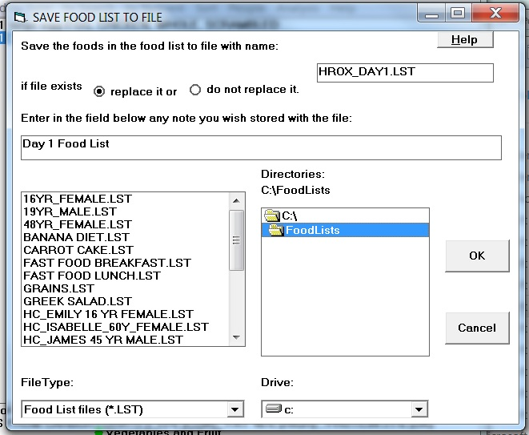
- Enter the first item from your 3-day food recall. (View the Food Focus 3.4 tutorial video for instructions on how to do this.)
- Click on Add to Food List.
- Save your Food List as “YourName_Day1.lst”. Make sure that you save it in the Food List folder by double clicking on FoodLists. (Just single clicking and highlighting the folder is not enough.)
- Enter the rest of the items in the first day of your 3-day food recall, saving them to the YourName_Day1.lst food list as you go.
- Go to your local drive and then open the Food Lists folder.
- Open the Microsoft Excel Comma Separated Values file (.csv) that has the same name as your food list.
- Delete the following columns: Mass (grams), Cost ($), Energy (KJ), Water (G), Fat (G), SatFAT (G), MonoUNSAT (G), PlyUNSAT (G), PUFA N6 (G), PUFA LA (G), PUFA N3 (G), PUFA ALA (G), EPA+DHA (G), N6/N3, Cholesterol (MG), VIT D (IU), VIT E (MG), VIT B6 (MG), POTASSIUM (MG), and ZINC (MG).
- Save it as a Microsoft Excel Workbook file.
- Repeat this process for your Day 2 and Day 3 files. Submit all 3 of these Excel files to the dropbox.

Submit your 3-day Nutrient Analysis via the appropriate dropbox to be checked by your DF. This information must be accurate before you begin Project 2: Diet Analysis.

Instructions if Food Focus 3.4 is installed on your local drive:
**VERY IMPORTANT: There are automatic default settings in the Food Focus program that you must change for each food item.

The defaults for the nutrient analysis are “100 grams” of each food and the “% Daily RNI”. These must be changed to the specific amount you ate and to “scientific units”.

For example, search “2% milk”, click on “milk, fluid, partly skimmed, 2%MF” and enter 250ml for quantity; click “Show Nutrient Data”. The data you see is for 100 grams and expressed as % RNI. In the bar at the top of the data screen, click on the radio button in front of 250ml and also on the radio button in front of “Scientific Units.” The screen that you need for your tables will then be showing.

If you have Remember, you can combine food items into a food list instead of entering each amount separately. For example, if you ate a ham and cheese sandwich with mustard and lettuce, you can enter each of the individual items into a food list before clicking on the nutrient analysis button. That is, the 2 slices of white enriched bread (commercial), 10 ml of unsalted regular butter, 2 slices of regular black forest ham, 1 slice of processed cheddar cheese, 5 ml regular mustard and 1 lettuce leaf are all combined into one analysis (review the FF video tutorial).

Submit your 3-day Nutrient Analysis via the appropriate dropbox to be checked by your DF. This information must be accurate before you begin Project 2: Diet Analysis.

Copy three (3) of the following charts into a WORD document. Within each chart, be sure to display the appropriate title of either Day 1, Day 2 or Day 3. Add in the names and specific amounts of the food items you ate for each of the 3 days (refer to your corrected Food Recall). The information that you add into each of the nutrient columns comes from using the Food Focus Program.

**It is crucial that your description of the food item in the left hand column be exactly as shown in the Food Focus program so that the DF can check your data.
For example, if you had a bowl of soup for lunch, you will notice that there are a hundred or so different “soup” lines to click on in Food Focus. You must be specific as to which line you go to for the data in your table. Therefore, write out “SOUP, CAMPBELL’S CHUNKY SOUPS, BEEF WITH COUNTRY VEGETABLES SOUP” if that is the data you use. Don’t forget the amount also!

Nutrient Analysis: Day 1
Food item and amount | Food energy  kcal | Protein  g | Carbs  g | Fat  g | Vit A  mcg | Thiamin  mg | Riboflavin  mg | Niacin  NE | Folate  mcg | Vit B12  mcg | Vit C  mg | Calcium  mg | Iron  mg | Sodium  mg
Totals for Day 1
*Add as many extra rows as required for each day’s data. To add rows, click on the table then click on “Table” in the nav bar, insert rows (choose above or below).
An example of a full day’s intake is shown at the end of this assignment.

Example Nutrient Analysis for one day:
Nutrient Analysis: Day 1
Food item and amount | Food energy  kcal | Protein  g | Carbs  g | Fat  g | Vit A  mcg | Thiamin  mg | Riboflavin  mg | Niacin  NE | Folate  mcg | Vit B12  mcg | Vit C  mg | Calcium  mg | Iron  mg | Sodium  mg
250ml canned apple juice, unsweetened, vitamin C | 123.1 | 0.2 | 30.6 | 0.3 | 0 | 0.1 | 0 | 0.3 | 0.3 | 0 | 107.4 | 18.3 | 1.0 | 7.9
2 small bagels, ww | 249.0 | 9.6 | 54.4 | 1.2 | 0 | 0.2 | 0.2 | 5.8 | 37.4 | 0 | 0 | 24.0 | 2.5 | 742.0
30g peanut butter, smooth, reduced fat | 156.0 | 7.8 | 10.7 | 10.2 | 0 | 0.1 | 0 | 5.8 | 18.0 | 0 | 0 | 10.5 | 0.6 | 162.0
1 banana | 105.8 | 1.2 | 26.9 | 0.6 | 9.2 | 0.1 | 0.1 | 0.9 | 22.0 | 0 | 10.5 | 6.9 | 0.4 | 1.2
1 pita bread, whole wheat | 170.2 | 6.3 | 35.2 | 1.7 | 0 | 0.2 | 0.1 | 3.4 | 22.4 | 0 | 0 | 9.6 | 2 | 340.5
75g tuna, light, canned, water drained, unsalted | 87.0 | 19.1 | 0 | 0.6 | 12.8 | 0 | 0.1 | 13.5 | 3 | 2.2 | 0 | 8.2 | 1.1 | 37.5
15ml mayonnaise, low sodium, low fat | 32.3 | 0 | 2.2 | 2.7 | 0 | 0 | 0 | 0 | 0 | 0 | 0 | 0 | 0 | 15.4
125ml carrots, raw | 48.2 | 1.2 | 11.4 | 0.2 | 3150.6 | 0.1 | 0.1 | 1.2 | 15.7 | 0 | 10.4 | 30.2 | 0.6 | 39.2
250ml apple juice, vitamin C added | 123.1 | 0.2 | 30.6 | 0.3 | 0 | 0.1 | 0 | 0.3 | 0.3 | 0 | 107.4 | 18.3 | 1.0 | 7.9
250ml sweet potato, baked in skin | 247.2 | 4.1 | 58.2 | 0.3 | 5236.8 | 0.2 | 0.3 | 1.9 | 54.2 | 0 | 59.0 | 67.2 | 1.1 | 24.0
125ml beans, green, boiled, drained | 23.1 | 1.2 | 5.2 | 0.2 | 44.2 | 0 | 0.1 | 0.6 | 22 | 0 | 6.4 | 30.4 | 0.8 | 2.0
125ml carrots, boiled, drained | 57.2 | 1.4 | 13.3 | 0.2 | 3117.8 | 0 | 0.1 | 0.9 | 17.7 | 0 | 2.9 | 39.4 | 0.8 | 83.8
500ml milk, 1% white | 216.7 | 17.0 | 24.7 | 5.5 | 304.4 | 0.2 | 0.9 | 4.4 | 25.8 | 1.9 | 5 | 634.7 | 0.3 | 258.0
125g pudding, ready-to-eat, fat free, vanilla | 483.8 | 2.8 | 28.4 | 0.1 | 50 | 0 | 0.2 | 0.6 | 3.8 | 0.2 | 0 | 75 | 0.5 | 266.2
1 banana | 105.8 | 1.2 | 26.9 | 0.6 | 9.2 | 0.1 | 0.1 | 0.9 | 22.0 | 0 | 10.5 | 6.9 | 0.4 | 1.2
50g cheddar cheese | 201.5 | 12.4 | 0.6 | 16.6 | 139.0 | 0 | 0.2 | 2.7 | 9.1 | 0.4 | 0 | 360.6 | 0.3 | 310.2
Totals for Day 1: | 2062.6 | 85.6 | 359.4 | 41.1 | 12074.0 | 1.4 | 2.3 | 43.3 | 273.5 | 4.8 | 319.6 | 1340.3 | 13.1 | 2298.9

