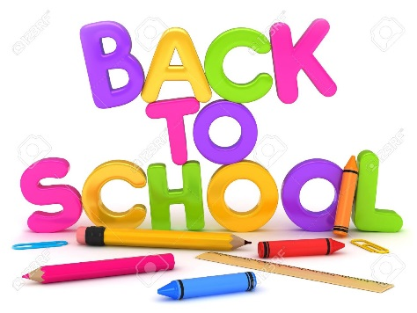

Blackville School Grade 2 English
School Supply List 2019-2020

- 8 duo tangs (2 orange,2 red,2 blue,1 green,1 yellow)
- 1 campfire notebook
- ½ plain ½ lined Hilroy Exercise Book (journal for writing)
- 4 Hilroy scribblers
- 1 hard cover 3 ring binder (1 inch)
- 4 large glue sticks
- 6 white erasers
- 30 HB brand pencils
- Scissors
- Colored pencils
- Markers
- Pencil box or case
- 20 page Hilroy Studio Scrap book (Blue cover)
- 2 boxes of Kleenex
- Headphones for the computer lab
- Inside sneakers for gym

