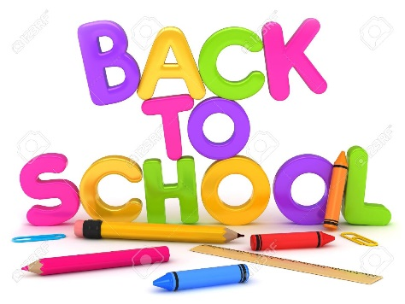

Blackville School Grade 2 English
School Supply List 2018-2019

- 10 duo tangs (2 orange,2 red,2 blue,2 green,2 yellow)
- 1 campfire notebook
- 1 hard cover composition book (found at Dollar Store)
- 4 Hilroy scribblers
- 1 hard cover 3 ring binder (1 inch)
- 4 large glue sticks
- 6 white erasers
- 40 HB brand pencils
- Colored pencils
- Markers
- Pencil box or case
- 4 boxes of Kleenex
- Headphones for the computer lab
- Inside sneakers for gym

