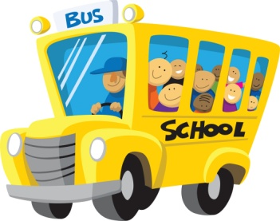
Blackville School Grade 3 School Supply List 2013-2014
PLEASE NOTE: Sharpen colored pencils and 12 regular pencils before you come to school on the first day. Please put your name on all books but do not put subjects on books. Thank you!
SUPPLIES NEEDED:
- Large Ring Scribbler
- 10 Duotangs
- 10 Hilroy Scribblers
- Hard covered Journal
- 250 sheets of looseleaf
- White glue/glue sticks
- White erasers
- HB pencils (sharpen 12)
- Colored Pencils (sharpen)
- Markers (if you wish)
- Pencil case/box
- 1 Metric ruler
- Highlighters
- Scissors
- 1 pkg of Large Zip Loc bags
- 2 boxes Kleenex
- Scrapbook (medium sized)
- Inside shoes for Gym

