2012 Miramichi River Adventures Three Week Summer Camp

Fun, Adventure, Technology, & a week at a true bona fide resort in the world’s first SMART showcase community!

Students who are enrolled in the camp will get a true Miramichi experience. The first week of camp students will embark on a rigorous outdoor adventure. Students will participate in activities such as rappelling, canoeing, archery, outdoor cooking, mountain biking, and much more.
The second week campers will travel to a variety of different operators around the Miramichi area.
- Fly casting at the Atlantic Salmon Museum.
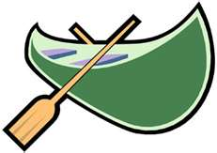
- Walking along the sandy beach of Escuminac and enjoying a lobster supper/BBQ.
- Experiencing a traditional native lunch at Metepenagiag followed by a GPS treasure hunt.
- Enjoy a relaxing day floating down the river on a tube.
- The big canoe adventure at Beaubears Island and many more exciting adventures.
On week three enjoy a weeks stay at the Morada Resort where campers will enjoy all the resort has to offer such as canoeing, kayaking, indoor swimming pool, campfire entertainment, etc. This last week students will be immersed in technology starting every morning off with “Being SMART with technology”. Students will learn how to create stop-motion animations and video productions. Additionally, they will learn how to create highly interactive SMART Notebook 11 technology projects and learn the basics of digital audio production. They will also be introduced to the art of digital photography. Students will leave the camp with their own file of original digital content and creations.
Call 773-4414 for more information.

Date: June 25th-July 13th
Age: 10-15
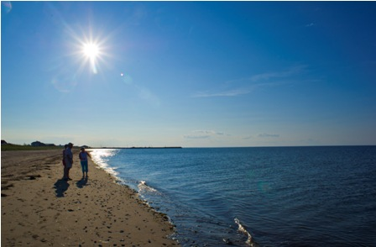
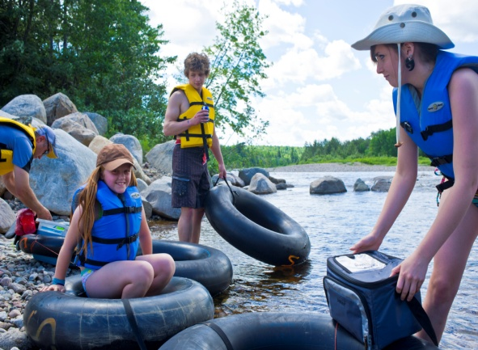
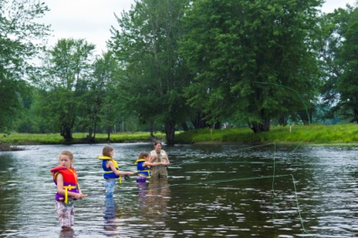
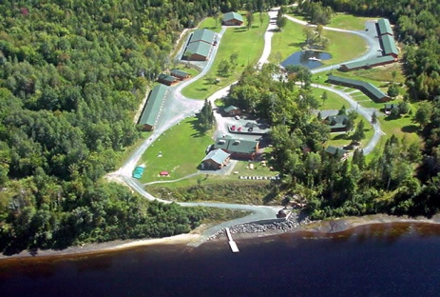
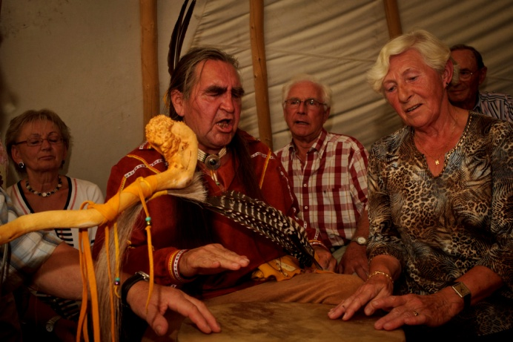
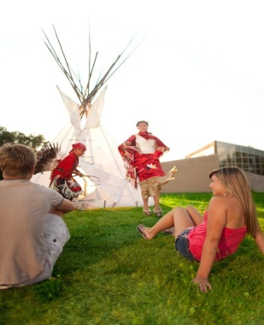
Cost: ONLY $400.00 for 3 Weeks of Camp!!!! Space is limited.

