Persuasive Writing – Introduction

Over the past few weeks, we have been working on:
- Creating a Sandwich Plan
- Writing down supporting details for your reasons
- Creating engaging hooks
This week we are going to complete our Introduction.
As you are aware, hooks are just part of our introduction. In order to have a complete introduction, we need the following:
- Engaging hook
- You need to state your opinion
- You need to state your reasons

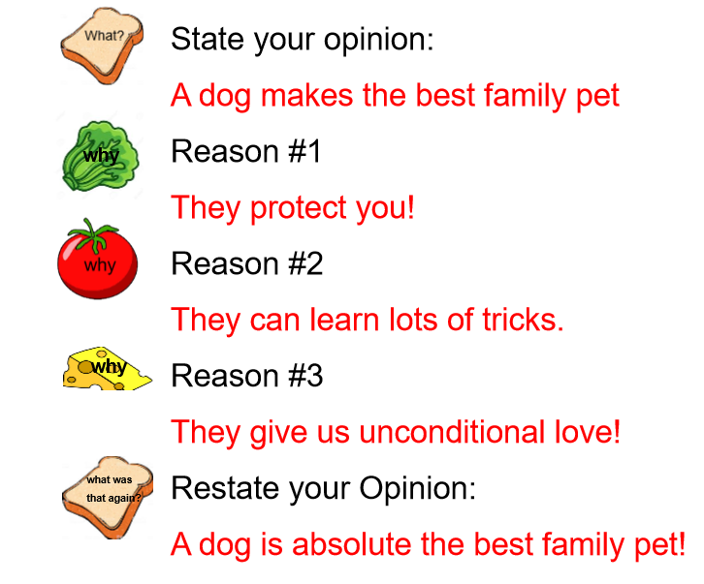
My Sandwich Plan – Week of April 14th to 17th

My Hook (Visual Image) – Week of April 27th to May 1st
On a warm sunny morning, the yellows beams of sunshine cast into the window, warming your sleeping dog. Slowly, she begins to open her sleepy eyes one at a time. Her mouth moves as if to breath in the rich warmth of the sun. Her paws slowly stretch out in front of her body and she gives a huge yawn and looks at you with such content. Having a dog as a family pet makes life a little happier.

My Introduction – This week’s assignment
On a warm sunny morning, the yellows beams of sunshine cast into the window, warming your sleeping dog. Slowly, she begins to open her sleepy eyes one at a time. Her mouth moves as if to breath in the rich warmth of the sun. Her paws slowly stretch out in front of her body and she gives a huge yawn and looks at you with such content. You have to agree that having a dog in your family makes for the best pet ever! First, they can protect you, they can learn many tricks and finally they provide unconditional love! What more would you want in a pet?

