Examples of Comprehension Strategies
Week of May 4th to May 8th
I will be using the novel “A Boy Called Bat” to demonstrate the following three strategies. (Log into Epic if you want to follow along).

- Choose 2 of the 3 Comprehension Strategies:

Monitoring | Predicting | Visualizing
As you read look for tricky words. Write them down. Then, use a dictionary to find out how to say them and what they mean. Write down the definitions. | Before you start the next chapter of your book, make a prediction about what you think will happen next. Then, after you read the chapter, tell whether your prediction was correct. | Choose a part of the book where the author used words to create a picture in your mind. Write the author’s description and draw a picture of what you visualize.

Strategy # 1 – Monitoring
Chapter 10
Philosophy - The word philosophy comes from the Greek language. It means “love of wisdom.” Philosophy is the study of some of the most basic questions about human life.
There are many branches, or areas, of philosophy. Some branches deal with questions about reality and how people understand and experience it. Other branches deal with questions about how people behave and what is good or bad behavior.

Strategy #2 – Predicting
Chapter 11 – Apartment 2A
Prediction:
At the end of chapter 10 it explained that Bat’s dad was picking him up from school. At the beginning of the book, we learned that Bat went to his dads every other Friday and he did not enjoy it. I predict that Bat is not going to have a good stay with his dad. He was already in a bad mood when he left school because he did not want to work with his group and he knew that he would not be able to see the baby skunk that his mother brought home. Also, it appears that Bat does not like change and by going to his dads, his regular routine will change.
What my Prediction Correct?
My prediction was correct. Dad took both Bat and his sister to get hot chocolate and Bat spilled it on himself. When they got to the apartment, it smelt like onions because dad made chilly for supper. Bat hated mushy food (only oatmeal). The last sentence of the chapter summed it up by saying “It was going to be a long weekend.”

Strategy #3 – Visualizing
Chapter 13 – What’s in a Name
Page 78
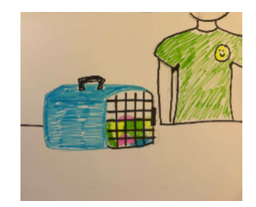
“The enclosure was nothing like Babycakes’s enclosure. It was just a dog kennel, a smallish one, blue plastic with a handle on the top and a black grate door that locked. But inside mom had made a nice nest out of old ripped-up T-shirts.

