May 25, 2020
Hello Grade 7!
I am going to continue reviewing outcomes that we have already completed throughout the year for the next few weeks of home learning. For the students that followed along and completed the assigned work, thank you! If you are just visiting and going to try some Math- great. There will be no more mental math for the year.

*Please send me ANY questions about anything we are doing this week!
Monday – Integers – adding, using tiles
Tuesday – Integers – adding
Wednesday – Integers - subtraction, using tiles
Thursday – Integers - subtraction
Friday – a “mini” assignment for review

*Remember, do what you are comfortable with. Do a little or it all, as long as you are doing something to keep your math skills fresh

Monday
Example (in case you need a review)
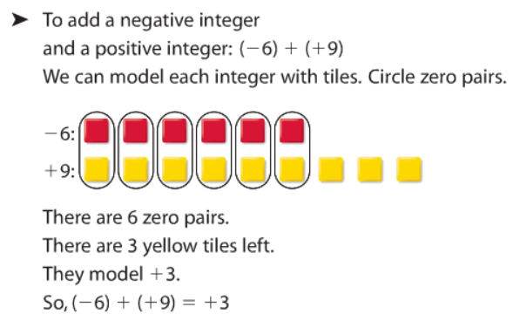
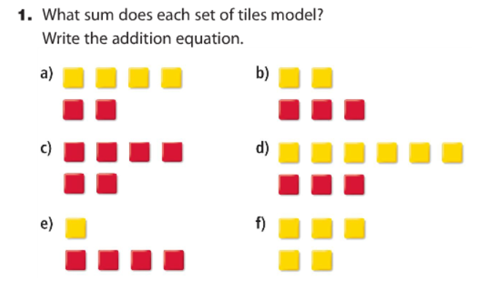

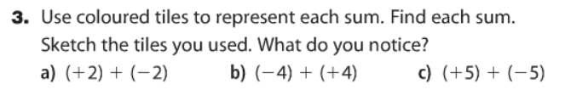

Tuesday
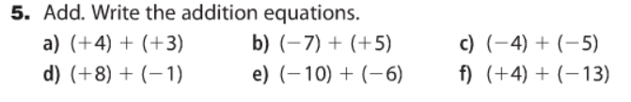

Wednesday
Review (if you need an example)
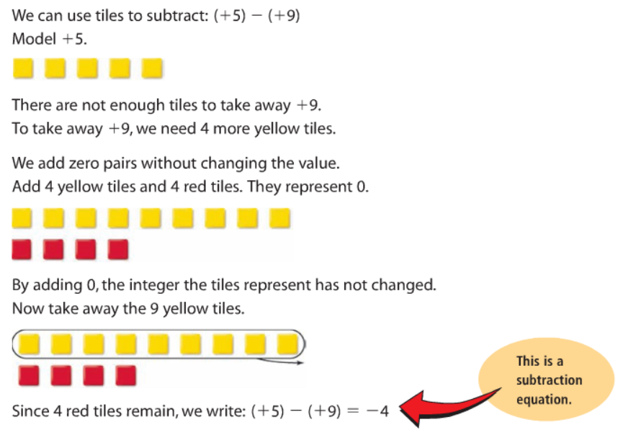

Second example:
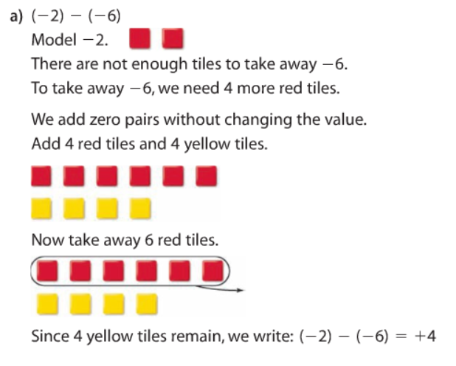

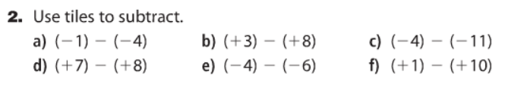

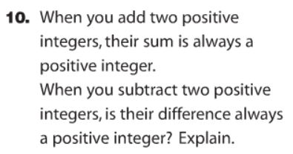

Thursday
Remember to ADD the OPPOSITE:
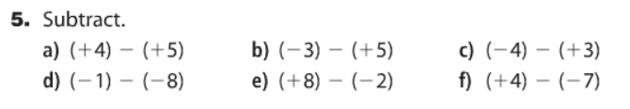

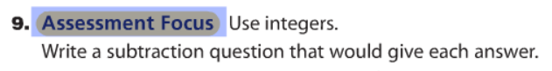

Friday

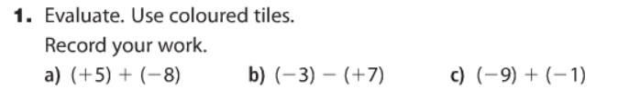
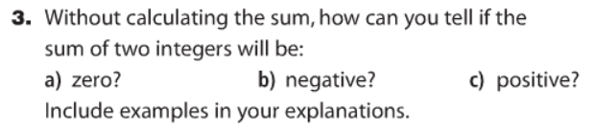
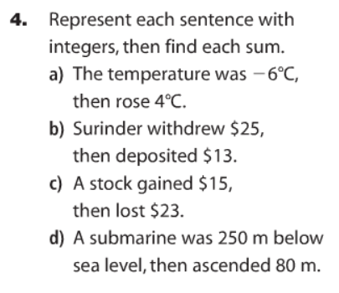
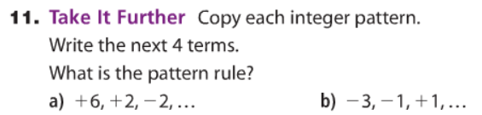

Another week of home learning complete! Now that the nice weather is here, I hope you are enjoying some outdoor activities! Summer will be here before you know it! Have a great week

