May 19, 2020
Hello Grade 7!
I am going to start reviewing outcomes that we have already completed throughout the year the next few weeks of home learning. For the students that followed along and completed the assigned work, thank you! If you are just visiting and going to try some Math- great.

*Please send me ANY questions about anything we are doing this week!
Monday – Divisibility rules
Tuesday – Divisibility rules
Wednesday – Venn Diagram
Thursday – Venn Diagram
Friday – a “mini” assignment for review

*Remember, do what you are comfortable with. Do a little or it all, as long as you are doing something to keep your math skills fresh

Monday (mm)
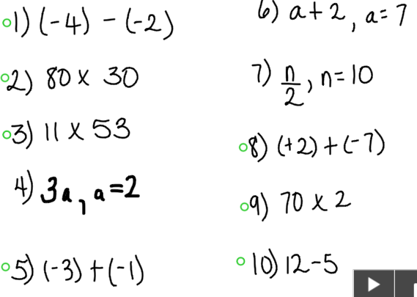

Tuesday (mm)
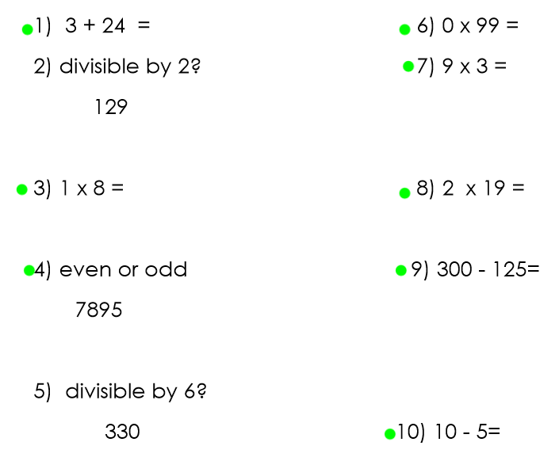

Wednesday (mm)
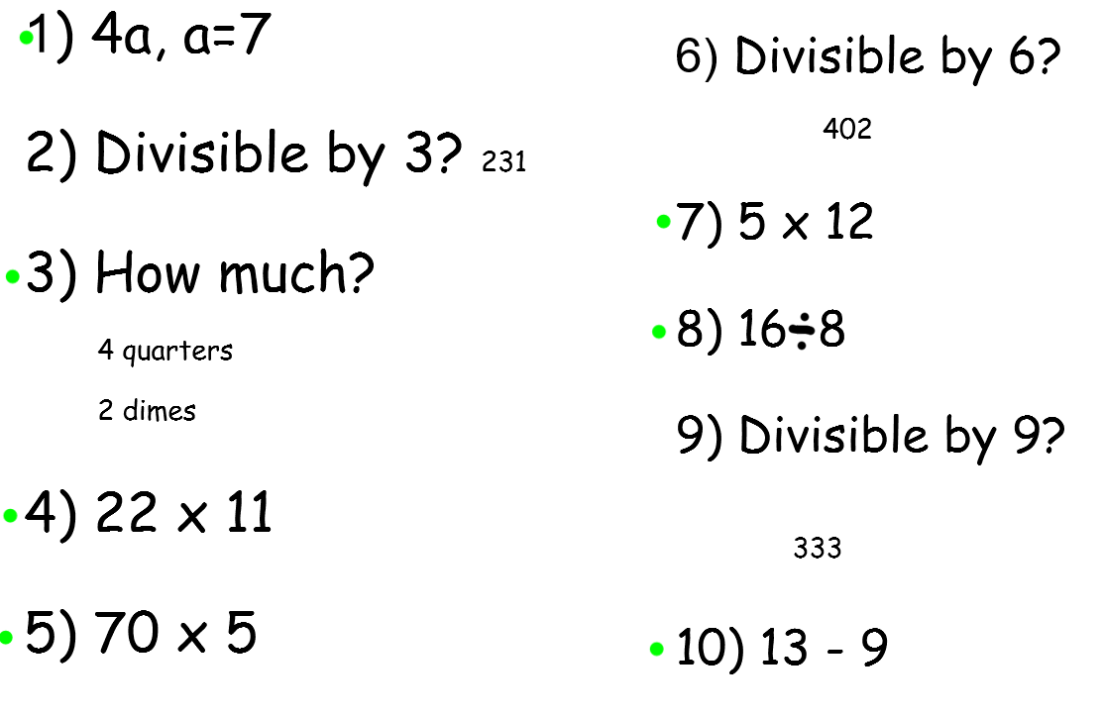

Thursday (mm)
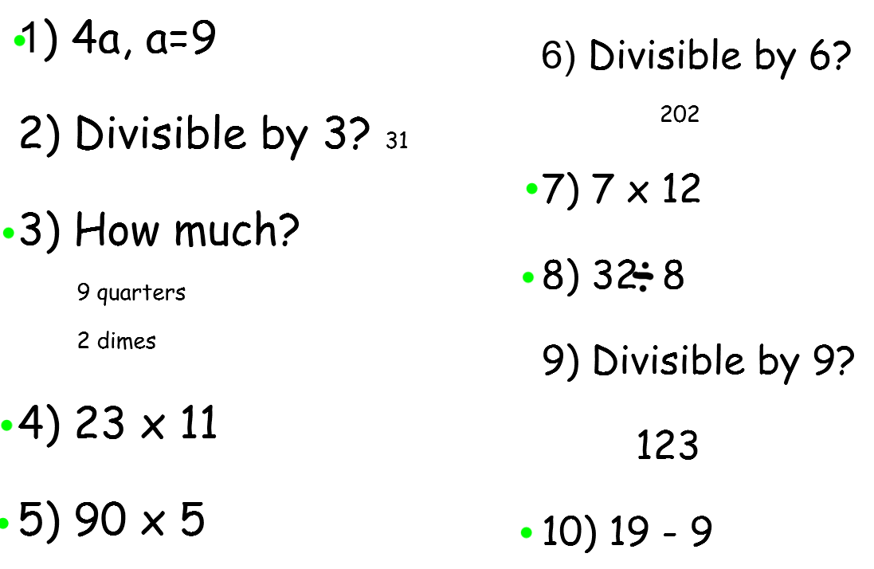

Friday (mm)
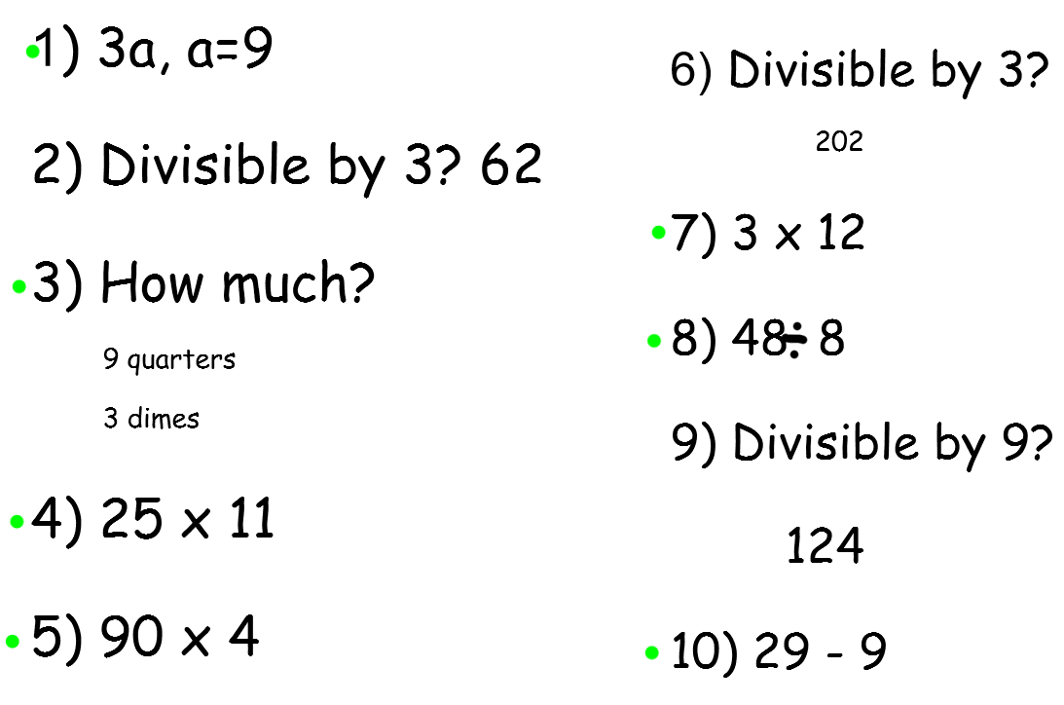

Monday

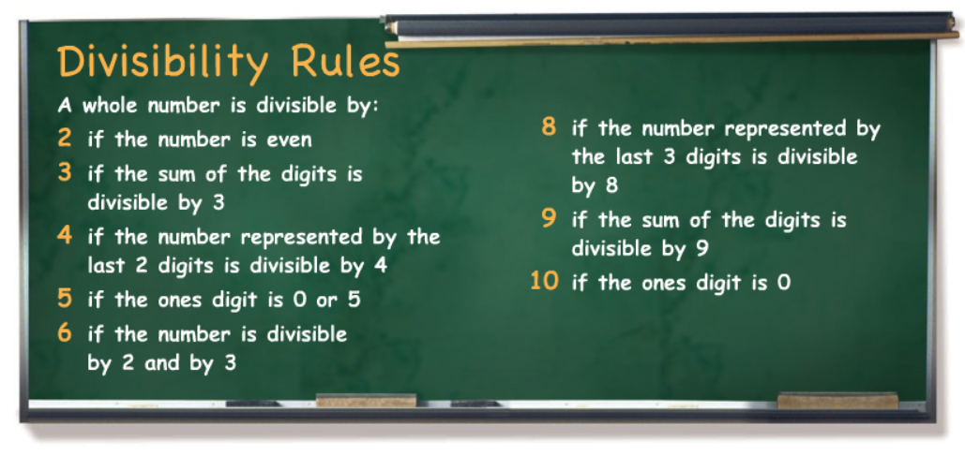

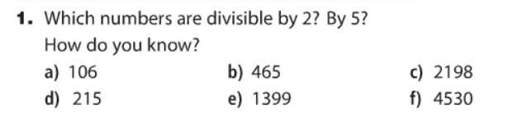

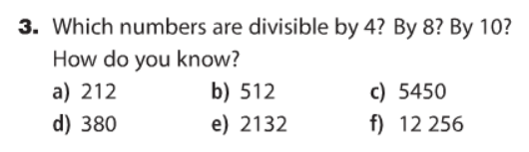
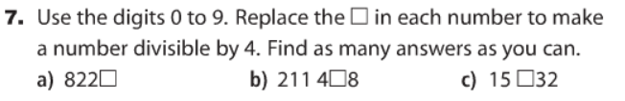
*Please just do 2 answers for each letter.

Tuesday:

4.

Wednesday
Watch this video: (Venn Diagrams):
https://www.youtube.com/watch?v=HZi4OFZshh8
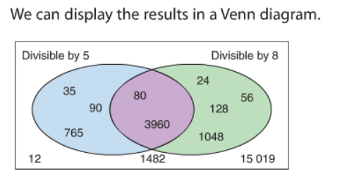
The blue section contains only numbers that are divisible by 5
The green section contains only numbers that can be divisible by 8
The purple section contains numbers that are divisible by 5 and 8
The white section contains numbers that are NOT divisible by 5 OR 8

Try this one:
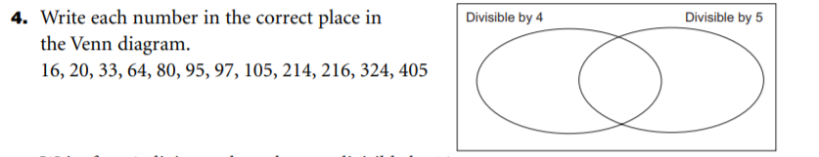
Thursday
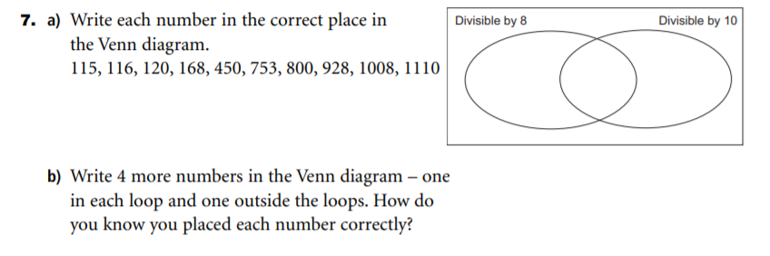

Finally Friday
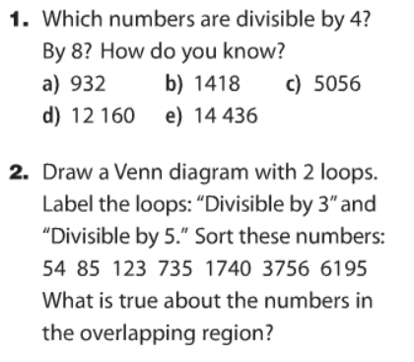

Thanks for all of your hard work in Math this week Things are looking up in our province, some restrictions have been relaxed! I hope you showed your mom some appreciation this past weekend !
Have a great weekend,
Mrs. Moody

