May 11, 2020
Hello Grade 7!
I am going to keep moving today in our Math 7. For the students that followed along and completed the assigned work, thank you! If you are just visiting and going to try some Math- great We will still do our Mental Math, but we are going to move into “Area of Triangles”. We will move slowly, so that you are able to remember vocabulary and the formula that you need for this outcome. *Please send me ANY questions about anything we are doing this week!
Monday – Intro to the formula for Triangles
Tuesday – Area formula practise – height inside the triangle
Wednesday – Area formula practise – height measured outside the triangle
Thursday – Area of Triangles
Friday – a “mini” assignment for review

*Remember, do what you are comfortable with. Do a little or it all, as long as you are doing something to keep your math skills fresh

# 3, 4, 6, 7,8,10 daily
Monday (mm)
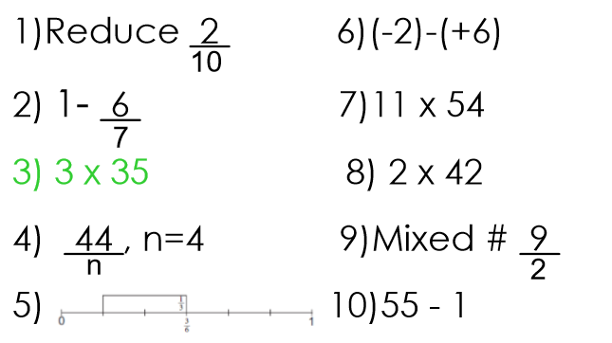
Write an addition equation

Tuesday (mm)
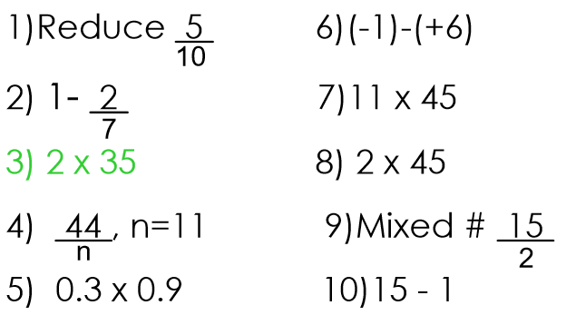

Wednesday (mm)
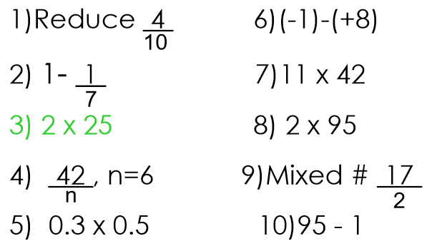

Thursday (mm)
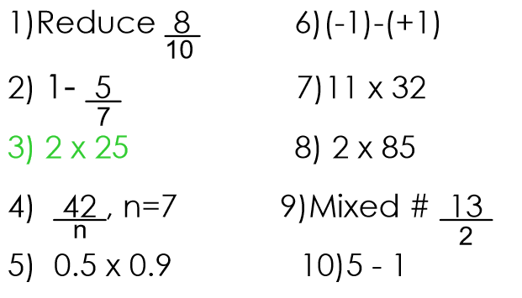
Friday (mm)
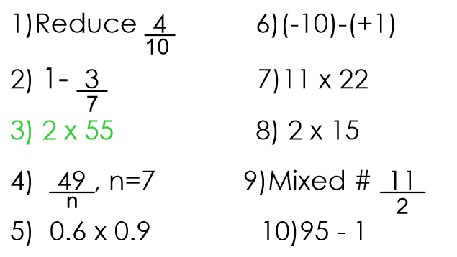

Monday

- Watch the following video:
https://m.youtube.com/watch?feature=youtu.be&v=PHKaqXlki6w
Do the following activity…
- Draw and measure the dimensions of a rectangle.
- Cut out the rectangle
- Find the area of the rectangle (*Remember that A = bh OR A= l x w – you did this in grade 6 Math, the formula for all quadrilaterals {4 sided shapes} is the same).

Example:
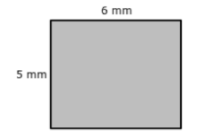
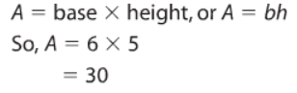

- Draw a diagonal on your rectangle:
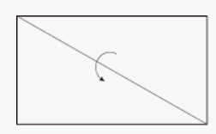
- This shows how you get to the formula for Area of a

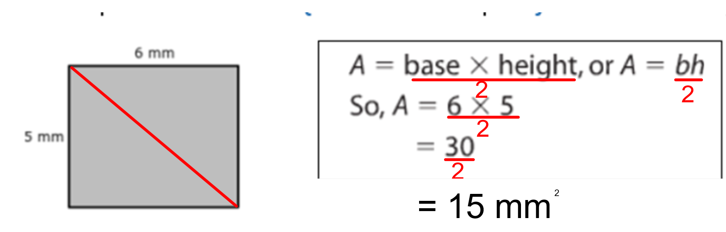

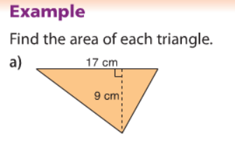
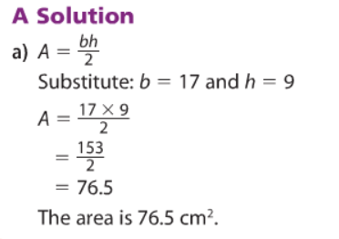
_____________________________________________________________________________________
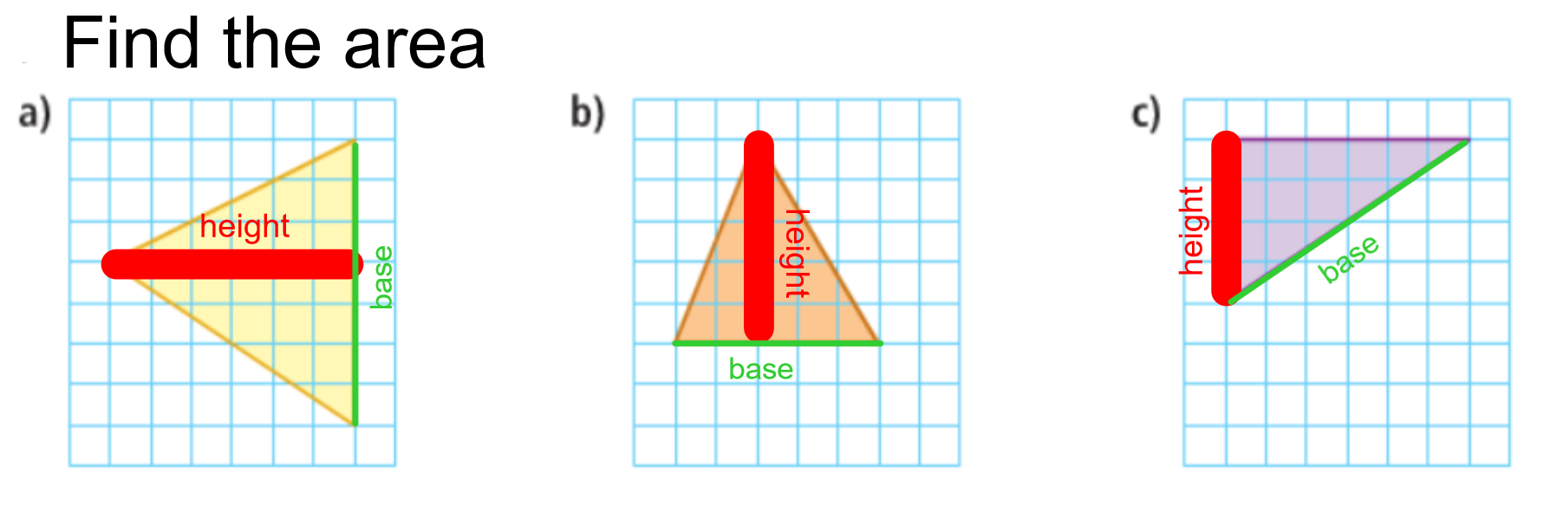

Tuesday:

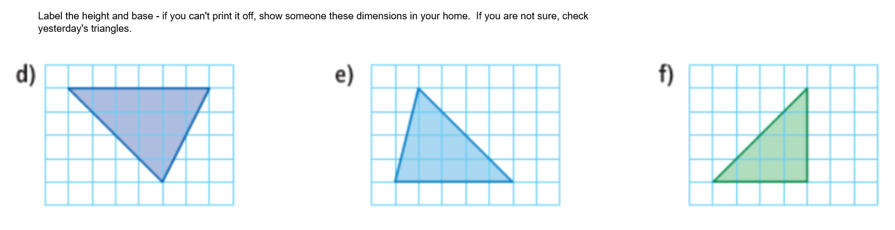

- Watch this video for a review:

https://m.youtube.com/watch?v=-mRqV6DrP_A&feature=youtu.be

- Try this website for practise of Area of Triangles (you will need paper and pencil plus a calculator – just send me your score!)

https://nb.mathgames.com/skill/7.85-area-of-right-triangles

Wednesday
Complete the following:

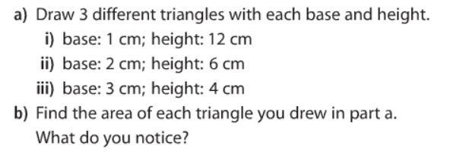

- Find the area of these 2 triangles:

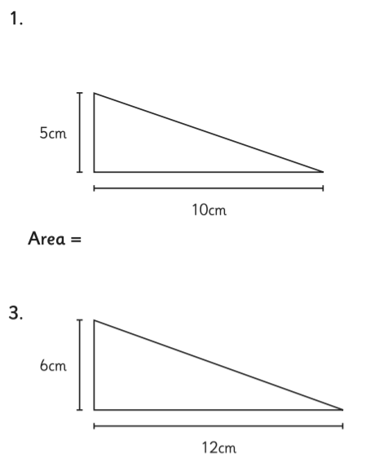
Thursday
Review with a word problem.
Remember to find the Area THEN the price they have to pay…
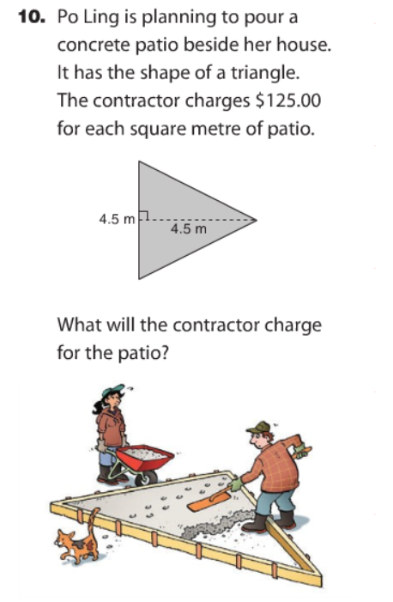

Finally Friday
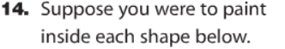
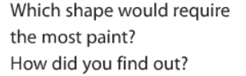

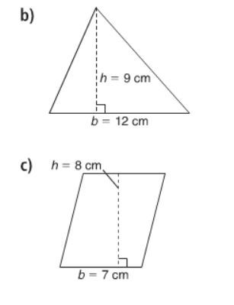

Challenge: Try it

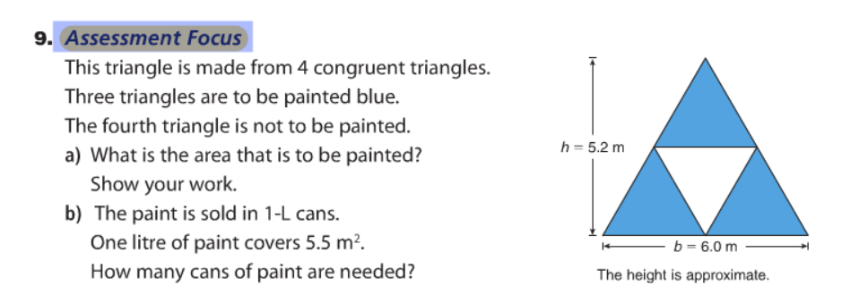

Thanks for all of your hard work in Math this week Things are looking up in our province, some restrictions have been relaxed! I hope you showed your mom some appreciation this past weekend !
Have a great weekend,
Mrs. Moody

