May 31, 2020
Hello Grade 7!
I am going to move into “Probability” this week. Probability is the number that describes the chance that a particular event will occur (An example would be the chances of winning a game). It will be based online, with some review and some games. Probability is fun and needs to be explored through games and hands on learning

*Please send me ANY questions about anything we are doing this week!
Monday – http://studyjams.scholastic.com/studyjams/jams/math/probability/probability-fraction.htm. On this site, choose “Step by Step” to go through the lesson, then “Test Yourself”.
Now play a game of “Rock, Paper, and Scissors with someone in your house. Play 10 matches. Out of 10 how many games did you win?
Tuesday – Go to this site http://www.mathgametime.com/games/daisy-petals. Play a few times, see how many matches you can win against the computer. Try to develop a strategy – predict how many matches you will win out of 10.
Wednesday – https://www.turtlediary.com/game/probability-wheel.html
Try out the game above
Thursday –https://www.ixl.com/math/grade-3/certain-probable-unlikely-and-impossible
There are 4 terms that you see with probability with this game –
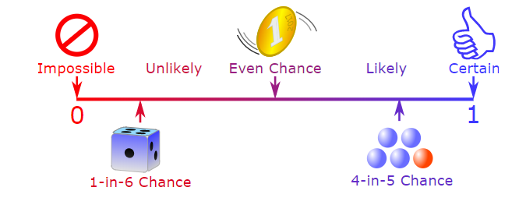

Read each question carefully to understand the difference between the 4 terms.

Finally Friday - http://www.trox5.com/interactive/games/pond.html

You can choose whichever game you would like to try. Try a few to see the different ways you can represent probability – words, per cents, fractions
* find a coin, flip it 20, 50 or 100 times. How many times did the ocin land on tails?
*Remember, do what you are comfortable with. Do a little or it all, as long as you are doing something to keep your math skills fresh

Have a great weekend! One more week to go then it is officially summer for you. Stay safe

